EXPERT TALK
AWARENESS, OPPORTUNITIES & INNOVATION IN ROBOTICS AND AUTOMATION
Date: 3rd September 2026
Time: 2:00 PM – 4:00 PM
Venue: VNR VJIET, Hyderabad
Organised by: IEEE Robotics and Automation Society - VNRVJIET Student Branch, IEEE VNRVJIET and Dept. of ECE, EIE & CSE-R&I
Event: RAS Day 2026
Awareness, Opportunities & Innovation in Robotics and Automation
Speaker: Ms. Mounika Sakhineti, Vice Chair – IEEE RAS Hyderabad Section; Founder & Director – RoboTech LLP
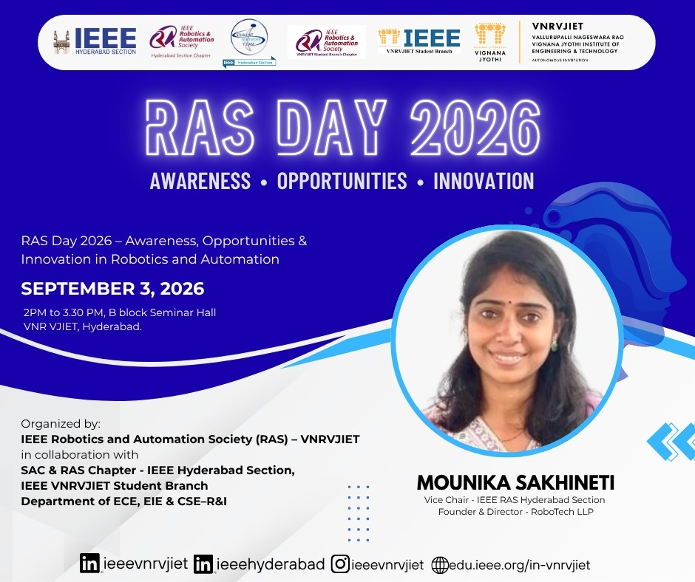

Introduction
On 3rd September 2026, on the occasion of RAS Day 2026, the IEEE Robotics & Automation Society (RAS) Student Branch Chapter of VNRVJIET, in collaboration with the SAC & RAS Chapter of IEEE Hyderabad Section, the IEEE VNRVJIET Student Branch, and the Departments of ECE, EIE & CSE–R&I, organized an expert talk titled “Awareness • Opportunities • Innovation in Robotics & Automation.” The guest lecture was delivered by Ms. Mounika Sakhineti, Vice Chair – IEEE RAS Hyderabad Section and Founder & Director of RoboTech LLP. The session was conducted from 2:00 PM to 3:30 PM at the B Block Seminar Hall , VNRVJIET.
The session aimed to enlighten engineering students on the growing landscape of robotics, industrial automation, and emerging technologies, offering direct guidance on how academic learning can translate into entrepreneurial and impactful career opportunities.
Benefits of IEEE and the RAS Ecosystem
A primary focus of the talk centered on the structural and professional value of engaging with IEEE and the Robotics & Automation Society. Ms. Mounika highlighted how active student participation bridges the gap between textbook engineering and real-world implementation.
She detailed the key advantages of holding an IEEE RAS membership, including:
- Direct access to top-tier technical publications, digital libraries, and specialized educational repositories.
- Global networking pathways connecting students with leading researchers, academicians, and industry pioneers.
- Structured mentorship frameworks that empower young engineers to cultivate leadership, technical writing, and organizational competencies.
Grants, Funding, and Student Support in RAS
The speaker placed considerable emphasis on the financial and logistical support offered by IEEE RAS to encourage grassroots innovation. Students were introduced to a variety of funding avenues tailored for student branches and individual innovators, including:
- Travel Grants: Opportunities enabling students to present research papers at flagship international conferences across the globe.
- Project & Chapter Support Grants: Dedicated funding lines to build competitive robotics projects, host local technical symposia, and set up hands-on robotics workshops.
- Humanitarian & Design Challenges: Programs that fund student-led automation initiatives aimed at solving community and sustainability challenges.
Ms. Mounika encouraged attendees to actively submit proposals, highlighting that many students miss out on funding simply due to a lack of awareness regarding application timelines and proposal drafting standards.
Flagship Conferences and Global Platforms To help students understand the academic and dissemination aspects of robotics, the session covered premier IEEE RAS conferences such as ICRA (International Conference on Robotics and Automation), IROS (International Conference on Intelligent Robots and Systems), and regional symposiums.
She illustrated how attending and publishing in these conferences establishes strong research credentials, fosters collaborative research across borders, and introduces students to cutting-edge developments in autonomous navigation, human-robot interaction, and smart manufacturing.
Industry Applications and Entrepreneurial Pathways
Drawing from her journey as the Founder and Director of RoboTech LLP, Ms. Mounika provided an industry-oriented perspective on how automation is reshaping core engineering disciplines. She outlined the transition of robotics from conventional industrial arms to flexible, AI-driven collaborative robots (cobots), service robots, and specialized medical automation systems.
She emphasized that building a successful technology venture requires identifying genuine market pain points, developing robust prototypes, and taking full advantage of incubator ecosystems, professional societies, and interdisciplinary team dynamics.
Interactive Session and Q&A The lecture concluded with an engaging question-and-answer exchange. Students actively sought advice on formulating competitive project proposals, securing IEEE conference travel grants, choosing project topics in robotics, and balancing core domain knowledge with software skills. Ms. Mounika offered practical advice, reiterating the value of consistency, peer collaboration, and leveraging the local Hyderabad Section network
Key Takeaways
- Global Exposure: IEEE and RAS memberships provide structured access to global research networks, mentorship, and high-impact digital resources.
- Accessible Funding: Numerous grants exist within IEEE RAS to support student branch activities, hardware projects, and international conference travel.
- Academic Milestones: Premier conferences like ICRA and IROS serve as critical launchpads for technical visibility and peer review.
- Idea-to-Product Mindset: Translating robotics concepts into commercial or applied solutions requires a strong interdisciplinary approach combined with an understanding of real-world industry demands.
Conclusion
The expert talk on “Awareness • Opportunities • Innovation in Robotics & Automation” served as an inspiring platform for the students and faculty of VNRVJIET. Ms. Mounika Sakhineti provided clear, actionable insights into maximizing the benefits of the IEEE RAS community, securing research support, and pursuing technological leadership. The event successfully motivated attendees to engage deeply with automation domains, explore student funding, and contribute actively to future technological innovations.

