**Event description**

On Thursday 22/04/2021, ΙΕΕΕ VTS/AESS Joint Chapter organized an interesting online Panel entitled ***“Satellite Communications in the 5G Era and Beyond"***. The panel was co-organized with IEEE Greek Section, IEEE Student Branch, and Communications Society Student Branch from National Technical University of Athens. The agenda included four main topics that covered a variety of issues regarding satellite communications systems.

1. *"Satellite Integration into 5G: Use Cases and Testbed Solutions"*, presented by Dr. Konstantinos Liolis, SES S.A., Luxembourg.
2. *“Optical Communications in Space”*, presented by Dr. Pantelis-Daniel Arapoglou, European Space Agency (ESA), The Netherlands.
3. *"Artificial Intelligence in Satellite Communications"*, presented by Dr. Charilaos Kourogiorgas, Atheras Analytics Ltd, UK.
4. *"Satellite Communications in Greece"*, presented by Prof. Athanasios D. Panagopoulos, National Technical University of Athens.

The panel lasted almost two hours including the discussion session, having approximately 80 participants from academia and industry.

**Panel opening**

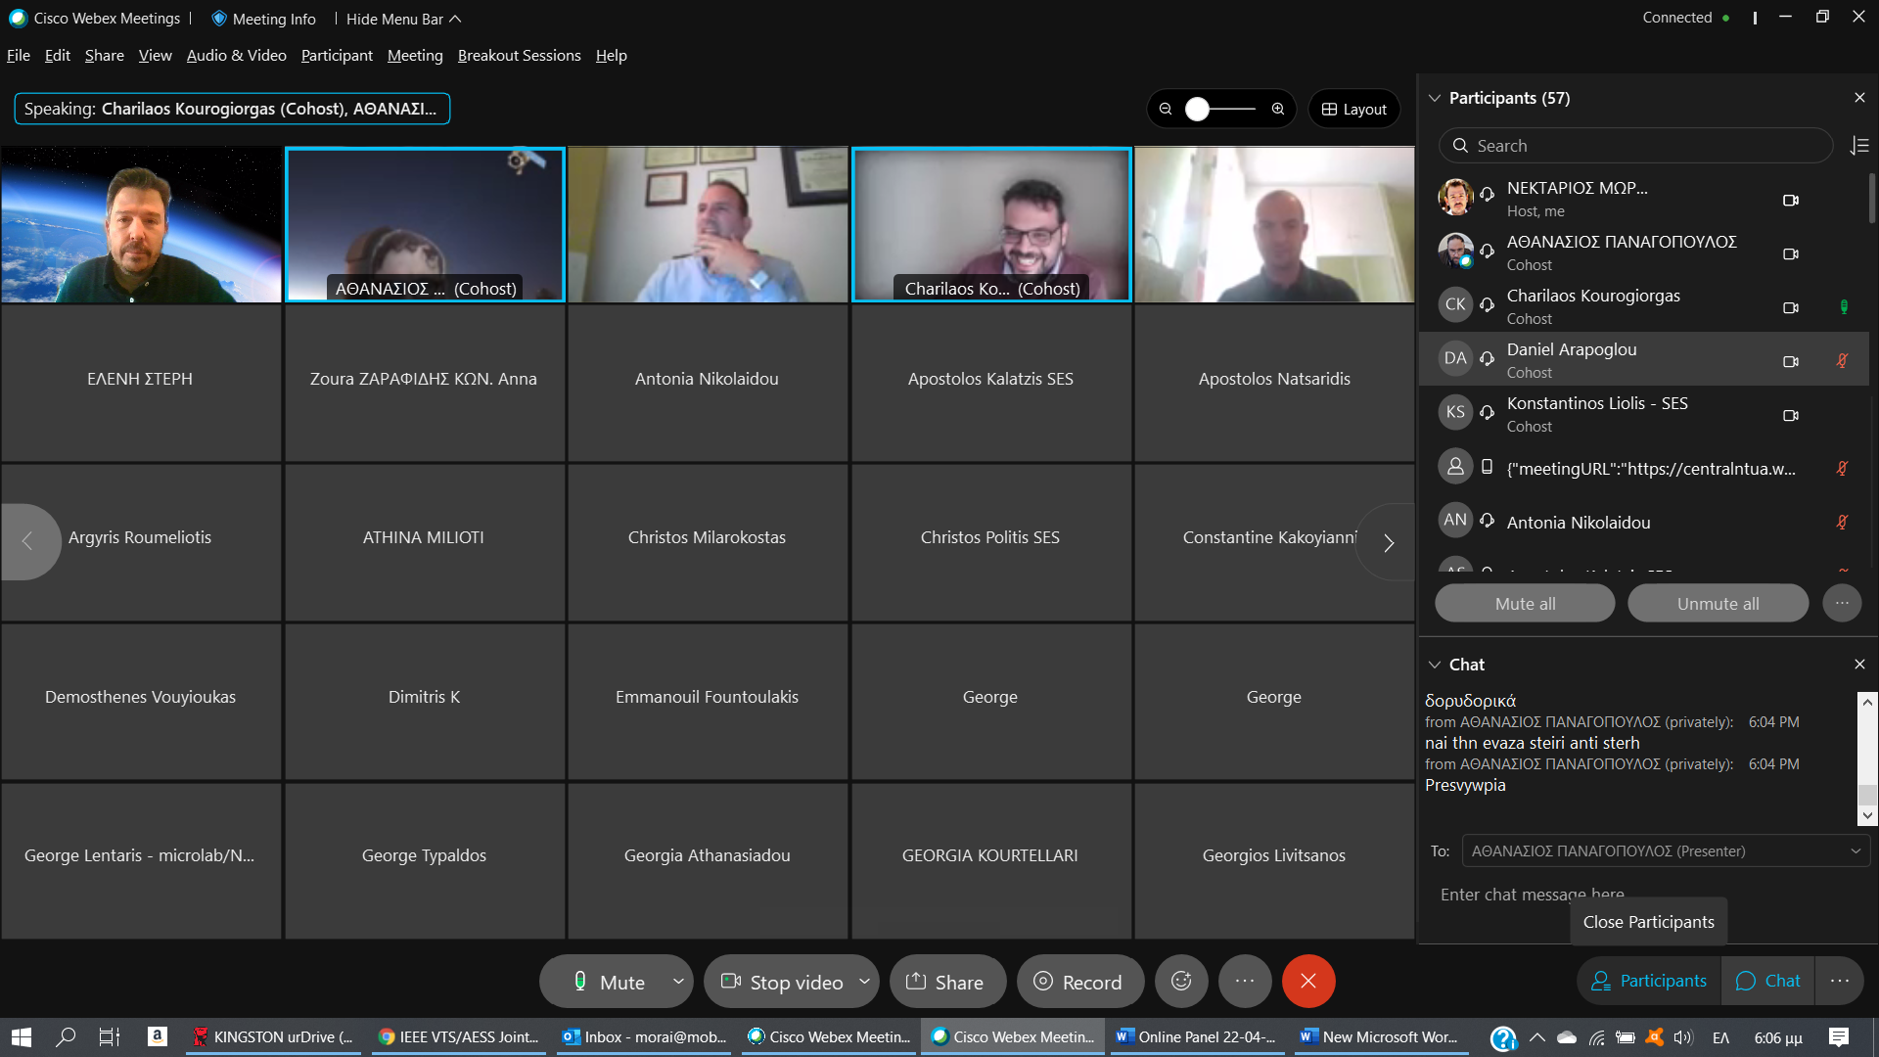

**Screenshot during Dr. Konstantinos Liolis presentation**

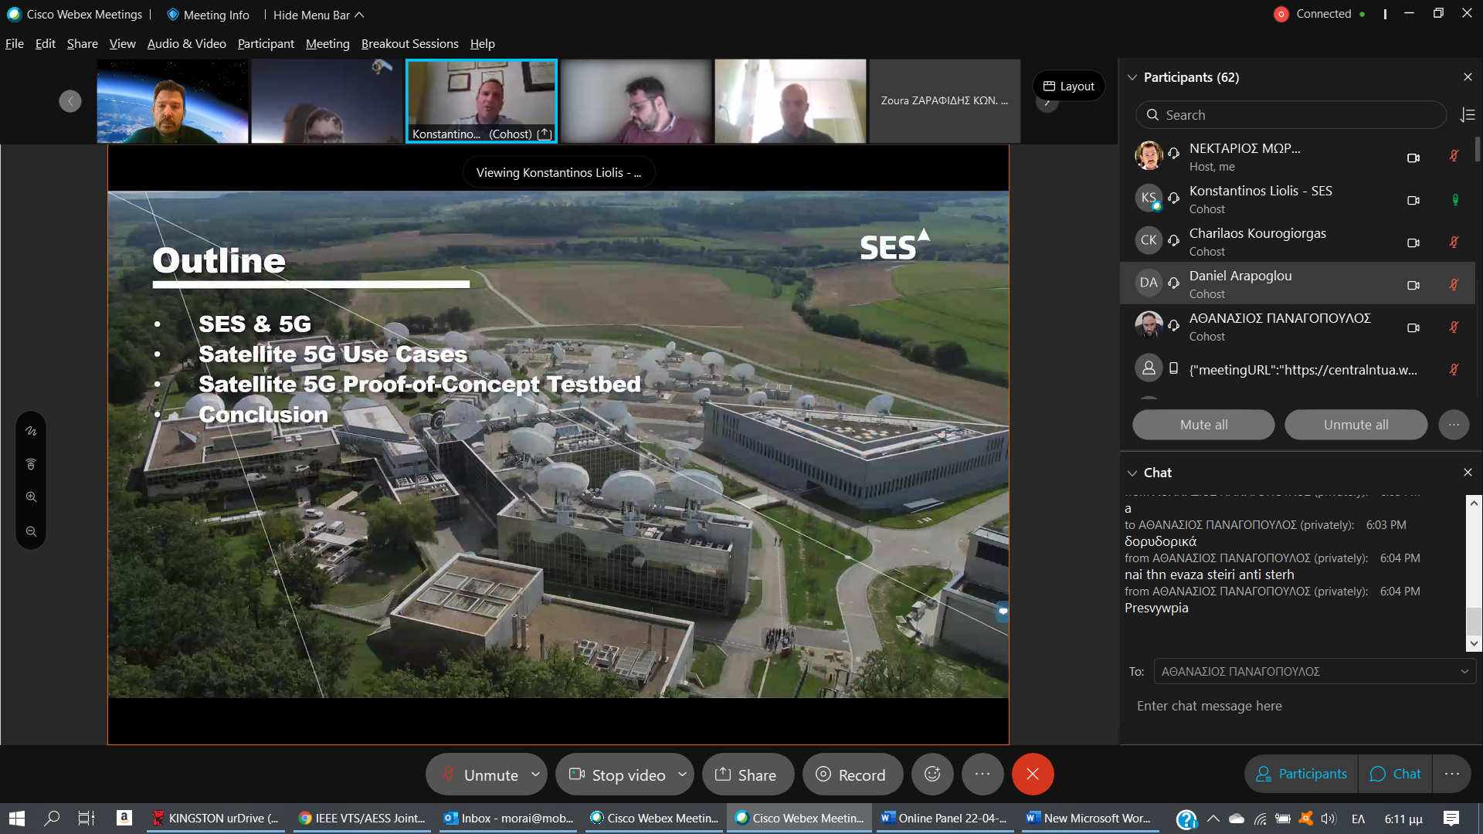

**Screenshot during Dr. Pantelis Arapoglou presentation**

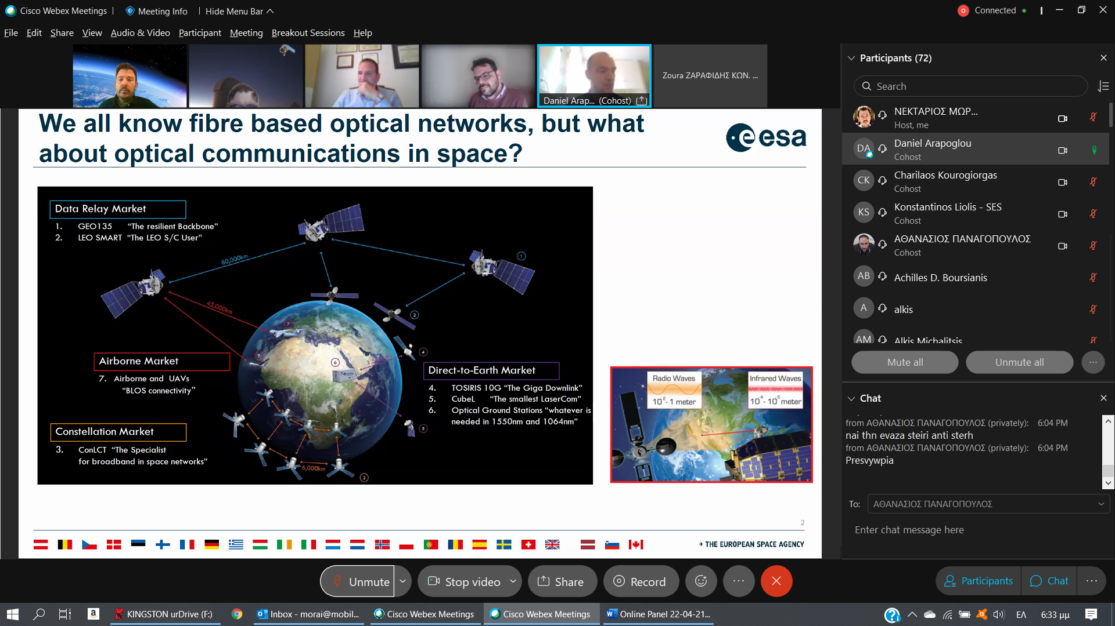

**Screenshot during Dr. Charilaos Kourogiorgas presentation**

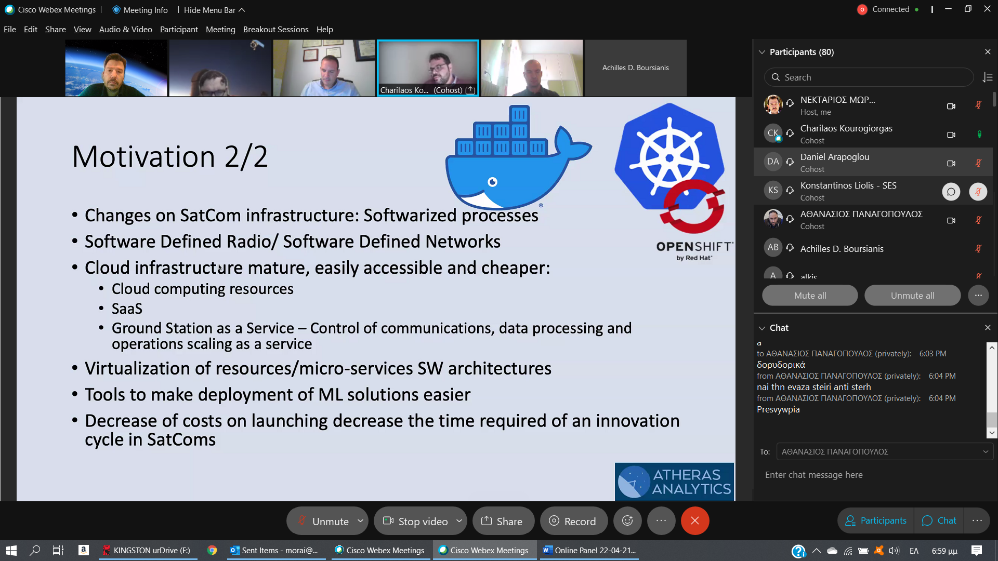

**Screenshot during Prof. Thanasis Panagopoulos presentation**

