
MEETING REPORT
02-21
Power & Energy Society Chapter
IEEE PES UFSM Chapter

Date: 29/07/2021
Started at: 7 pm Horário de Término: 8pm
Place: Virtual meeting
Attendees: Felipe Souza (Vice chair) Flávia Duarte (volunteer), Giovanni Pozzobon (marketing director), Juliano Damiani (volunteer), Leonardo Silveira (volunteer), Mauricio Carazzo (volunteer), Mauricio Sperandio (advisor), Miguel Martins (treasurer), Olatunji Adeyanju (volunteer), Pedro Henrique Eisenkraemer (chair) and Pedro Henrique Sebastiany (secretary).

In July 29th, at 7 pm, the IEEE PES executive committee, under the chairmanship of Pedro Eisenkraemer, organized a virtual meeting, to discuss about:

1- Vtools
The chair presented the IEEE Vtools platform and defined the necessary actions to update all the events, meetings and reports in the Vtools platform.
It was defined that is necessary to update all the events done in 2020.

2- Future events
We discussed the realization of future events. The figure presented below illustrates, in green, the events we have already organized, and, in red, the events we haven’t organized yet. The idea is to keep organizing the green events, and start to organize the red ones. For that, we discussed how to complete this goal. Some ideas are: Make a campaign for blood donation, organize a virtual technical visit, in an electrical substation or in a hydroelectric plant, watch a soccer game, or a movie together, with the objective to do some group recreation activity.

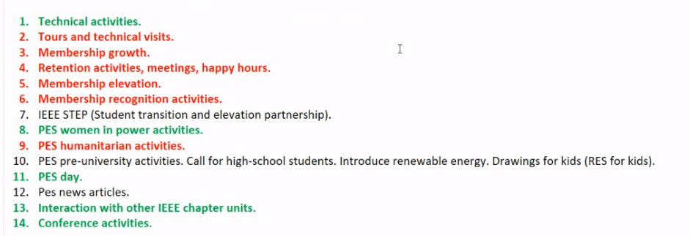

3- Chapter’s elections:
In the meeting, we discussed the election of a new directory. Some members volunteered to be the new chair, vice chair, secretary and treasurer, but we haven’t defined the new directory yet.

With all being decided and having no further issues to discuss, the present report was written, read and approved by the secretary, Pedro Sebastiany and by the chair, Pedro Eisenkraemer.

