**Final Project Report**

**Of**

**Knowledge Hub-3.0**

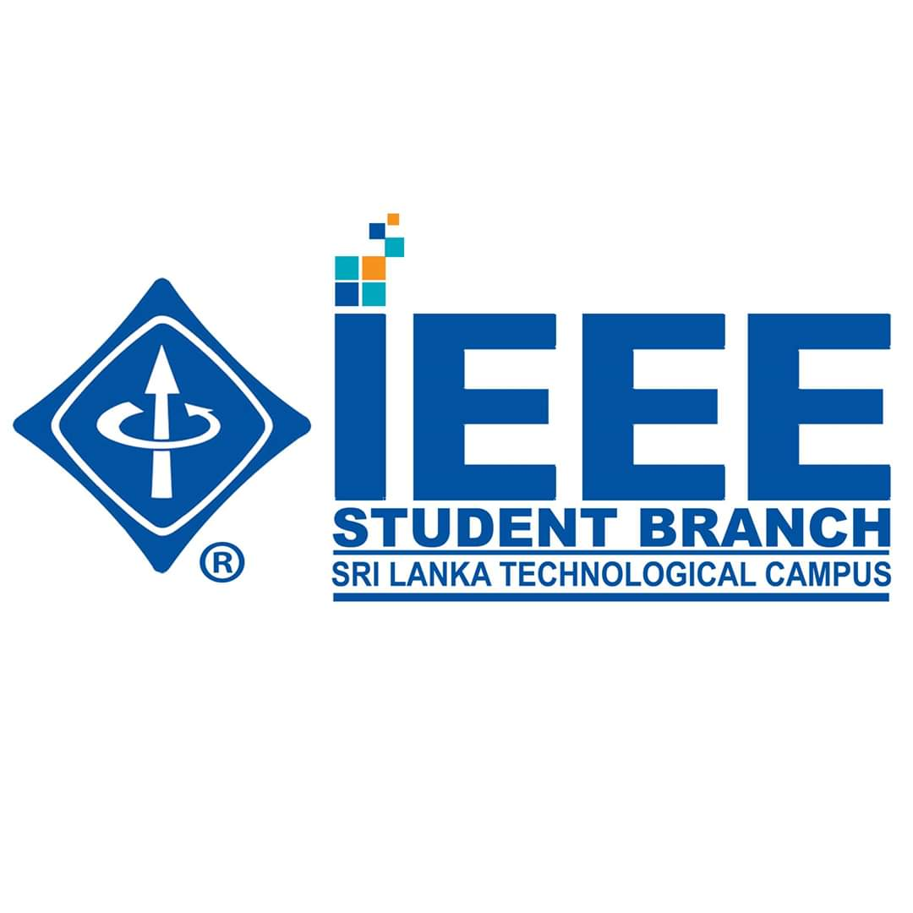

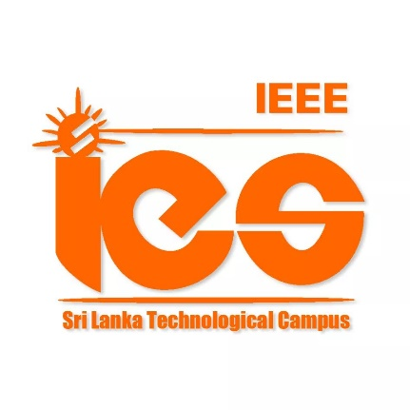

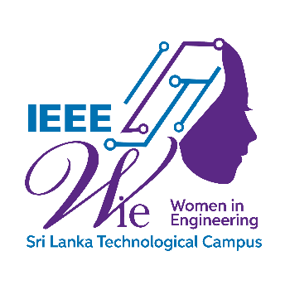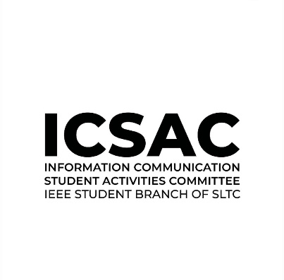

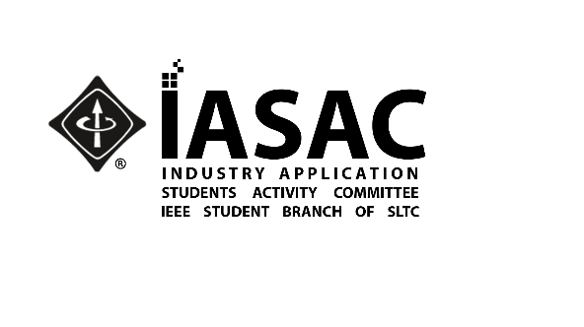

**Project Details**

|  |  |
| --- | --- |
| Title | “Knowledge Hub- 3.0” workshop |
| Project Start Date and Time | 29th of December 2020 |
| Project End Date and Time | 8th of January 2021 |
| Keywords |  |
| Project Description  (More than 1000 words) | Knowledge Hub 3.0 is a workshop which was organized by the IEEE IES student branch chapter  of SLTC in collaboration with the Get Sync club of SLTC with the participation of undergraduates  of SLTC, in order to achieve a common goal of improving subjective matters which are difficult to understand and also improves creativity, problem solving, empower skills and gaining the  confidence in facing examinations, so students are able to increase their results. This project is a series which is conducted throughout the year with modules related to the particular semester.  The key requirement here is to gather and share knowledge with one another.  Objectives of this project;  ❖ Improves creativity and problem-solving.  ❖ Gaining the courage to face examinations.  ❖ Students are able to increase their results.  ❖ Inspiring students in Electronics, IT and Technological fields.  Event Agenda:   1. Welcome speech 2. Commencing of the workshop 3. Vote of thanks   This was considered as very beneficial for those within the campus as well as students inside the student branch. We decided to conduct the session not only for technology fields, but also for every batch in campus according to their requests. Along with the workshops, a model paper was also given which we believe was a huge opportunity and a guide to face final examination and to solve questions correctly.  This session was purely academic and was conducted under the guidance of Dr. Udesh Oruthota, Senior lecturer (Grade 1) in SLTC. He obtained the PhD in communication Engineering from Helsinki University of Technology, MEng Information and communication Technologies from Asian Institute of Technology and graduated BSc. Electrical and Electronic Engineering from University of Peradeniya, Sri Lanka.  We arranged workshop series with 5 webinars for Engineering school to cover all faculties including Civil, Mechatronics, Electronics, Bio system and Information Communication.  When taken in detail,  The first webinar:  For -Material Science module.  Conducted by – Thasindu Kavishka and  Kushan Ferando  Date -29th of December 2020  Time -8.30 am – 12.00 pm    The second webinar :  For –Analog Electronics 1 module.  Conducted by – Sajith Thamalka  Date -4th of January 2021  Time -6.00 pm – 9.00 pm    The Third webinar :  For –Data Structure and Algorithms module.  Conducted by – Shamila Udayantha  S.S.Arunjith  Date -6th of January 2021  Time -6.00 pm – 9.00 pm    The Fourth webinar :  For –Probability and Statistics module.  Conducted by – Uthpala wanninayaka  Date -7th of January 2021  Time -6.00 pm – 9.30 pm    The Fifth webinar :  For –Differential Equations module.  Conducted by – Prince Akila and  Nawanjana Madushanka  Date -8th of January 2021  Time -6.00 pm – 9.00 pm  Resource person/ guest speakers  Academic resource person - Dr. Udesh Oruthota  Dr. Udesh Oruthota was the academic resource person for the project and he is,  •Senior lecturer/ Director in Academic resources at Sri Lanka Technological Campus.  •Received the Ph.D. in Communication Engineering from Helsinki University of Technology  •MEng Information and Communication Technologies from Asian Institute of Technology  •Received BSc Electrical and Electronic Engineering from University of Peradeniya, Sri Lanka  ▪ Speakers  1. Material Science  • Mr. Thasindu Wickrama  Mr. Thasindu Wickrama was a speaker of Material Science webinar and he is an undergraduate  in Mechatronics Engineering at SLTC. Also, he elected IASAC Assistant Secretary.  • Mr. Kushan Fernando  The other speaker of the Materials Science webinar was Biosystems Engineering undergraduate Mr. Kushan Fernando and he also done course in MOLECULAR GENETICS & IT'S APPLICATIONS, university of Sri Jayawardanapura (2015), workshop on ASTRONOMY & SPACE SCIENCE, Space application division, Arthur C Clarke institute for modern technology. (2010) and course of ICT, American cyber media network, California. (2009)  2. Analog Electronics I  • Mr. Sajith Thamlka  Electronic and power system engineer undergraduate Mr. Sajith Thamlka was speaker of Analog electronic 1 webinar. He serves as Assistant webmaster of the IES Chapter of the SLTC IEEE.  3. Data Structure & Algorithms  • Mr. Samila Gunarathna  Data Structure & Algorithms webinar speaker was Mr. Samila Gunarathna, who is an undergraduate in Information and Communication Engineering. Further, he is treasurer of IEEE CS of SLTC.  • Mr. S.S.Arunjith  Mr. S.S.Arunjith was a another speaker of the Data Structure & Algorithms webinar and he is an undergraduate in Information and Communication Engineering. Also, he is an IEEE CS chapter executive committee coordinator (2021) and IEEE executive committee assistant coordinator (2020).  4. Probability & Statistics  • Miss Uthpala Wanninayaka  Miss Uthpala Wanninayaka undergraduate in Mechatronics Engineering was the speaker of the Probability & Statistics webinar and she is an executive member of WIE in IEEE at SLTC.  3|Page    5. Differential Equations  • Mr. Nawanjana Madhushankha  Electronics and Telecommunication undergraduate Mr. Nawanjana Madhushankha was a speaker of the Differential Equations webinar. He has a membership of IES of IEEE in SLTC.  • Mr. Prince Akila  Prince Akila was a speaker of the Differential Equations webinar, who is an undergraduate in Electronics and Telecommunication and an Undergraduate in TLM at the University of Moratuwa.  More than 600 participants participated in all the workshops. On an average, about 120 people attended one workshop.    Publicity and Registration  We shared notices through WhatsApp status, groups and Facebook. Then posted flyers before one day to be held each one with attach each WhatsApp joining link and also, we made separate WhatsApp groups for each module and asked them to join those are like to participate. After that we shared all learning materials such as previous notes, past papers, YouTube video links and zoom link for joining the session and the link has also been added to a google drive.  link with notes and giving access to in the description of WhatsApp group. We supplied zoom recording as their requests. Session was open for all the students inside the campus.    Coordination  First, we informed advisors of IEEE student branch and the project through emails with attach the project proposal. Then we received the approval and got started. Even then we were planning who the speakers would be. This could be very useful for them to develop their skills also. Then we discussed with them about the project and explained what should be done here.  We talked to each batch representors and got feedbacks on what they want from each module, either a summary or a paper discussion. We obtained their notes and feedbacks of what needs be done, then again coordinated with speakers with updates.  . Event Summary  Knowledge hub phase 3 was completed after held successfully five webinars with support from all the organizing committee and by guidance from both the academic advisor and student advisors. Averagely over 100 participants join with all five webinars of the Knowledge Hub project phase 03. There are so many positive feedbacks from participants. We hope to use their feedback to organize a higher quality webinar more than that in the next project and also consider their requirement of modules and we will arrange the webinars.  The Knowledge Hub phase 03 project has come to an excellent conclusion after a great effort by the organizing committee and the speakers in each module. The feedback received from the participants shows that the project has made great success. Knowledge hub was another beneficial project for students that releases from IEEE of SLTC |
| Location  (Online Project – Attach the Link  Physical – Room Number, Building, Address, Province, Postal Code) | Via Zoom :  <https://learn.zoom.us/j/68764203577?pwd>=  ck5XT1kzVHllMXZFWm1LalE1a1RCUT09 |
| Agenda | 6.00 p.m. – Start  6.10 p.m. – Welcome speech  6.15 p.m – Commencing the webinar  9.00 p.m – Vote of Thanks |
| Host Organizational Unit  (Branch/WIE/IES/ICSAC/IASAC) | IES |
| Co-sponsors  (If there are any co-sponsors) | Get Sync club of SLTC |
| No. of Guest Attended | - |
| No. of IEEE Participants |  |
| No. of Non-IEEE Participants |  |
| Event Photographs  (Collage 4 photographs into 1 photograph) |  |

**Speakers**

Speaker 1

|  |  |
| --- | --- |
| Topic | Knowledge Hub – 3.0 (Differential Equation webinar) |
| Prefix (Miss, Mrs., Mr., Dr., Prof.) | Mr. |
| First Name | Prince |
| Middle Name | Akila |
| Last Name | Fernando |
| Display Name | Mr. Prince Akila Fernando |
| Description | He is an undergraduate of Bsc. Electronic Engineering, school of Engineering in Sri Lanka Technological campus and undergraduate of Bsc. TLM, faculty of Engineering, University of Moratuwa. |
| Address, City, Province, Postal code (Optional) | 164/12, Demel Lane, Koralawella, Moratuwa, Colombo 10400. |
| Email | princea@sltc.ac.lk |
| Biography |  |
| Photograph | C:\Users\baba\Downloads\000 - Prince A.jpg |

Speaker 2

|  |  |
| --- | --- |
| Topic | Knowledge Hub – 3.0 (Differential Equation webinar) |
| Prefix (Miss, Mrs., Mr., Dr., Prof.) | Mr |
| First Name | Nawanjana |
| Middle Name | Madhushanka |
| Last Name | Pathirage |
| Display Name | Mr.Nawanjana Madhushanka Pathirage |
| Description | He is an undergraduate of Bsc. Electronic Engineering, school of Engineering ( Batch 6) in Sri Lanka Technological campus . |
| Address, City, Province, Postal code (Optional) | 128,A/5,Viharamawatha,Kirillawala,Weboda |
| Email | madhushankhap@sltc.ac.lk |
| Biography | Nawanjana Madhushanka is a member in IEEE student branch of SLTC and member in IES chapter. He was the chairman of project Ardioflo which conducted by IES chapter. |
| Photograph |  |

Speaker 3

|  |  |
| --- | --- |
| Topic | Knowledge Hub – 3.0 (Data Structure & Algorithm webinar) |
| Prefix (Miss, Mrs., Mr., Dr., Prof.) | Mr |
| First Name | Sugarithagandhi |
| Middle Name | Shawn |
| Last Name | Arunjith |
| Display Name | Mr.S.S.Arunjith |
| Description | He is an undergraduate of Information and Communications Engineering ,school of Engineering in SriLanka Technological Campus. Also, he is an IEEE CS chapter executive committee coordinator (2021) and IEEE executive committee assistant coordinator (2020). |
| Address, City, Province, Postal code (Optional) |  |
| Email | Shawna@sltc.ac.lk |
| Biography | Mr.Shawn Arunjith is an IEEE CS chapter executive committee coordinator (2021) and IEEE executive committee assistant coordinator (2020). |
| Photograph | C:\Users\baba\Downloads\S.Shawn Arunjith - Shawna Arunjith.jpeg |

Speaker 4

|  |  |
| --- | --- |
| Topic | Knowledge Hub – 3.0 (Data Structure & Algorithm webinar) |
| Prefix (Miss, Mrs., Mr., Dr., Prof.) | Mr |
| First Name | Samila |
| Middle Name | Udayantha |
| Last Name | Gunarathne |
| Display Name | Mr.Samila Udayantha Gunarathne |
| Description | He is an undergraduate of information and Communication,school of Engineeringin SriLanka Technological Campus. |
| Address, City, Province, Postal code (Optional) |  |
| Email | samilag@sltc.ac.lk |
| Biography | Mr. Samila Udayantha is active member in computer Society (SLTC) who workedin several IEEE projects and He is the treasurer of CS. |
| Photograph | C:\Users\baba\Downloads\01. Resume - Samila G.jpg |

Speaker 5

|  |  |
| --- | --- |
| Topic | Knowledge Hub- 3.0 ( Material Science) |
| Prefix (Miss, Mrs., Mr., Dr., Prof.) | Mr. |
| First Name | Thasindu |
| Middle Name | Kavishka |
| Last Name | Wickrama |
| Display Name | Mr.Thasindu kavishka Wickrama |
| Description | He is an undergraduate of Mechanical Engineering, school of Engineering in SriLanka Technological campus. |
| Address, City, Province, Postal code (Optional) |  |
| Email | thasinduw@sltc.ac.lk |
| Biography | Mr.Thasindu Wickrama is a member of IEEE student branch,SLTC and the assistant secretary of IASAC, SLTC. |
| Photograph | C:\Users\baba\Downloads_Thasindu W.jpg |

Speaker 6

|  |  |
| --- | --- |
| Topic | Knowledge Hub- 3.0 ( Material Science) |
| Prefix (Miss, Mrs., Mr., Dr., Prof.) | Mr. |
| First Name | Kushan |
| Middle Name |  |
| Last Name | Fernando |
| Display Name | Mr. Kushan Fernando |
| Description | He is an undergraduate of Bio systems Engineering, school of Engineering in SriLanka Technological campus. He completed MOLECULAR GENETICS & IT'S APPLICATIONS, university of Sri Jayawardanapura (2015). |
| Address, City, Province, Postal code (Optional) |  |
| Email | kushanf@sltc.ac.lk |
| Biography | He plays roles in Event Manegment community head,Media unit ,SLTC(2020) and  vice president ,Media unit ,SLTC(2021) |
| Photograph | C:\Users\baba\Downloads\Kushan.JPG |

Speaker 7

|  |  |
| --- | --- |
| Topic | Knowledge Hub- 3.0 ( Analog Electronics 1) |
| Prefix (Miss, Mrs., Mr., Dr., Prof.) | Mr. |
| First Name | Sajith |
| Middle Name | Thamalka |
| Last Name |  |
| Display Name | Mr. Sajith Thamalka |
| Description | He is an undergraduate of Electronic Engineering, school of Engineering in SriLanka Technological campus. |
| Address, City, Province, Postal code (Optional) |  |
| Email | sajitht@sltc.ac.lk |
| Biography | Mr.Sajith Thamalka is a member in IEEE ,SLTC and the assistant webmaster of IES chapter. |
| Photograph | C:\Users\baba\Downloads_Sajith T.jpg |

Speaker 8

|  |  |
| --- | --- |
| Topic | Knowledge Hub- 3.0 (Probability and Statistics) |
| Prefix (Miss, Mrs., Mr., Dr., Prof.) | Miss. |
| First Name | Uthpala |
| Middle Name |  |
| Last Name | Wanninayaka |
| Display Name | Miss.Uthpala Wanninayaka |
| Description | She is an undergraduate of Mechatronic Engineering, school of Engineering in SriLanka Technological campus. |
| Address, City, Province, Postal code (Optional) |  |
| Email | uthpalaw@sltc.edu.lk |
| Biography | Miss.Uthapla Wanninayaka is a member of IEEE,SLTC and committee head of WIE affinity group. |
| Photograph | C:\Users\baba\Downloads\33-1 - Uthpala Wanninayaka.jpg |