

A

Report

On

**Mosquito Repellent Drive**

**On the Occasion**

**Of**

**“World Mosquito Day”**

**Reported By: Editorial team,**

**Extreme Club and STB07021**

**Mosquito Repellent Drive**

**On the Occasion**

**of**

**“** **World Mosquito Day”**

**DATE: 20 August 2021**

**VENUE: College Campus**

**TIME: 4:00pm to 6:00pm**

**About the Event:**

**World Mosquito Day**, observed annually on **20 August**, is a commemoration of British doctor Sir Ronald Ross's discovery in 1897 that female anopheline mosquitoes transmit malaria between humans. Prior to the discovery of the transmitting organism, vector, there were few means for controlling the spread of the disease although the discovery of quinine in treatment had alleviated the problem of treatment.

Even today a lot of diseases are causing due to mosquito in Human Beings. So, on **20th August 2021, Extreme Club of CSE Department** had organised a **Mosquito Repellent Drive** in the college campus and also in places around the college. This drive takes place under the students or volunteers who were available offline on that day. All the Covid protocols were also followed.

The main aim of this event was to make the college campus and college surrounding mosquito free and to minimize the risk of diseases caused due to mosquito bite.

**Event Pictures:**

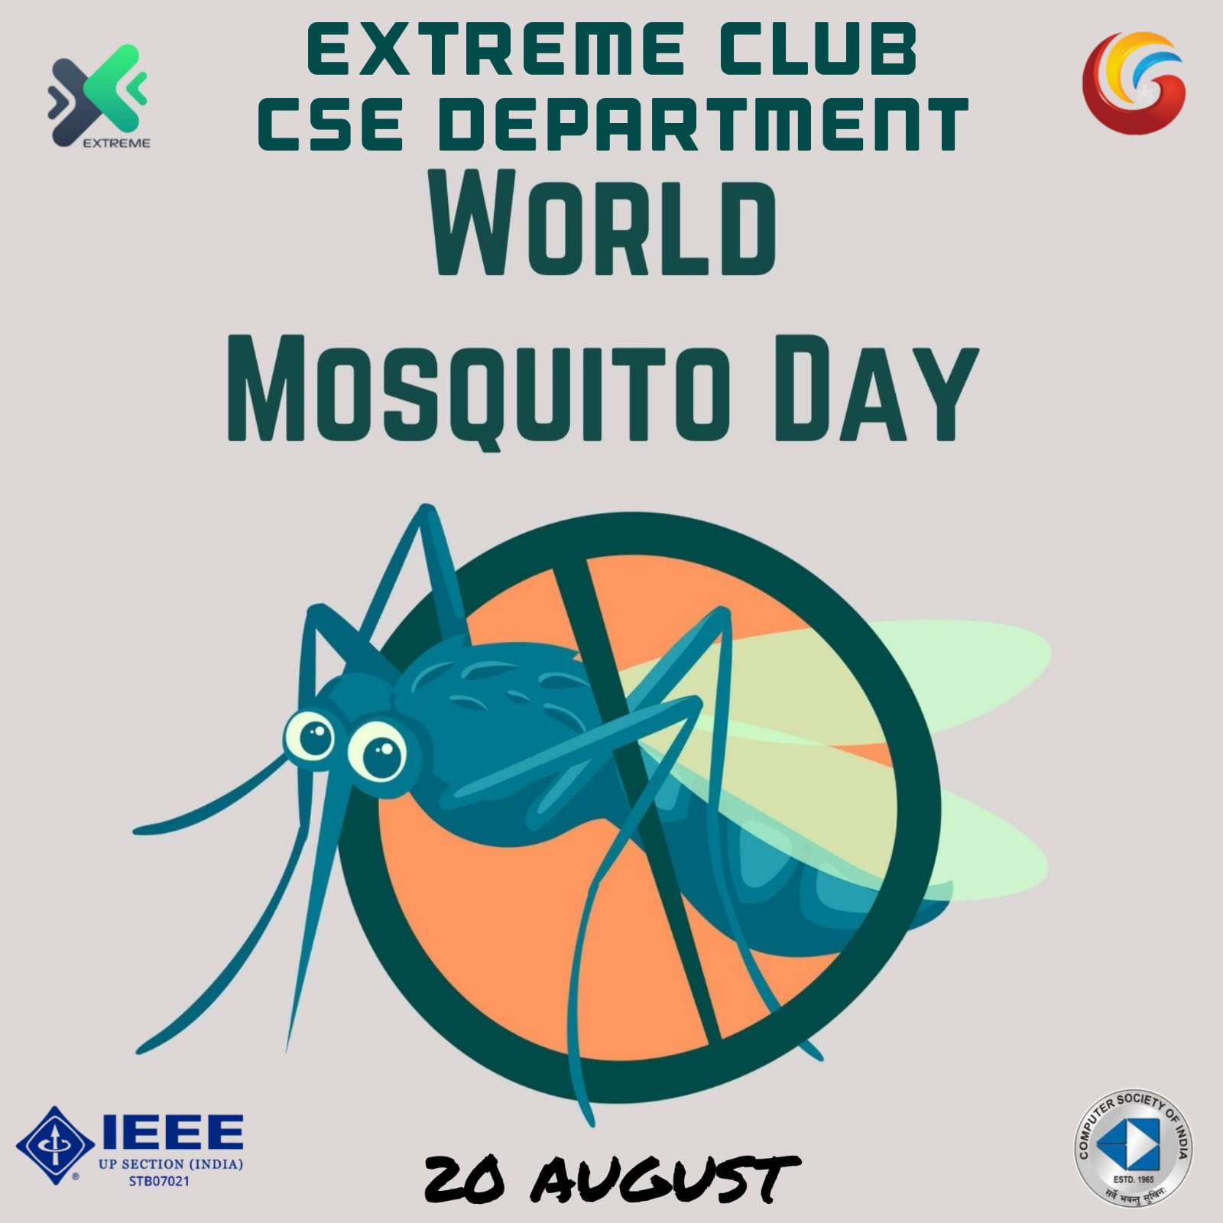

**(Poster of the Event)**

|  |  |
| --- | --- |
| **Event Summary** | |
| **Title of the event** | Mosquito Repellent Drive |
| **Start time** | 4:00pm |
| **End Time** | 6:00pm |
| **Category of the event** | Non-Technical |
| **Sub- Category of the event** | Social |
| **Time Zone** | India |
| **Primary Host Organization Unit** | Galgotias College of Engineering and Technology (STB07021) |
| **Primary Host Contact Event** | [vishnu.sharma@galgotiacollege.edu](mailto:vishnu.sharma@galgotiacollege.edu) |
| **Venue** | College Campus |
| **Physical Address** | Galgotia college, knowledge park-2, Greater Noida, Uttar Pradesh, India- |
| **Registration Starts/Date** | -- |
| **Registration Ends/Date** | -- |
| **Participants** | Students of CSE, GCET |
| **Number of Participants** | 15 |

**Co-ordinator:**

**Ritesh Srivastava**