A

Report

on

**WORKSHOP**

*on*

**SALESFORCE**

**In Collaboration**

**with**

**CETPA**

**(7, February, 2022)**

**Reported By: Editorial team,**

**Extreme Club and STB07021**

 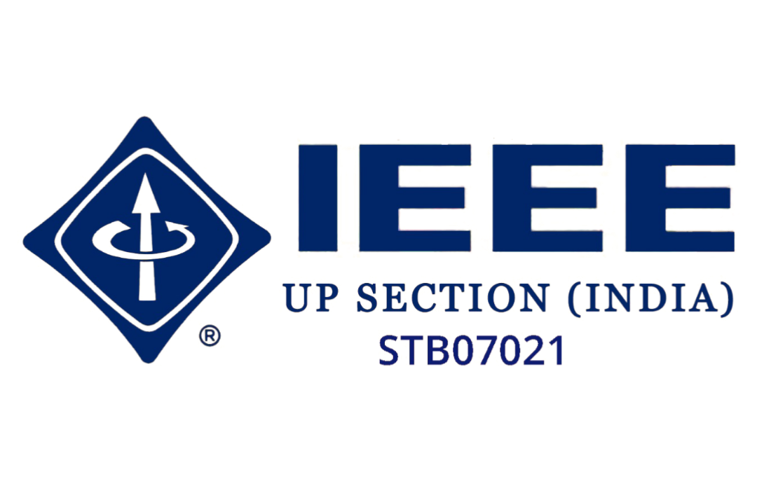

**Galgotias College of Engineering and Technology (STB07021)**

**WORKSHOP**

**ON**

**“SALESFORCE”**

**In Collaboration**

**with**

**CETPA**

(7 February,2022)

**DATE: 7 February, 2022**

**VENUE: GoTo APP**

**TIME: 2:30 PM to 4:30 PM**

**About the Event:**

On **7th February 2022**, the Department of Computer Science and Engineering, STB07021 organized a workshop on **“SALESFORCE”** in collaboration with CETPA.

This workshop was oriented in such a way that it can give full information about the SALESFORCE software and explain the work ethics in corporate world. It also provides an opportunity to participants to strengthen professional skills and gain expertise in a subject.

The participants showed their interest by actively participating in this workshop, interacting with the speaker and asking questions. Overall, it helped students to develop new skills

**About The Speaker**

Name- **Mr. Rakesh Gautam**

Designation- Cloud Trainer,

**CETPA INFOTECH. Pvt. Lt**

**Learning Outcomes:**

**LO1:** Provide hands on experience of SALESFORCE software

**LO2:** Understand work ethics in corporate world and knowledge about corporate job

**LO3:** Provide clarity to the students about their interests

**LO4:** Provide industry exposure and innovative way of learning a subject

**Event Pictures:**

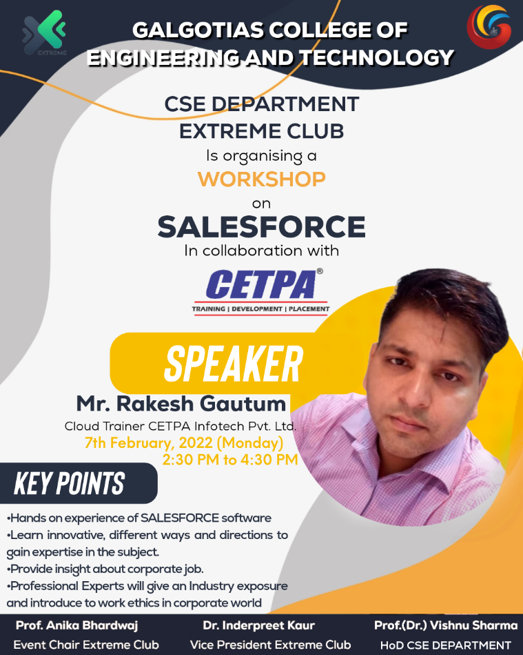

**(Poster of the Event)**

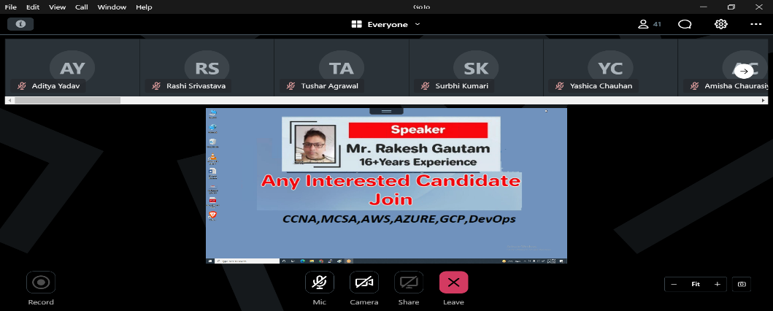

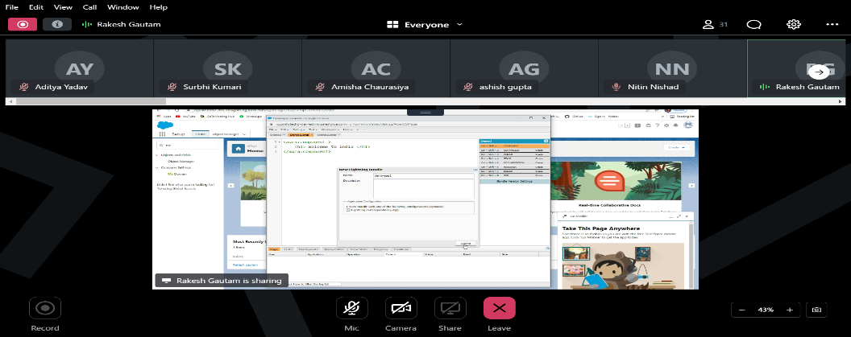

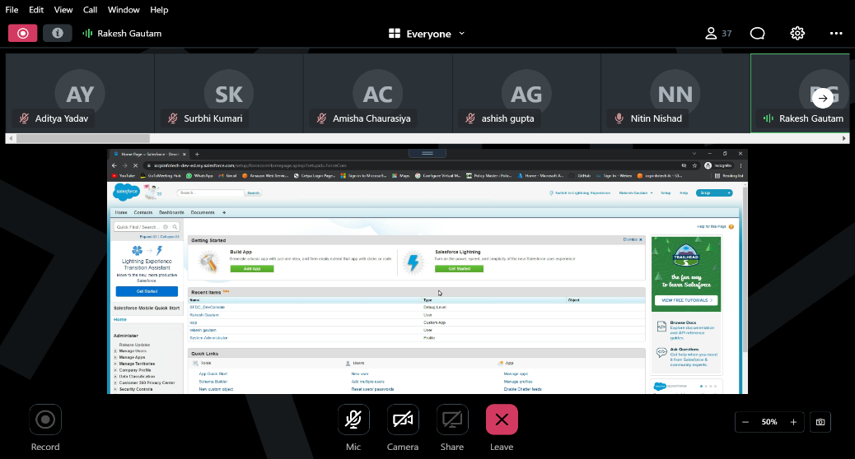

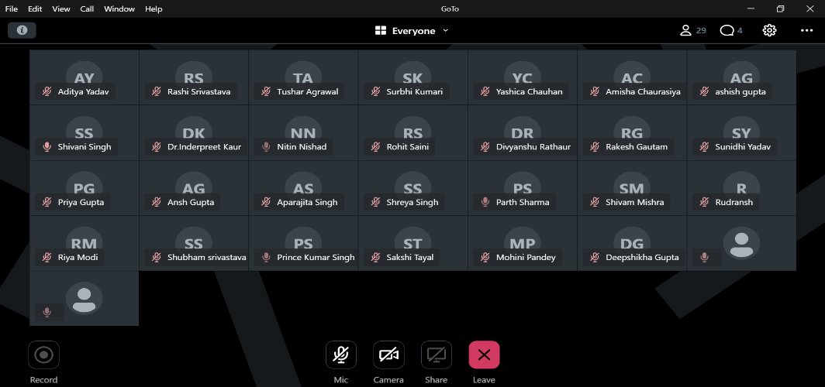

**(Screenshots of Workshop through GoTo)**

|  |  |
| --- | --- |
| **Event Summary** | |
| **Title of the event** | Workshop on Salesforce |
| **Start time** | 2:30 pm |
| **End Time** | 4:30pm |
| **Category of the event** | Technical |
| **Sub- Category of the event** | Informative |
| **Time Zone** | India |
| **Primary Host Organization Unit** | Galgotias College of Engineering and Technology (STB07021) |
| **Primary Host Contact Event** | [vishnu.sharma@galgotiacollege.edu](mailto:vishnu.sharma@galgotiacollege.edu) |
| **Platform** | GoTo Application |
| **Meeting Link** | https://meet.goto.com/355390653 |
| **Registration Link** | https://events.vtools.ieee.org/event/register/303523 |
| **Physical Address** | Galgotias College of Engineering and Technology, knowledge park-2, Greater Noida, Uttar Pradesh, India |
| **Registration Starts/Date** | 1/2/2022 |
| **Registration Ends/Date** | 3/2/2022 |
| **Participants** | Students and Faculty of CSE, GCET |
| **Number of Participants** | 83 |

**Co-ordinator:**

**Dr. Inderpreet Kaur**

**Prof. Anika Bharadwaj**