A

Report

on

**Bollywood Buzz**

**(23rd February, 2022)**

**Reported By: Editorial team,**

**Extreme Club and STB07021**

 

**Galgotias College of Engineering and Technology (STB07021)­­**

**Bollywood Buzz**

(23rd February, 2022)

**DATE: 23rd February, 2022**

**VENUE: E-Block(E-104)**

**TIME: 3:30 PM to 4:30 PM**

**About the Event:**

Bollywood Buzz event was an interesting and fun event in which participants took an active participation. It was a quiz in which questions were popped up on the screen and the participant who knew the answer need to press the buzzer and whoever pressed the buzzer first was the winner.

**Rules:**

* Participants will have to answer questions based on a picture/meme shown, or an audio played.
* 2)There will be 5 questions each on movies, memes, audios and so on.
* The first three to answer correctly will get 10, 5 and 3 points respectively.
* If someone from the first three answers wrong, he/she will get -2 points.
* Those who get the maximum amount of points shall win.

**Winner:**

Anuj Pratap singh

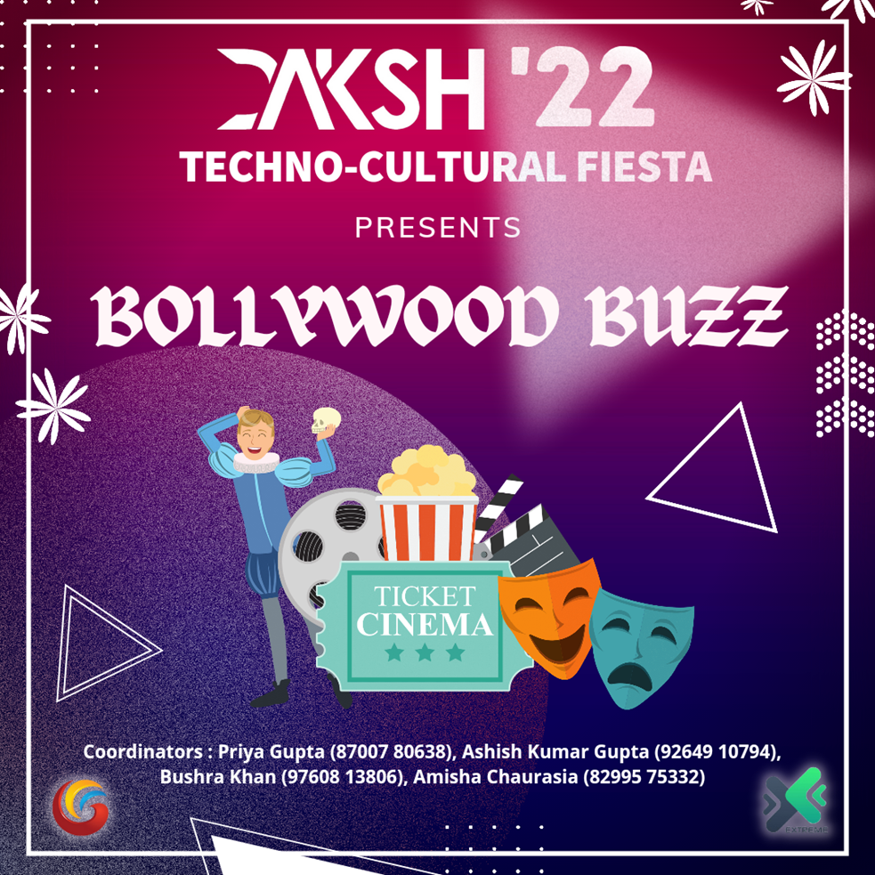

**(Poster of the Event)**

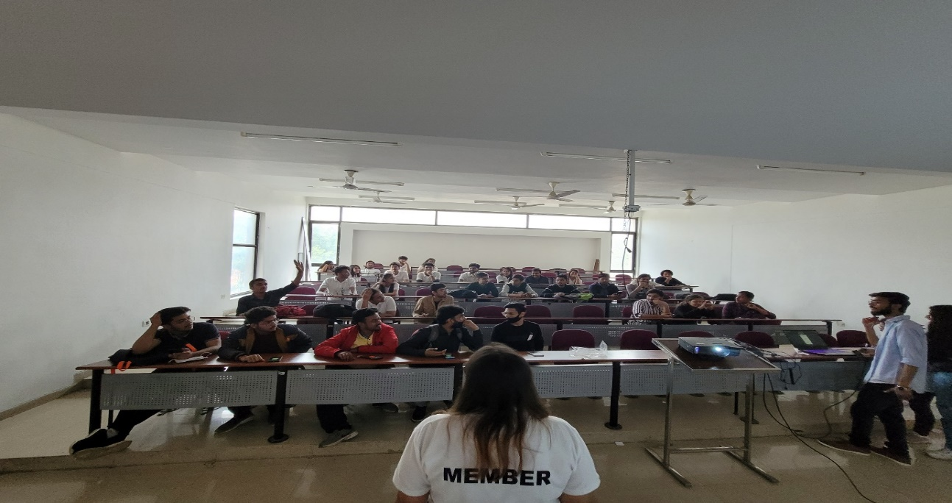

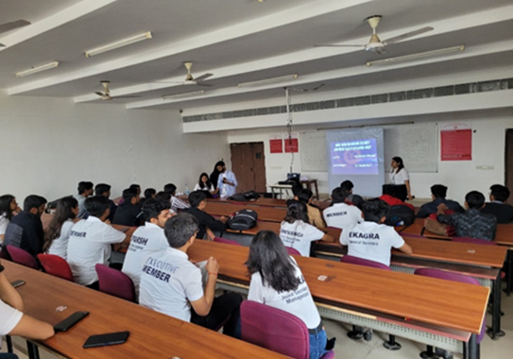

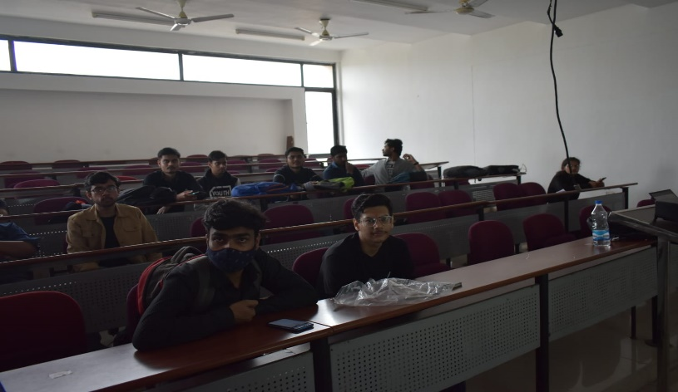 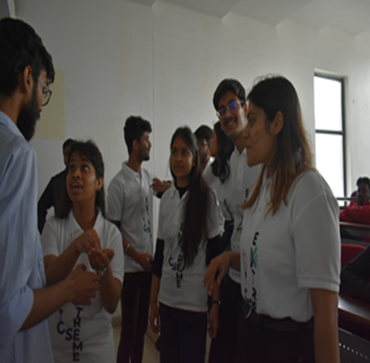

**(Pictures of the event)**

|  |  |
| --- | --- |
| **Event Summary** | |
| **Title of the event** | Bollywood Buzz |
| **Start time** | 1:00 P.M. |
| **End Time** | 2:00 P.M. |
| **Category of the event** | Non-Technical |
| **Sub- Category of the event** | others |
| **Time Zone** | India |
| **Primary Host Organization Unit** | Galgotias College of Engineering and Technology (STB07021) |
| **venue** | E-104 |
| **Registration Link** | https://linktr.ee/extremecse |
| **Physical Address** | Galgotias College of Engineering and Technology, knowledge park-2, Greater Noida, Uttar Pradesh, India |
| **Registration Starts/Date** | 19/02/22 |
| **Registration Ends/Date** | 23/02/22 |
| **Participants** | Students and Faculty of CSE, GCET |
| **Number of Participants** | 30 |



Co-ordinators:

Ashish kumar gupta

Bushra khan

Amisha Chaurasiya

Priya gupta