**Galgotias College of Engineering and Technology (STB07021)**

A

Report

on

**SEMINAR**

on

**“T.I.M.E Career Planning”**

**(1st April, 2022)**

**Reported By: Editorial team,**

**Extreme Club and STB07021**

 

**WEBINAR**

**ON**

**“T.I.M.E Career Planning”**

(1st April, 2022)

**DATE: 1st March, 2022**

**VENUE: E-009**

**TIME: 11:00 AM to 12:00 PM**

**About the Event:**

On 1st of April, the Department of Computer Science and Engineering, STB07021 organized a seminar on “**T.I.M.E Career Planning**.”

This seminar provided an overview on the options encountered after graduation for pursuing higher studies and an insight on MBA and the perks of pursuing it especially after B.Tech.

The seminar was conducted in offline mode in the presence of Dr. Inderpreet Kaur, Vice-President, Extreme club and was addressed by Ms. Sweta Sahu, Centre Director, T.I.M.E, Greater Noida. The attendants asked a number of questions and actively participated in the session.

**Speaker:**

**Ms. SWETA SAHU**

Centre Director

T.I.M.E Institute, Greater Noida

**Learning Outcomes:**

**LO1**: Inform participants about the importance of career planning.

**LO2**: Acknowledge and discuss the various career options available after graduation and also differentiating between traditional and offbeat options.

**LO3**: Discussing several important entrance exams.

**Event Poster:**

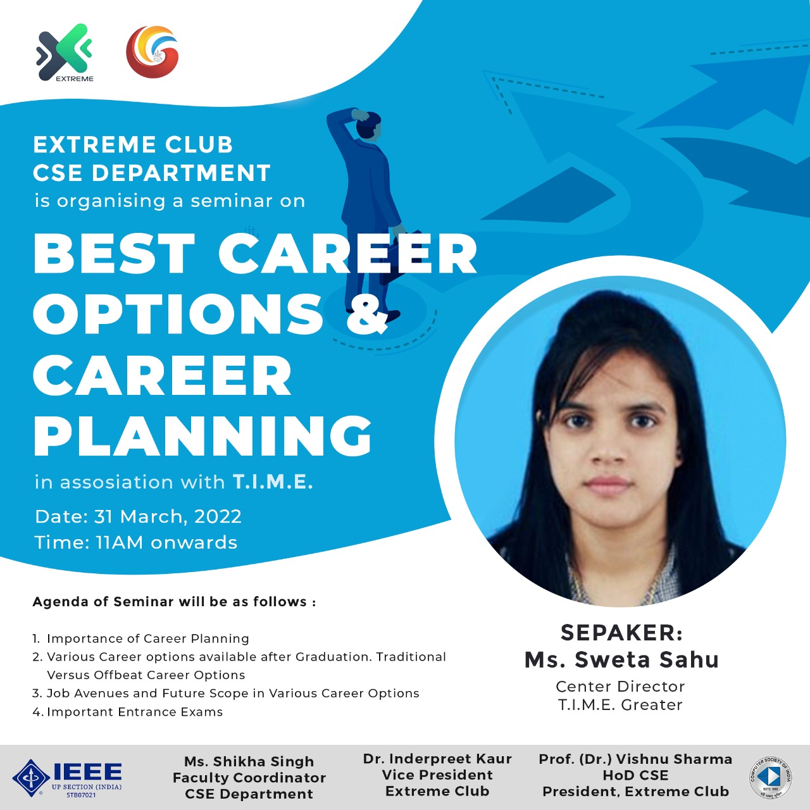

**Event Pictures:** 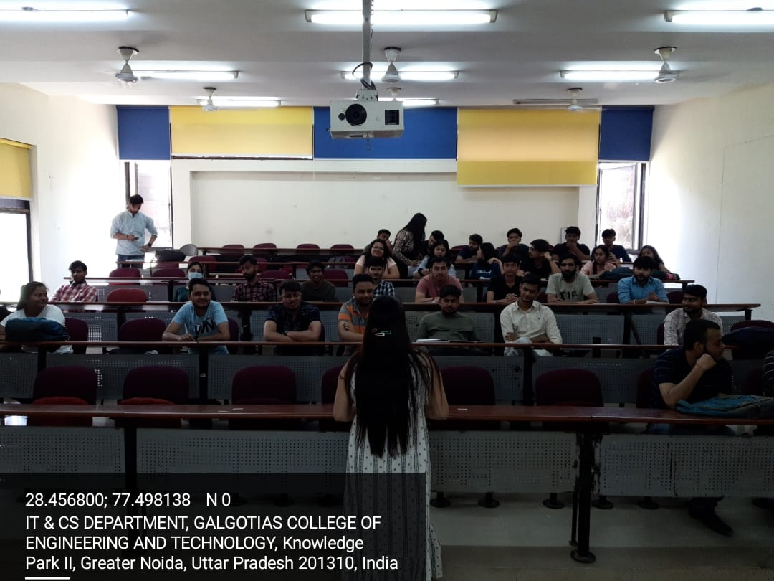

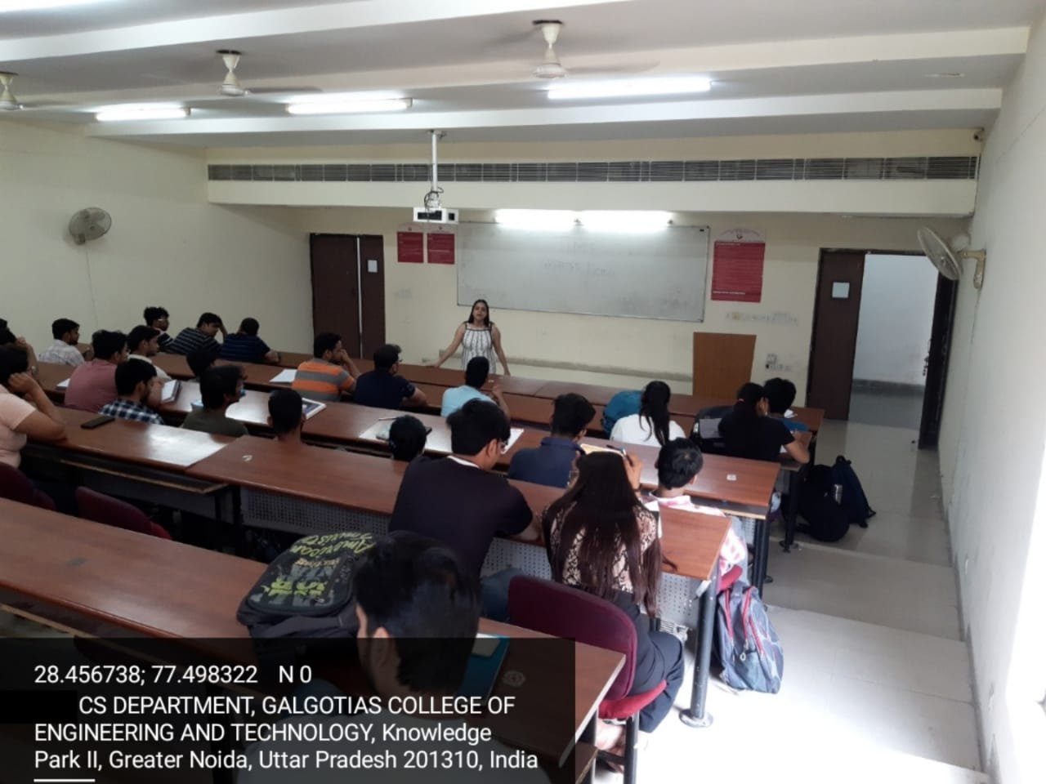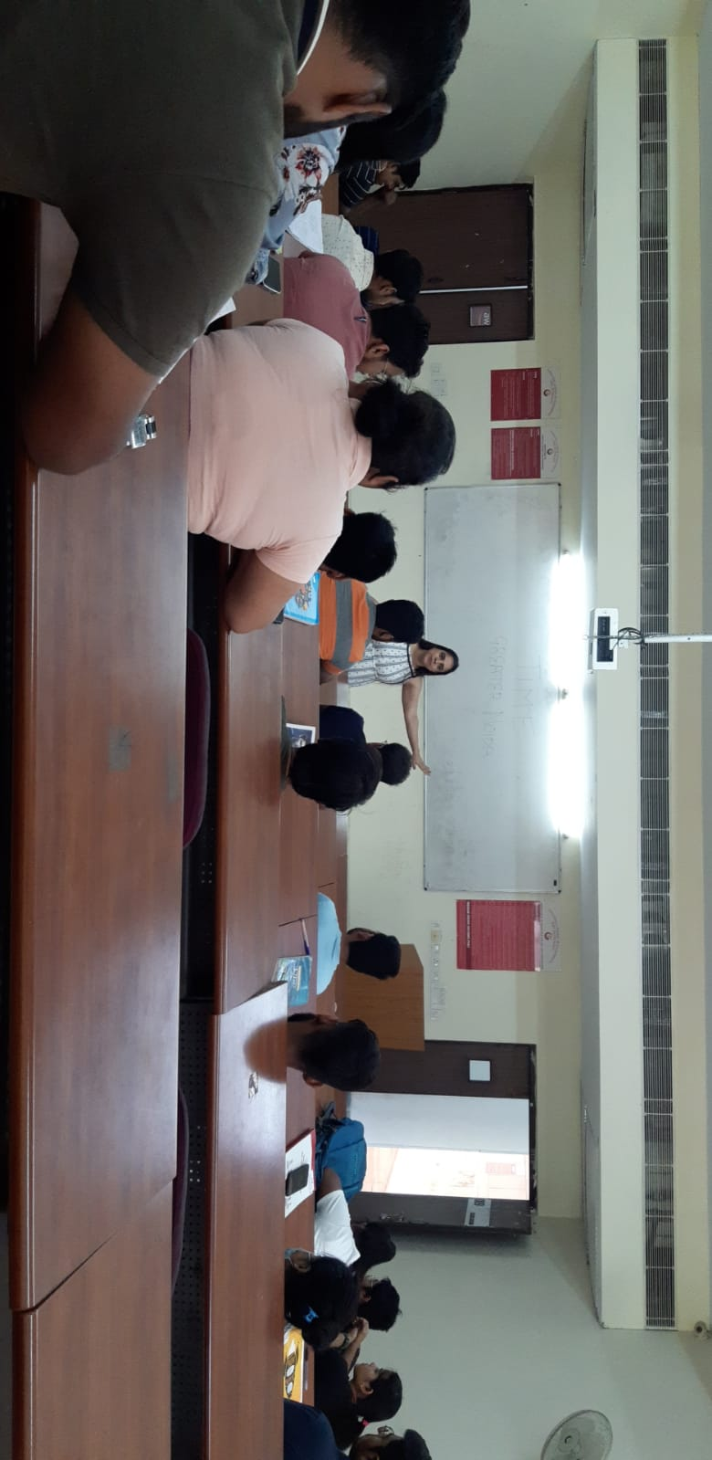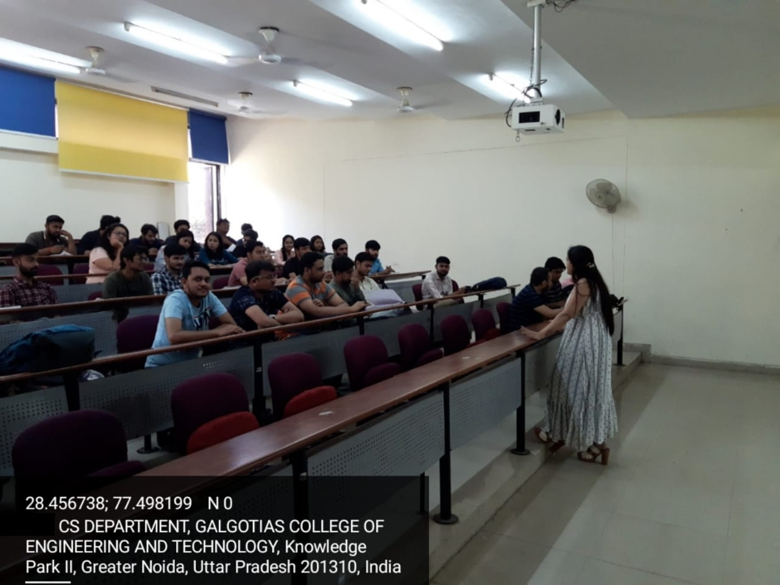

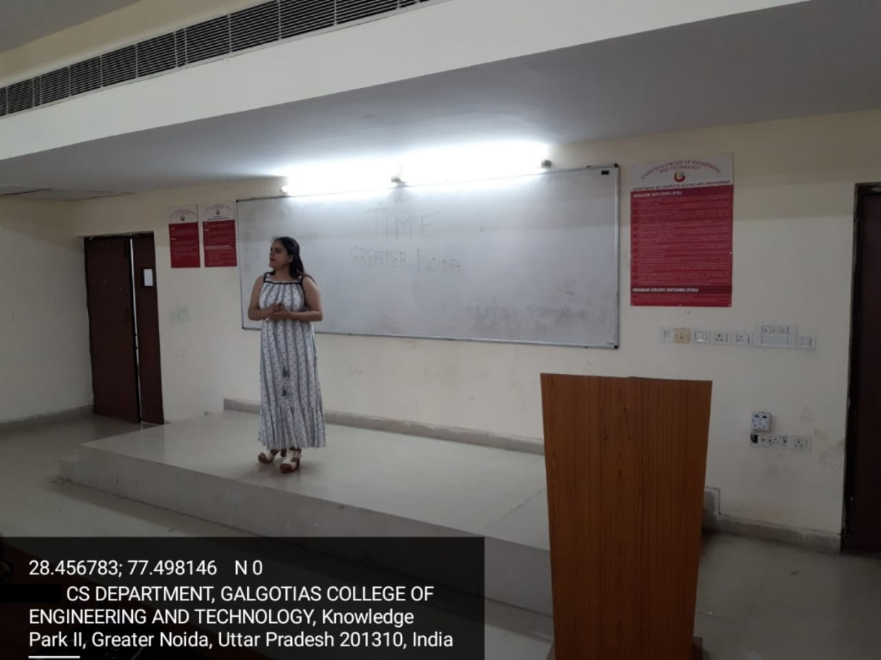

|  |  |
| --- | --- |
| **Event Summary** | |
| **Title of the event** | Webinar on **T.I.M.E Career Planning** |
| **Start time** | 11:00 A.M. |
| **End Time** | 12:00 P.M. |
| **Category of the event** | Professional |
| **Sub- Category of the event** | Career |
| **Time Zone** | India |
| **Primary Host Organization Unit** | Galgotias College of Engineering and Technology (STB07021) |
| **Primary Host Contact Event** | [vishnu.sharma@galgotiacollege.edu](mailto:vishnu.sharma@galgotiacollege.edu) |
| **Platform** | E 009 |
| **Registration Link** | https://events.vtools.ieee.org/event/register/310266 |
| **Physical Address** | Galgotias College of Engineering and Technology, knowledge park-2, Greater Noida, Uttar Pradesh, India |
| **Registration Starts/Date** | 29/3/2022 |
| **Registration Ends/Date** | 1/4/2022 |
| **Participants** | Students of CSE and IT, GCET |
| **Number of Participants** | 35 |

**Co-ordinators:**

**Dr. Inderpreet Kaur**