

A

Report on

# SEMINAR

on

# “MANTHAN’22 ”

## (08th April, 2022)

**Reported By: Editorial team, Extreme Club and STB07021**

## Galgotias College of Engineering and Technology (STB07021)

**SEMINAR ON**

# “MANTHAN’22”

(8th April, 2022)

DATE: 08th April, 2022 VENUE: D-Block Auditorium TIME: 11:00 AM to 12:00 PM

## About the Event:

Manthan’22, conducted by the Department of Computer Science & Engineering in association with the BYJUS exam prep was a seminar that focused on building the clarity among the students regarding their career goals and dream of cracking higher exams like GATE and CAT.

The seminar discussed several important issues that are faced by an individual in his journey of preparing for such exams. The speakers Mr. Saral Nashier and Mr. Chandan Jha interacted with the students and told them the importance and need of having the correct mindset, planning and strategy before starting the preparation of higher level competitive exams of GATE and CAT. They also discussed the proper exam pattern of the exams so that one can easily comprehend the proper structure of it.

The audience found the seminar quite insightful that clarified all of it’s doubts and dilemmas regarding the exams. They were highly impressed with the spirited speakers who eagerly interacted with the audience and included them in various fun activities.

The seminar was successfully completed clearing the picture about such exams and motivated the students to make an extra step forward towards their career goal. The event concluded by thanking all the coordinators and staff who worked day in and out for making the event a successful one.

## About Speaker:

### Mr. Saral Nashier

Speaker for CAT

MBA- Finance, MDI Gurgaon **Mr. Chandan Jha** Speaker for GATE

M.Tech, NIT Hamirpur.

## Outcomes:

**LO1:** Helped aspirants get a detailed understanding of CAT, GATE and other competitive exams.

**LO2:** Provided conceptual clarity on how to prepare and formulate a right preparation strategy.

**LO3:** Provided an opportunity to interact with faculties who themselves have cleared the exams with good ranks and have high experience of giving lectures in IITs, NITs and IIMs.

## Event Poster:

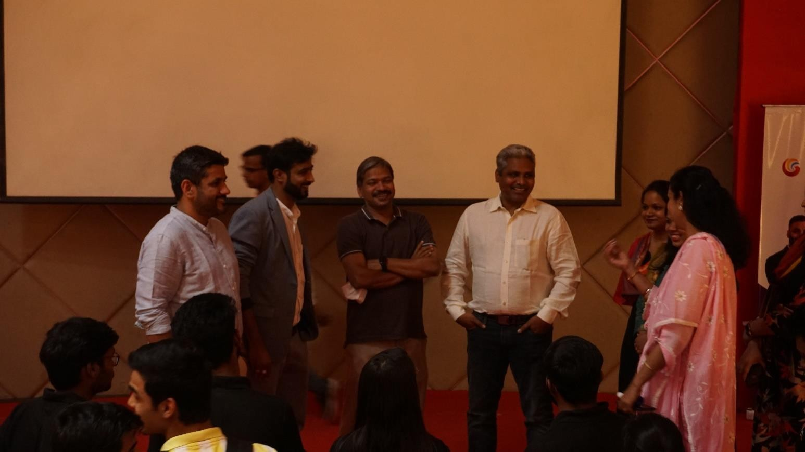

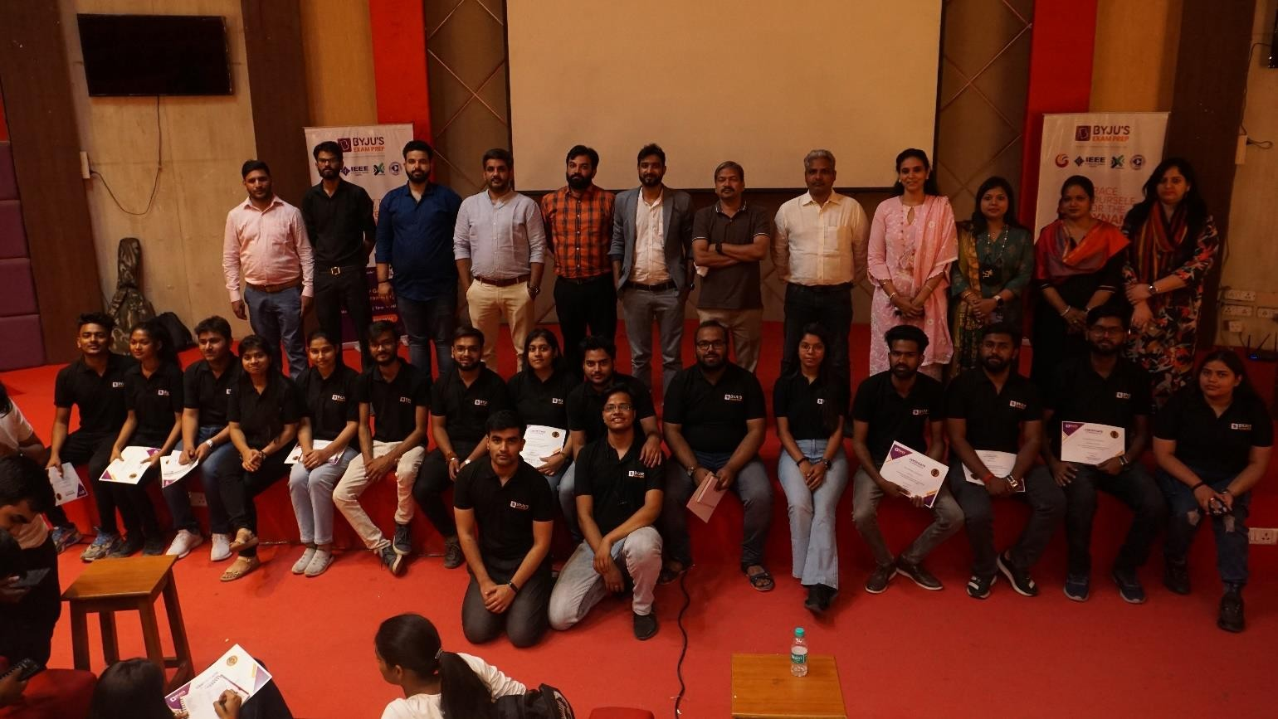

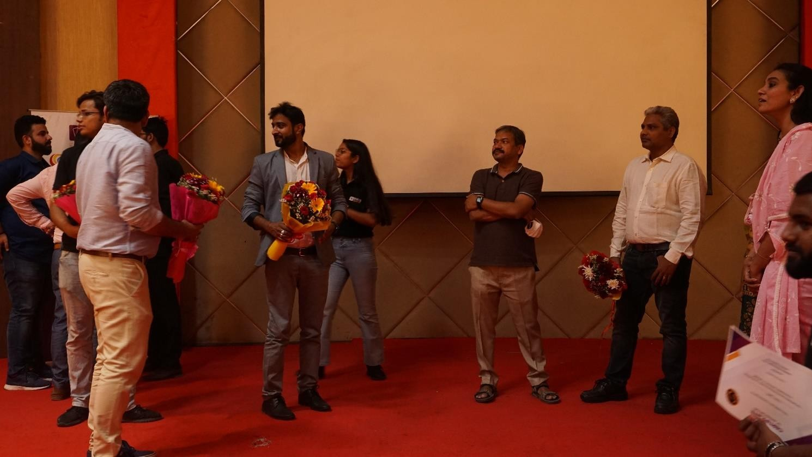

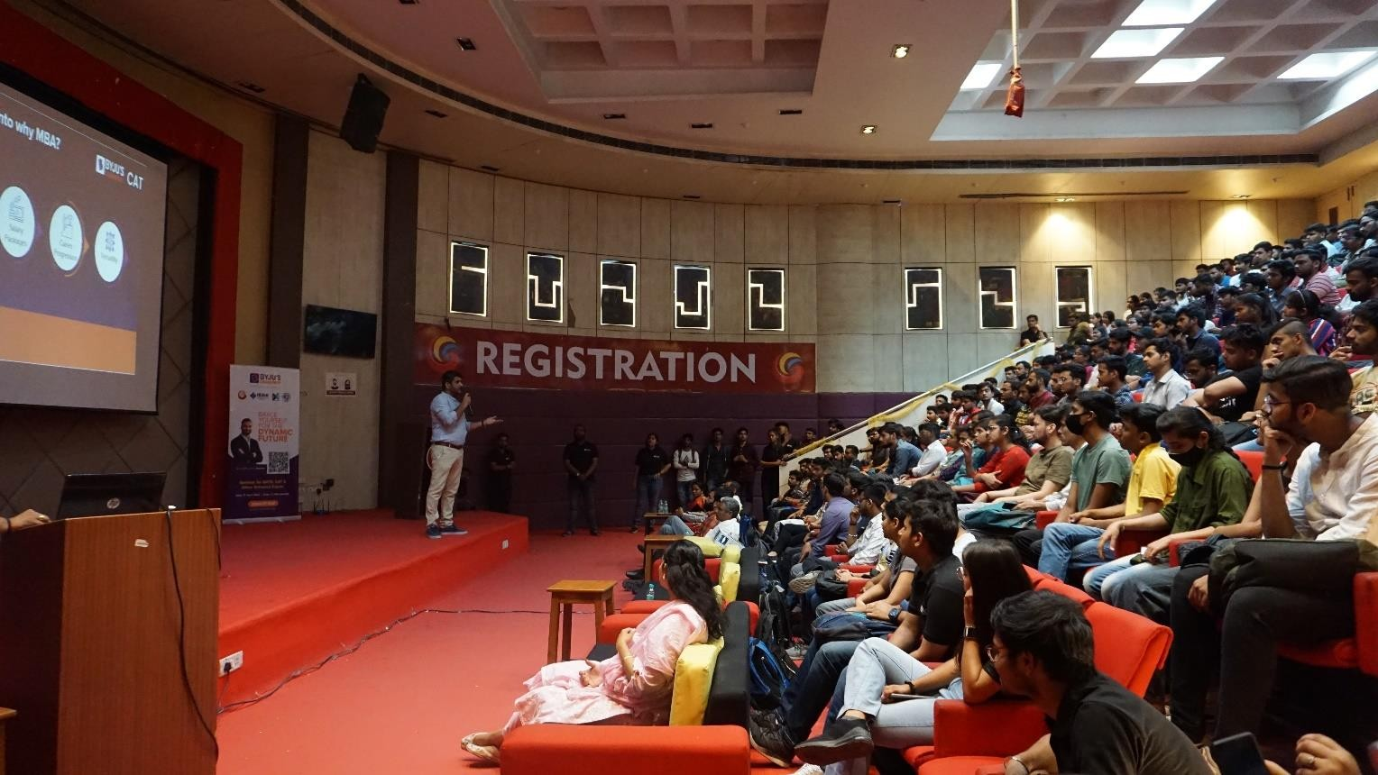

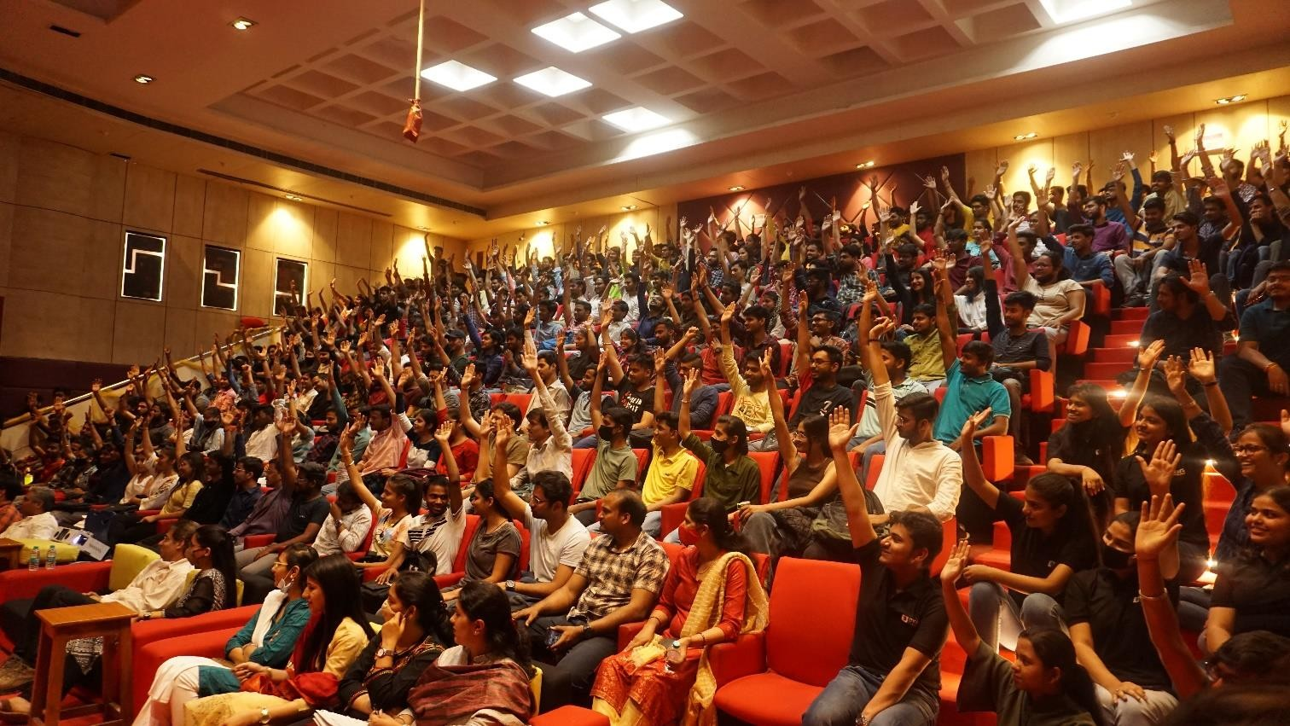

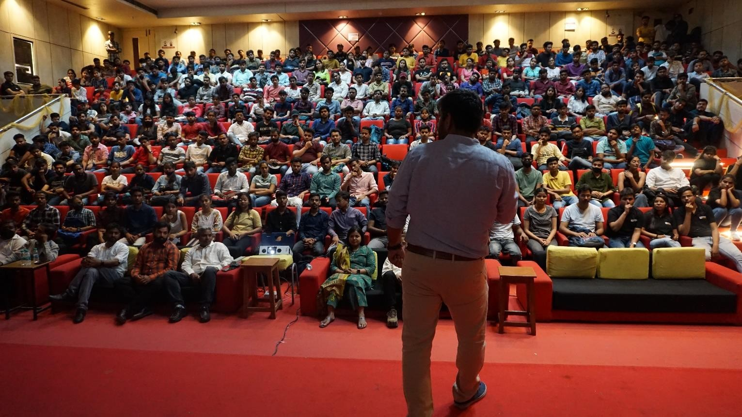

|  |  |
| --- | --- |
| **Event Summary** | |
| **Title of the event** | Seminar on Manthan’22 |
| **Start time** | 11:00 A.M. |
| **End Time** | 1:00 P.M. |
| **Category of the event** | Professional |
| **Sub- Category of the event** | Continuing Education |
| **Time Zone** | India |
| **Primary Host Organization Unit** | Galgotias College of Engineering and Technology (STB07021) |
| **Primary Host Contact Event** | [vishnu.sharma@galgotiacollege.edu](mailto:vishnu.sharma@galgotiacollege.edu) |
| **Platform** | D Block Auditorium |
| **Registration Link** | https://forms.gle/9twXQWfFGidys3gK6 |
| **Physical Address** | Galgotias College of Engineering and Technology, knowledge park-2, Greater Noida, Uttar Pradesh, India |
| **Registration Starts/Date** | 29/3/2022 |
| **Registration Ends/Date** | 08/4/2022 |
| **Participants** | Students of GCET |
| **Number of Participants** | 470 |

**Coordinator:**

**Secretariat, Extreme Club**