Expert talk on

"Machine Learning

and

Natural Language Processing :

Basics to Applications"

**IEEE SPS GCET STUDENT BRANCH**

**JULY 9 , 2022**

**Opening:**

The Hosting of the of the Expert talk on "Machine Learning and Natural Language Processing: Basics to Applications" was called to order at 5:00 PM on 9th July on the online platform, Google Meet.

**Agenda :**

This session includes discussion about inter-relation between machine learning and natural language processing, how NLP helps machine for human language interpretation and uses of NLP in Google Assistant and chatbots.

**About Speaker :**

Dr. Tejas Dhamecha

He is Senior Research Scientist and Manager at IBM. For about a decade, he has been working in the research area of machine learning and pattern recognition with application into computer vision, biometrics, and natural language processing. He is also currently working upon inventing and expanding NLP capabilities for various Indic languages.

**Total Number of Attendees:**

The Total of 60 Students from various departments of GCET , as well as from the other colleges attend this expert talk. There are also some faculties from various colleges which includes Dr Kavindra R Jain , Dr Chirag Paunwala and Prof. Chintan Varnagar.

**Discussed Topics :**

1. Machine learning
2. Natural Language Processing

**Discussion Order:**

Welcome

About IEEE Signal Processing society

Expert Talk

Q&A session

Felicitation

Vote of Thanks

**Flow:**

The session was hosted by Kandarp Shah. The session began with introduction of the speaker and after that, session was carried forward by Dr. Dhamecha.

In this session, Dr. Dhamecha discussed about important concepts of machine learning and how it is related to artificial neural networks and natural language processing. This includes discussion about types of approaches towards a problem (unsupervised and supervised, which includes classification and regression), applications of numerical method and analysis in mathematical computations performed on clusters and a hands-on demonstration of these concepts. After that, sir answered the questions asked by attendees.

The session was carried further with discussion about artificial neural network and a brief discussion about Kohonen networks. A hands-on demonstration was presented by Dr. Dhamecha along with illustrating the accuracy of testing, training and validating datasets. Furthermore, sir cleared some doubts of the students.

The final segment of Dr. Dhamecha’s discussion consisted of varieties of tasks and examples which can be solved using natural language processing and it includes examples based on primitives, parsing, semantics and discourse. A small Q/A session was conducted to solve the doubts of attendees.

Afterwards, Dr. Kavindra Jain, Educational Academic Chair And Conference Chair, IEEE SPS GS, invited Dr. Chirag Paunwala, IEE SPS GS Chair, to say a few words about the speaker and Dr. Chirag also encouraged the students.

Thereafter, Darshan Modi, Vice-Chairperson of IEEE SPS GCET SB, presented Vote of Thanks and LOA to Dr. Tejas Dhamecha.

Each participant gained new information about machine intelligence and natural language processing. The session ended at 6:50 PM by the host Kandarp Shah.

**Event Poster :**

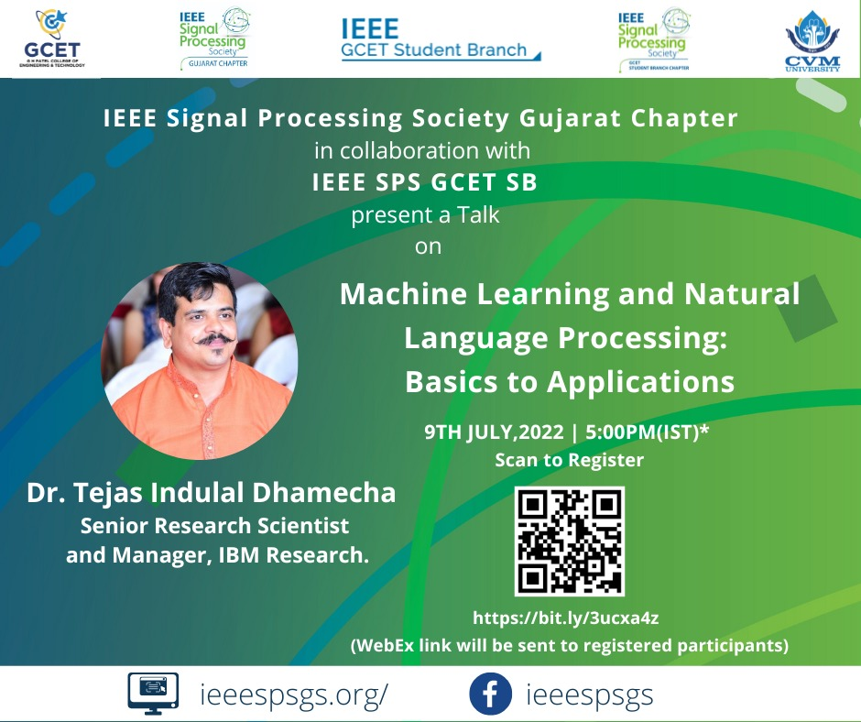

**Letter of Appreciation :**

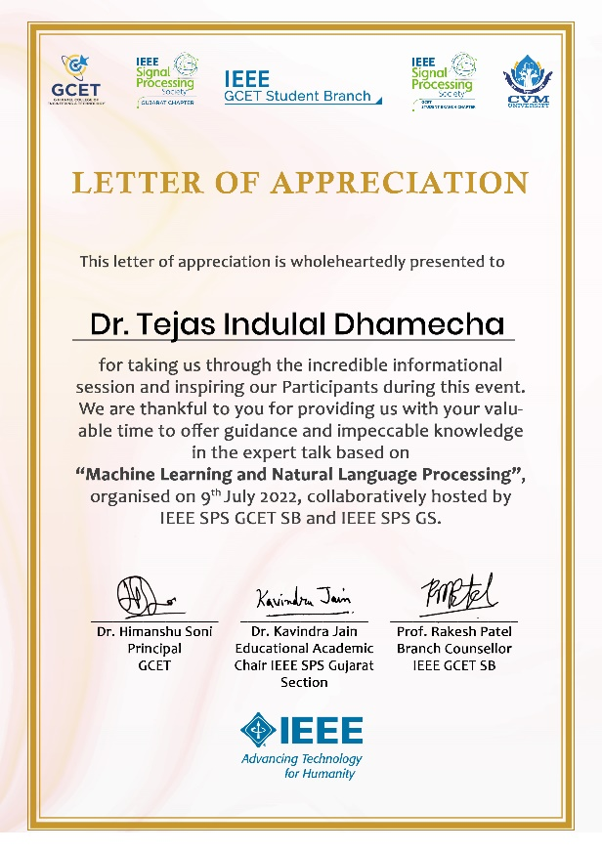

**Glimpse of Event :**

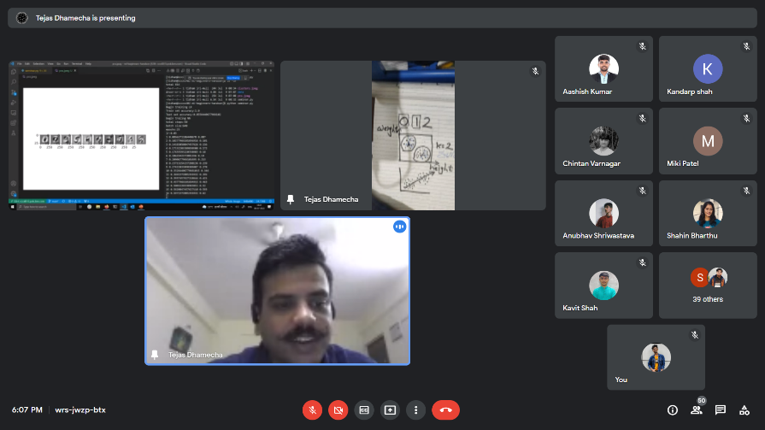

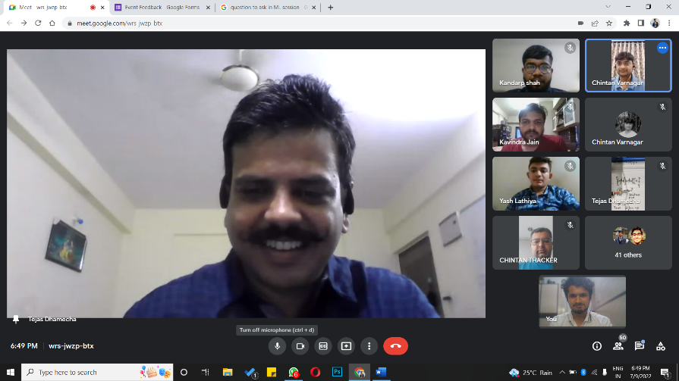

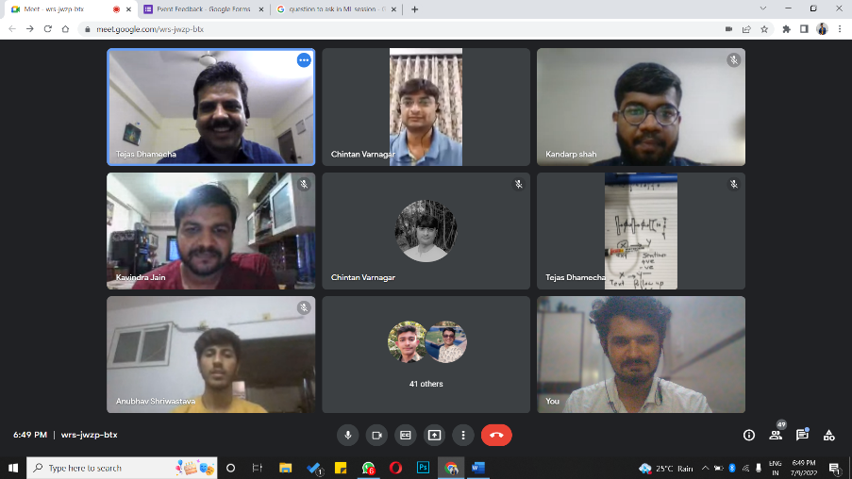

**Conclusion:**

With the goal of imparting knowledge of Machine learning and Natural Language processing of participants, Expert talk was a great success owing to the efforts of the organizing team and the energetic attendees. Looking at the usage and ever increasing importance Machine learning and Natural Language processing of in today's era, the expert talk paved a great way to begin learning from the very start and go through live examples. There was ample participation in expert talk, and it got conducted smoothly. Moreover, good feedback was received from the participants of the expert talk , and they want some more Hand-on session on various other domains.