|  |  |
| --- | --- |
|  | **RICHMOND CHAPTER OF IEEE PES**  **PES OFFICERS**  **Alan Ott – (804)257-4823  Brian King – (804) 320-8005  Dev Walia – (804) 928-8095  Hung-Ming Chou – (804) 418-0598**  **Tin Nguyen – (804) 257-4999**  **Mahesh Karki – (804) 801-3955** |

***Power System Grounding and Corrosion Control***

**Date: THURSDAY, September 15th, 2022**

**Place: Classroom B/D in Substation Building of Dominion Energy Safety and Training Center (11501 Old Stage Rd, Chester, VA 23836)**

**Abstract:**

In this seminar, two major topics will be covered. The first topic is about system grounding, especially about distribution, transmission, and substation grounding practices and why they need to evolve with the rapid expansion of wind & solar connections to the grid. The second topic is about corrosion control and cathodic protection design for electrically shorted pipelines. Two leading industry experts are invited for this seminar.

**Seminar Outline:**

8:15 am to 9:00 am Registration (Breakfast Provided)

9:00 am to 9:10 am           Opening Remarks

9:10 am to 10:10 am How System Grounding Affects Utility Reliability & Employee/Public Safety

10:10 am to 10:30 am Coffee Break

10:30 am to 11:30 am How System Grounding Affects Utility Reliability & Employee/Public Safety

11:30 am to 12:30 am Lunch Provided

12:30 am to 1:30 pm Fundamental of Corrosion and Corrosion Control

1:30 pm to 1:50 pm Coffee Break

1:50 pm to 2:50 pm Cathodic Protection Design for Electrically Shorted Pipeline

2:50 pm to 3:00 pm         Chapter Announcement

**Instructors:**

* Kris Cox, SAE Inc
* Sasan M Hosein, POND

**Seminar Cost:**

**$30 ($20 for students)  
(includes breakfast, lunch, and breaks)**IEEE membership is not required to attend this seminar.

**Special:** Bring a friend to the seminar (someone who has not previously attended a Richmond PES seminar) and you will get a $10 discount on the seminar cost. When making your reservation, you must reserve your friend’s attendance at the same time to get the discount.

**Reservations:** We will accept payment at the meeting, but reservations should be made in advance by September 7, 2022. Payment will need to be by Cash or check only. Checks should be made payable to **IEEE PES.** Advance payment for the seminar is not required**.**

**Reservation link:**

<https://events.vtools.ieee.org/m/322479>

**PDHs: 5** professional development hours (PDHs) will be issued for completing this course. A PDF Certificate will be sent out for all attendees following the seminar.

|  |
| --- |
| **Questions? Contact the following:** |
| [PESRichmond@ieee.org](mailto:PESRichmond@ieee.org)  [alan.ott@dominionenergy.com](mailto:alan.ott@dominionenergy.com) |

**Direction**

Classroom B/D in the Substation Building of Dominion Energy Safety and Training Center

(11501 Old Stage Rd, Chester, VA 23836)  
Parking space is available near the substation building and inside the entrance of the training center.

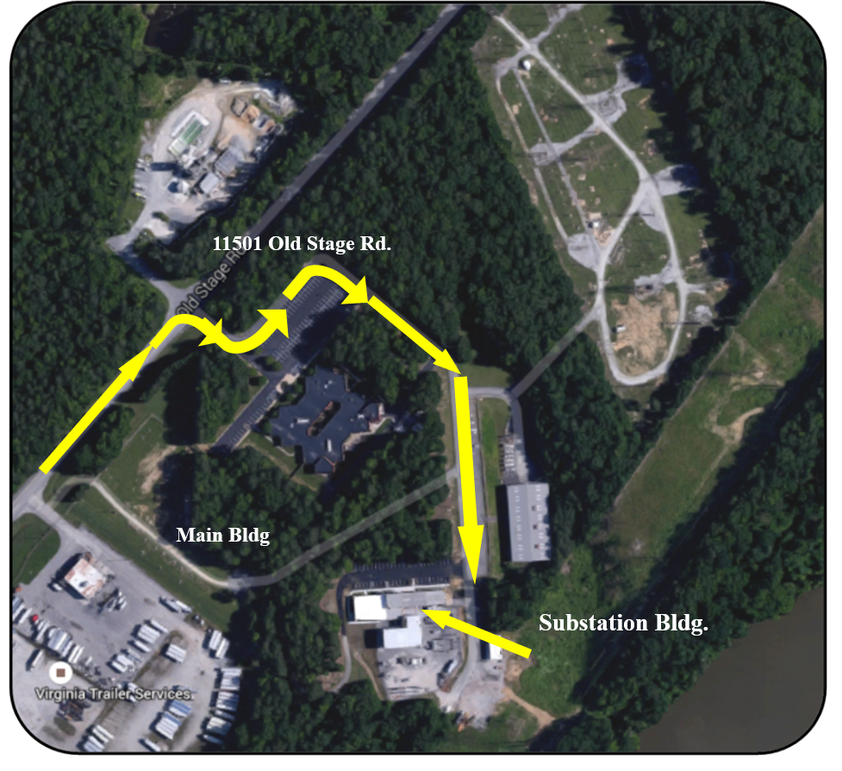

**Presentation Abstracts and Speaker Bios:**

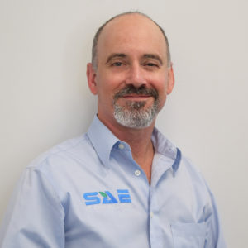

**Presentation title**: How System Grounding Affects Utility Reliability & Employee/Public Safety

**Abstract**:  While utilities are leveraging new technology and materials for grid hardening and better data analytics, they often still approach system grounding with a legacy philosophy.

This talk will look at Distribution, Transmission and Station grounding practices and why they need to evolve. In the distribution world increased burial of infrastructure & safety incidents are pushing OH pole grounding into the pole hole. This combined with new backfill materials can effectively negate electrode performance. The relationship between arrester performance, pole down ground routing and effective grounding will be explained to illustrate what is required for successful lightning mitigation and reduced equipment failure. Common UG issues such as premature cable and sub-division open point transformer failures will also be examined. It is vital that an engineered GROUNDING solution (horizontal and /or vertical solution) be developed that will be effective for the service territory challenges they operate in (rock, sand, corrosive soils, sidewalks etc.)

On the OH Transmission side of the business, it is commonplace to leave grounding to the last stage of the project, where construction forces are required to install an unknown number of grounds rods /counterpoise /per structure until utility target is met. If we are fortunate, a list of non- compliant structures emerges, to be dealt with separately. Grounding audits often find large discrepancies between target and “installed” after associated reliability issues. Engineering the grounding design, before construction, (using soil resistivity testing and CDEGS software/innovative materials) ensures that all structures meet reliability requirements for the life cycle of the structures. Grounding costs can be accurately estimated and project in “service delays” minimized. Other key issues such as direct buried metal pole sub--surface corrosion and copper theft will be discussed as well.

With the rapid expansion of wind & solar connections to the grid, increases in available fault current at our ageing stations is commonplace. We will look at common soil Resistivity testing issues and grid design solutions. We will also look at what happens to touch & step potential at stations assigned a “hi-split” factor, when the connected Tx structures do not meet grounding targets or copper theft occurs. The common practice of installing communication towers inside the fence will be reviewed as well a common causes for lightning related damage. A list of factors will be examined that will help Stations Asset managers decide where to prioritize their maintenance dollars.

**Kris Cox** is the Utility Technical Specialist for SAE Inc. Prior to his employment with SAE, Kris enjoyed a career with Ontario Hydro /Hydroone Transmission & Distribution Engineering & Operations Divisions. Although engaged in many steering committees and significant reliability/equipment failure/public safety investigations, the complete Overhaul of their Distribution OH&UG standards, materials & work practices was a significant milestone.

Today, Kris is enjoying working with Tx, Dx & stations groups across North America as they look to improve their reliability & safety performance.

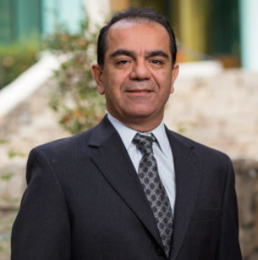**Presentation title**: Fundamental of Corrosion, Corrosion Control, and Cathodic Protection Design for Electrically Shorted Pipeline

**Abstract**: This presentation will present two major topics. The first topic is about fundamental of corrosion and corrosion control, including: corrosion definition, soil corrosivity, corrosion control, cathodic protection principal, cathodic protection system design, monitoring program and enhanced survey program. The second topic is about cathodic protection design for electrically shorted pipeline, including shorted system complexity, integrity management program, cathodic protection design, protection system criteria, design options, design process, design challenges, commissioning, and monitoring program, etc.

**Sasan M Hosein** has been involved in the corrosion control industry for more than twenty-five (25) years. Sasan received his master’s degree in Corrosion Engineering from Florida Institute of Technology (FIT). Sasan has done extensive research in establishing specifications for cathodic protection systems, electrical sub-station CP design, Nuclear Power Plant CP design, Factors Influencing Potential Measurement, and protective coatings for several projects. He also has experience in supervising and installing many and various types of AC Mitigation System on different pipelines. As a result of his research, his extensive experience to conduct data collection, linear and correlation analysis, base line analysis and integrity management, Sasan has developed “Correlation Potential Correction” (CPC) process for over-the-line survey within Nuclear Plant which eliminates the effect of concrete paving to measure pipeline potential.

Sasan Hosein serves as Pond & Company Vice President of Corrosion Control and as such, Sasan has been developing and directing several technical research for developing new techniques in corrosion control industry. Sasan holds a Bachelor of Science in Marine Engineering, Master of Science in Corrosion Engineering and is certified by the National Association of Corrosion Engineers (NACE) as both a CP-4 Cathodic Protection Specialist and a Corrosion Specialist.

Sasan has been involved in the corrosion control industry for more than twenty-five (25) years. By reason of his academic background, experience, technical certification, and professional training acquired over the years, he is highly qualified to perform technical services associated with providing training for cathodic protection, design, installation, testing, data analysis, and integrity management and correlation analysis of all types of cathodic protection systems.