A
Report
on

Extempore Speech
Contest

Reported By: Editorial team,
Extreme Club and STB07021


Galgotias College of Engineering and Technology (STB07021)
Extempore Speech Contest
(2 December 2021)
DATE: 2 December 2021
VENUE: Online, Zoom
TIME: 1:00 PM TO 4:00 PM

About the Event:
"If your tongue can convey the message of your heart, you can communicate properly."
The C.S.E department and STB07021 organized an Extempore Speech Contest.
The attendees were told to dress formally for this function. The subjects for their speeches were decided on the spot because the competition was extemporaneous in nature. They were told to project confidence and employ appropriate body language, including facial gestures. No advance planning was permitted under the guidelines.

The event was attended with great excitement by the participants, and three winners were announced. They are as follows:
First is saksham Yadav
Bharat chauhan came in third, followed by amar kumar.
Under the kind direction of HOD sir, the CSE Secretariat managed the competition.
Skills in public speaking are more important. It offers us the chance to confront difficulties and get over our stage fright. It gives us more self-assurance and makes it possible for us to express our opinions honestly.
Learning Outcomes:
LO1: Importance of public speaking.
LO2: Formal way to represent ourself and build ample amount of confidence.
LO3: Prepares us to be spontaneous.

(Event Poster)

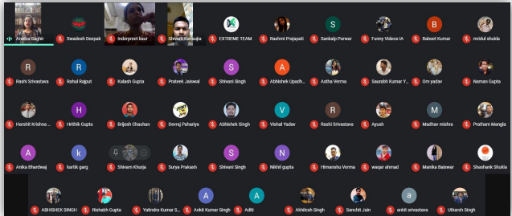

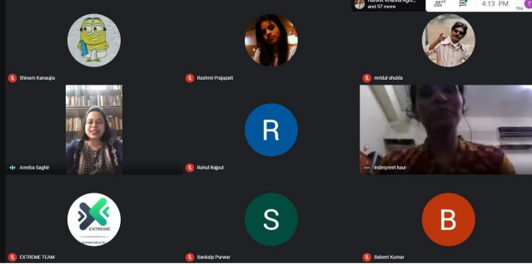

Event Summary
Title of the event | Extempore Speech Contest
Start time | 1:00 PM
End Time | 4:00 PM
Category of the event | Technical
Sub- Category of the event | Informative
Time Zone | India
Primary Host Organization Unit | Galgotias College of Engineering and Technology (STB07021)
Primary Host Contact Event | vishnu.sharma@galgotiacollege.edu
Platform | Online, Google Meet
Physical Address | Galgotias College of Engineering and Technology, knowledge park-2, Greater Noida, Uttar Pradesh, India
Registration Starts/Date | 28/11/2021
Registration Ends/Date | 1/12/2021
Participants | Students of CSE and allied branches, GCET
Number of Participants | 60

Co-ordinator:
Dr. Inderpreet Kaur

