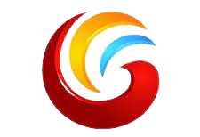
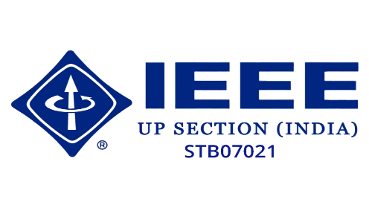
A
Report
On
Debate Competition

(13, December,2021)

Reported By: Editorial team,
Extreme Club and STB07021

Galgotias College of Engineering and Technology (STB07021)
“Debate Competition”
DATE: 13 December 2021
VENUE: Zoom
TIME: 10:00 AM Onwards

About the Event:

The C.S.E department and STB07021 organized “Debate Competition, In order to foster great oral and writing communication abilities among CSE Department students, the club has been holding this competition.

The teams spoke in favor of or against the motion on three different subjects.

Topics:

1. Internet neutrality has to be reinstated.

2. AI will never take the place of Humans.

3. Does digital money use make people's lives better or worse?

Rules:

1. The positive side speaks up first. After that, the opposing side responds negatively. It is appropriate for each member of the opposing factions to speak once.

2. The allotted time for each speaker is one minute. The speaker must end their speech before the timer runs out to avoid being cut off.
3. Interrupting the speaker is not allowed under any circumstances.
4. The audience, which frequently serves as the debate's judges, is not permitted to speak.
5. A show of hands is frequently used when the audience votes. Majority rule prevails.
Through debate competition, students were able to see how well-supported facts, compelling arguments, and reasoning work. It enabled them to more effectively communicate their stance through language. It greatly improved the poise and self-assurance of debaters. They gained knowledge on how to conduct fruitful research, assemble compelling presentations, and effectively convey their results.
The competition for the individual themes was won by Teams spirit, the elite and rockers.
Learning Outcomes:
LO1: Develop excellent critical thinking skills.
LO2: Develop effective tools for research, organization and presentation.
LO3: Develop strategies to overcome fears of public speaking.

Event Pictures:

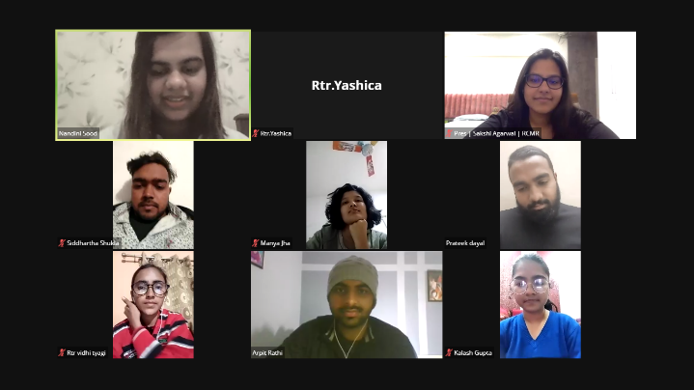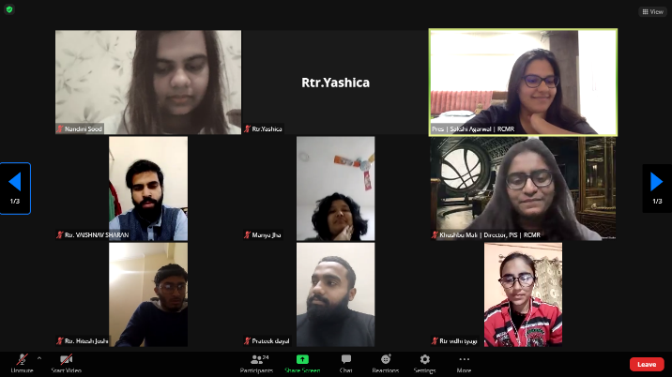

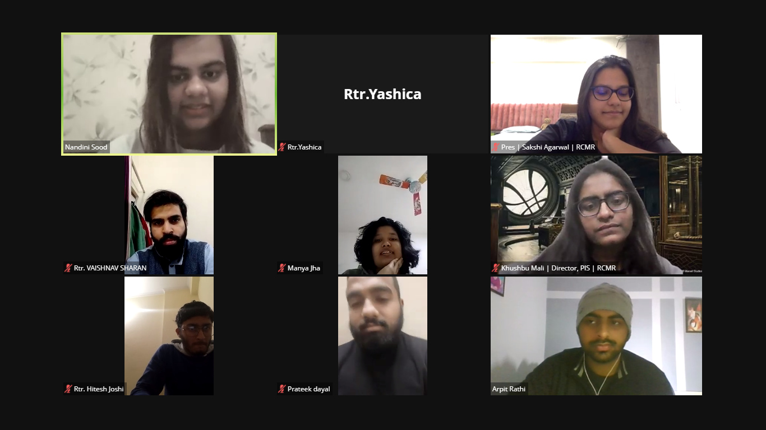

Event Summary
Title of the event | Debate Competition
Start time | 10:00 am
End Time | 2:00 pm
Category of the event | Technical
Sub- Category of the event | Competition
Time Zone | India
Primary Host Organization Unit | Galgotias College of Engineering and Technology (STB07021)
Primary Host Contact Event | vishnu.sharma@galgotiacollege.edu
Platform | Online,Zoom.
Physical Address | Galgotia college, knowledge park-2, Greater Noida, Uttar Pradesh, India-
Registration Starts/Date | 10/12/21
Registration Ends/Date | 13/12/21
Participants | Students of CSE, GCET
Number of Participants | 34

Co-ordinator:
Dr. Inderpreet Kaur

