A
Report
On

Group Discussion
About
“AI, GOOD or BAD”

Reported By: Editorial team,
Extreme Club and STB07021


Galgotias College of Engineering and Technology (STB07021)
Group Discussion
About
“AI, GOOD or BAD”
DATE: 23 December 2021
VENUE: Google Meet
TIME: 3:00 PM to 5:00 PM

About the Event:
C.S.E department organized a group discussion on topic “AI,Good or Bad”.
While there are many advantages to AI, renowned figures including Elon Musk, Bill Gates, and Stephen Hawking have cautioned against its development. These worries are legitimate. In instance, Hawking said that AI will be "either the best or the worst thing, ever to happen to humanity." Indeed, the World Economic Forum outlined 9 ethical worries regarding AI.
The attendees voiced their concerns during the conversation.
The first cause for concern is the loss of jobs when computers replace current human jobs. The participants asserted that switching to a way of life that prioritizes spending quality time with family would really be more compassionate.
Machine learning may "nudge society towards more good conduct," according to the Forum. Additionally, as they develop, neural networks can serve as a catalyst for progress.
The best way to ensure that concerns about AI are kept to a minimum is to embrace it. AI may help create a store of knowledge that is more coherent, contextualised, and accessible in terms of academic publication. Publishers may streamline procedures using AI to make sure all articles are of the highest calibre.

Learning Outcomes:
LO1: Importance and disadvantages of AI.
LO2: Discussion over will ‘AI’ lead to various other major problems hence we need to prevent it.
LO3: How to prevent job scarcity occurred due to advancement of Ai and how can we spread awareness.

Event Pictures:

(Poster of the Event)
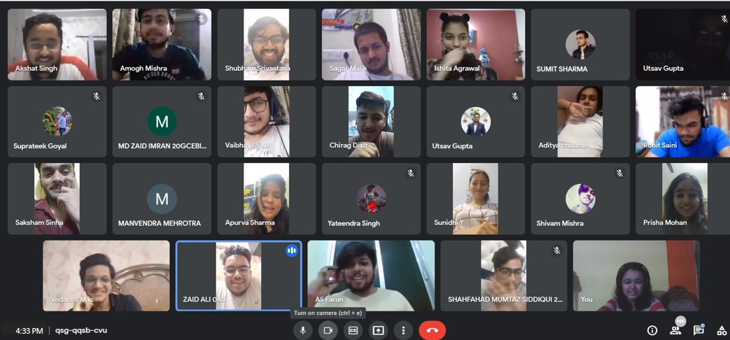
(GD: PICTURE)

Event Summary
Title of the event | Group Discussion: “AI, Good or Bad”.
Start time | 3:00 pm
End Time | 5:00pm
Category of the event | Technical
Sub- Category of the event | AI
Time Zone | India
Primary Host Organization Unit | Galgotias College of Engineering and Technology (STB07021)
Primary Host Contact Event | vishnu.sharma@galgotiacollege.edu
Platform | Google Meet
Physical Address | Galgotia college, knowledge park-2, Greater Noida, Uttar Pradesh, India-
Registration Starts/Date | --
Registration Ends/Date | --
Participants | Students of CSE, GCET
Number of Participants | 106

Co-ordinator:
Ritesh Srivastava

