
IEEE (PI)² Austin Chapter
https://r5.ieee.org/ctx-pi2/

Institute of Electrical and Electronic Engineers
Central Texas Section
https://r5.ieee.org/ctx/

2023 NESC CHANGES, plus
ARC FLASH CALCULATION FOR
SMALL SERVICES WORKSHOP
Wednesday, May 10th, 2023
Scottish Rite Theatre
207 W. 18th St. Austin, TX

WORKSHOP DETAILS:
This one-day workshop has four parts under two major divisions:
Parts 1 – 3 will explore the changes in the 2023 version of the National Electrical Safety Code Handbook (NESC, IEEE STD C2-2023), a print copy of which will be provided each registered participant as Workshop material. The IEEE Handbook contains the full NESC plus the commentary in one text. This is new this year.
Part 4 will cover arc flash including two effective methods to calculate arc flash for small electrical services, especially single-phase 100-amp services, and the strengths of each method.
Participants will need to bring a laptop or notebook capable of running Microsoft Excel spreadsheets for Part 4.
This Workshop is intended for Electrical Designers, Estimators, and Field Engineers for utilities, and for designers and contractors who work near utilities.
It is also highly recommended as a review supplement for those preparing to take the Electrical P.E. exam.
In addition, there will be exhibits by industry manufacturers and suppliers. The workshop fee includes breakfast tacos, break refreshments, and a copy of the IEEE NESC Handbook for each registrant.

 | Time |  | Subject
7:00 – 7:15 AM |  | Center opens - Manufacturers set up displays
7:15 – 8:00 AM |  | Registration and Breakfast
8:00 – 8:25 AM |  | Opening, Speaker Introduction, and Breakfast Sponsor introduction
8:25 – 9:40 AM |  | Part 1 2023 NESC Changes – Dave Hernandez, P.E.
9:40 – 10:00 AM |  | Morning Break - Visit Sponsor's displays.
10:00 – 11:30 AM |  | Part 2 2023 NESC Changes – Dave Hernandez, P.E.
11:30 – 1:00 PM |  | Lunch and visit Sponsor's displays.
1:00 – 2:00 PM |  | Part 3 2023 NESC Changes – Dave Hernandez, P.E.
2:00 - 2:20 PM |  | Afternoon Break - Visit Sponsor's displays.
2:20 – 4:25 PM |  | Part 4 Arc Flash Calculations and Estimations – Dave Hernandez, P.E.
4:25 – 4:45 PM |  | Wrap-up and Q&A

Institute of Electrical and Electronic Engineers
Central Texas Section
https://r5.ieee.org/ctx/

IEEE (PI)² Austin Chapter
https://r5.ieee.org/ctx-pi2/

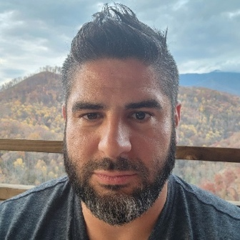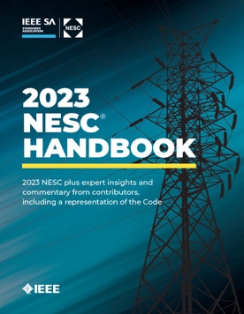

Mr. Dave Hernandez, PE, CEM, GBE, CESCP.
Founder & CEO of DCH Global

Mr. Dave Hernandez is among the nation's top experts in the Power & Energy sector. He is distinguished as a licensed Professional Engineer in 52 U.S. jurisdictions. He has held responsible charge of over 25,000 electrical projects throughout his 17-year career and is frequently retained nationally by design firms and construction companies.
Mr. Hernandez is an IEEE Senior Member in Cincinnati, Ohio where he serves as the Vice Chair of the Cincinnati Section and Chair of the Joint Chapter for IAS/PES/ PELS. He is also a senior member of AEE, a Certified Energy Manager, a Certified Green Building Engineer, a voting member of NFPA, and a Certified Electrical Safety Compliance Professional. Mr. Hernandez is an NCEES record holder designated International Registry Professional Engineer and Model Law Engineer. He is an Appointed Qualified Inspector for the Texas Department of Insurance and a former member of the NEMA MG1 committee where he helped develop electrical legislation across North America.
Mr. Hernandez holds Bachelor and Master degrees in Electrical Engineering specialized in Power Systems, and holds a Professional Certification in Mechanical Engineering. He has conducted over two dozen workshops and has been published nine times through various industry outlets.

Membership Status | Thru 4/26/2023 | After 4/26/2023
IEEE Member | $525 | $750
Non-IEEE Member | $750 | $975
IEEE Life Members & Students | $450 | $650

*Become an IEEE member & enjoy the substantial IEEE member discount at https://www.ieee.org/membership/join/index.html

Upon completion of the workshop, participants will receive a PDH certificate for eight hours.

IEEE (PI)² Austin Chapter
https://r5.ieee.org/ctx-pi2/
Institute of Electrical and Electronic Engineers
Central Texas Section
https://r5.ieee.org/ctx/

REGISTRATION:
Registration and payment for this workshop must be completed at https://events.vtools.ieee.org/m/341023. Wednesday, 5/03/2023 is the final day for registering online. Walk-ins will be accepted but must have a check for the full amount made out to IEEE-CTS.

LOCATION DETAILS:
The historic Austin Scottish Rite Theater is located at 207 W. 18th Street, Austin, TX 78701. The building was erected in 1871 as Turner Hall, also known as the German Opera house. No daytime parking is available at the Theater. Please park in the Bob Bullock Museum garage, one block east on 18th Street and bring the Amano McGann receipt to the Workshop for immediate reimbursement.

CONTACT & OTHER INFORMATION:
If you have any questions or need any additional information about the workshop, please contact James Mercier at jmercier@ieee.org.
James Mercier, IEEE - 518 Academy Drive, -Austin, TX 78704
All cancellation and refund requests must be submitted in writing and received by James Mercier at the address above prior to April 26, 2023. There will be a 20% processing fee charged for all refunds. Fees paid after May 5, 2023, will be paid at the door via check payable to IEEE-CTS.

