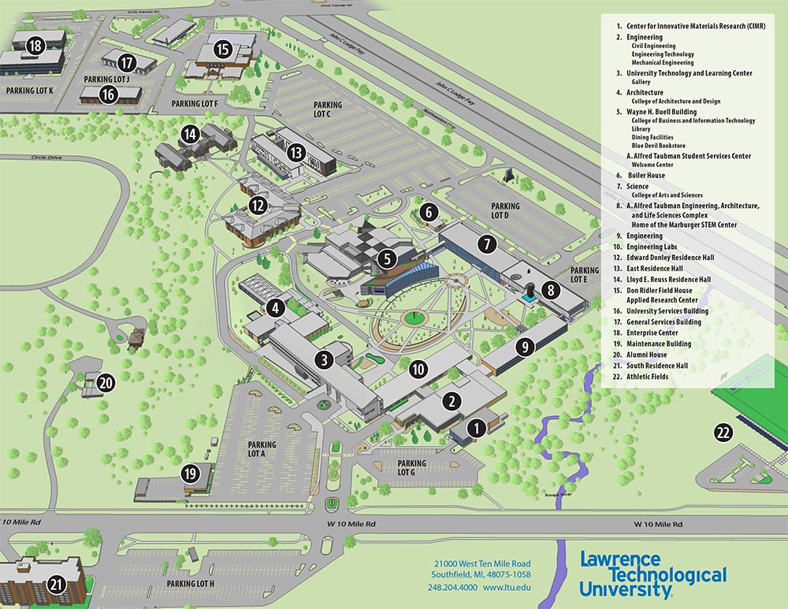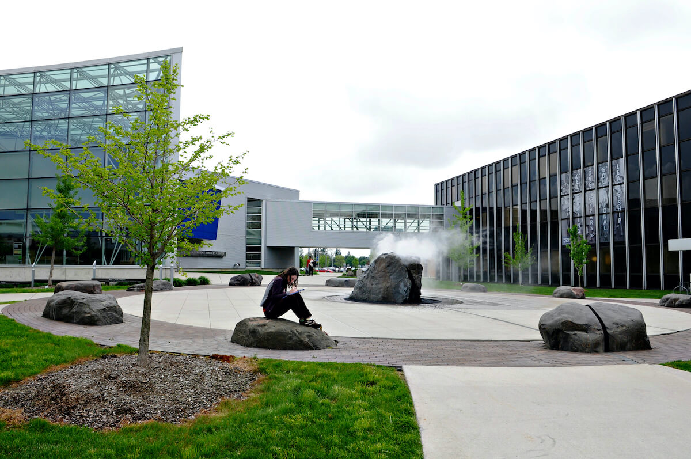­

**Lawrence Technological University**

Event

**Event Location:**

building, No. 3 building on the map.

UTLC (University Technology and Learning Center)

### Free Parking:

### Parking Lot A & Parking Lot G

Event Parking

### Room Number: T210, UTLC Gallery

### Lawrence Tech University

### 21000 West Ten Mile Road,

### Southfield, Michigan,

### United States 48075-1058

### 42.474229920561356, -83.24997890977096

### <https://www.google.com/maps/@42.4737935,-83.2499199,256m/data=!3m1!1e3?hl=en>

**March 28th, 2023, Tuesday, 4:00 PM**

**IEEE Southeastern Michigan Spring 2023 Conference**

**Venue: Lawrence Tech University**

[**conference@ieee-sem.org**](mailto:conference@ieee-sem.org)

[**https://events.vtools.ieee.org/m/328899**](https://events.vtools.ieee.org/m/328899)

**Venue**

