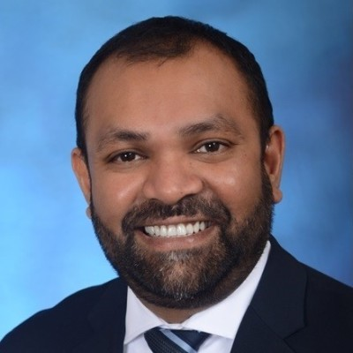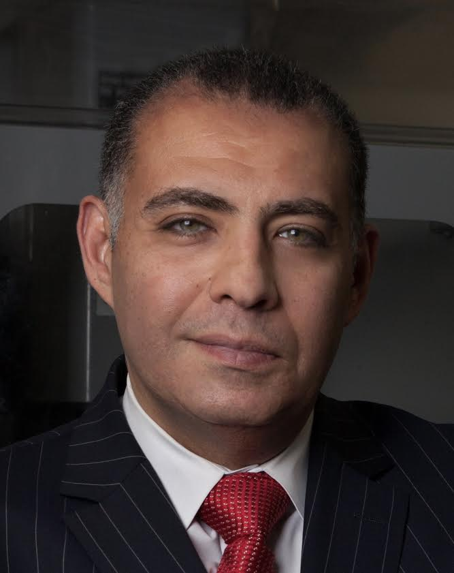­

**Venue: Lawrence Tech University, Southfield, Michigan, USA**

**March 28th, 2023, Tuesday, 4:00 PM**

**Dr. Tarek M. Sobh**

**Santhosh Jogi**

**Kelsey Peterson**

**Industry Keynote Speaker:**

**Topic:** DTE’s EV program, Charging Forward, is designed to encourage EV adoption and fuel EV charger infrastructure growth in Michigan by offering incentives and rebates to Michigan residents and businesses. Ms. Kelsey Peterson will be discussing DTE’s electrification plans.

**Ms. Kelsey Peterson, Manager, Transportation Electrification, DTE Energy**

Ms. Kelsey Peterson is a manager for DTE (NYSE: DTE), a Detroit-based diversified energy company involved in the development and management of energy-related businesses and services.

Currently, Peterson leads the team responsible for DTE’s electric vehicle (EV) strategy, from pilot development to program execution. Prior to joining DTE in August 2016, Peterson was a quality manager at BMW in Greenville, South Carolina, and Munich, Germany. She holds a Bachelor of Science in Industrial Engineering and a Bachelor of Business Administration from the University of Michigan and a Master of Business Administration from Duke University.

**Inauguration and Keynote Speaker:**

**Topic: TBD**

**Dr. Tarek M. Sobh, President, Lawrence Technological University**

Dr. Tarek M. Sobh is the eighth president of Lawrence Technological University and assumed office on January 1, 2022.

Dr. Tarek M. Sobh, a licensed professional engineer, has received a Bachelor of Science in engineering with honors in computer science and automatic control from Alexandria University, Egypt, and a Master of Science and Ph.D. degree in computer and information science from the University of Pennsylvania.

Dr. Tarek M. Sobh is a noted scholar who has authored more than 250 refereed journal and conference papers and book chapters, in addition to 27 books. His background is in the fields of robotics, computer science and engineering, control theory, automation, manufacturing, AI, computer vision, and signal processing.

**Industry Keynote Speaker:**

**Topic:** TBD

**Mr. Santhosh Jogi, Vice President, Our Next Energy**

Mr. Santhosh Jogi is Vice President of Software Engineering at Our Next Energy (ONE), a Michigan-born energy storage company focused on battery technologies that will accelerate the adoption of EVs and expand energy storage solutions.

Currently, Mr. Jogi leads the creation of a digital strategy for ONE’s battery products, after establishing the direction for Battery Management System software. Prior to joining ONE, Mr. Jogi was at Stellantis and dSPACE, in leadership roles of global propulsion system software product development, and embedded software strategy, methodology, and tools.

Mr. Jogi holds a Bachelor of Engineering in Mechanical Engineering from Purdue University, and soon (April 2023) an Executive MBA from the University of Michigan – Stephen M. Ross School of Business.

**IEEE Southeastern Michigan Spring 2023 Conference**

[**conference@ieee-sem.org**](mailto:conference@ieee-sem.org)[**https://events.vtools.ieee.org/m/328899**](https://events.vtools.ieee.org/m/328899)

**Keynote Speakers**

