1. **PROJECT EXPO-2022**

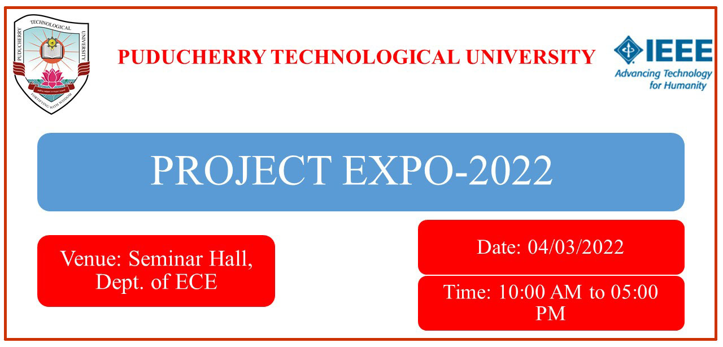

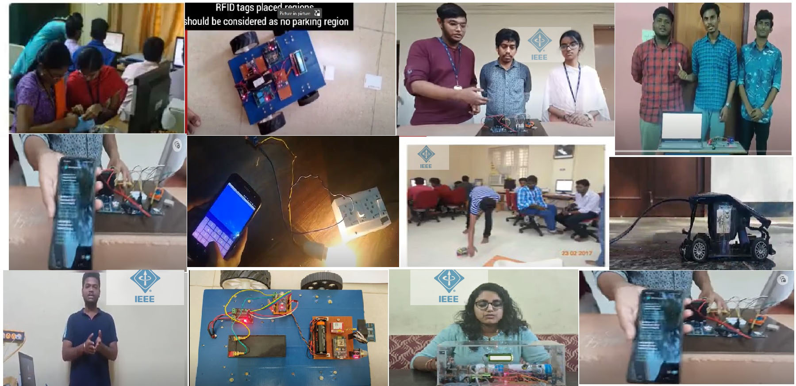

**Project Expo 2022**: The final demo cum presentation for the project expo will be held on 04.03.2022. The faculty mentors concerned are requested to inform the shortlisted teams to appear before the selection committee on 04.03.2022 at 10.00am onwards in the Seminar hall, ECE Department. Each team will be given a maximum of fifteen minutes for presentation and demonstration of their project.

1. Design of a 32-bit processor based on RISC – V Architecture     -  <https://youtu.be/xzqjcZlF444>
2. 2. Smart Pothole detection for Two-Wheelers during floods-   <https://www.youtube.com/watch?v=FWK-UCE2Pvo>
3. Patient monitoring system using IoT -  <https://www.youtube.com/watch?v=bhOEi9scY4s>
4. Handling Traffic Regulation using RFID and IoT -  <https://www.youtube.com/watch?v=YK4YO6gt0Lg>
5. Smart Pothole detection for Two-Wheelers during floods - <https://youtu.be/BVGmOyhv9DY>
6. Assistive system for improving livelihood of visually impaired by using Li-Fi -  <https://youtu.be/Fglw-rEyS7k>
7. Smart Security Surveillance System using IoT**-**<https://youtu.be/BVGmOyhv9DY>

**Event Coordinators:**

Dr. Gnanou Florence Sudha Dr.A.V.Anathalakshmi

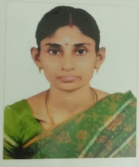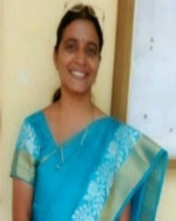

**Jury members:**

Dr. M. Arunachalam, Assoc. prof, EEE, PTU. Dr. K. Sarulatha, Assoc. prof, CSE, PTU.



The following teams compete for the Project expo 2022. The final demo cum presentation for the project expo will be held on 04.03.2022. The faculty mentors concerned are requested to inform the shortlisted teams to appear before the selection committee on 04.03.2022 at 1.30pm in the ECE Department. Each team will be given a maximum of fifteen minutes for presentation and demonstration of their project.

**Final Teams**

|  |  |  |  |  |
| --- | --- | --- | --- | --- |
| **SI.No** | **Title of the Project** | **Students** | **Batch** | **Faculty Mentors** |
| 1. | Patient monitoring system using IoT | 1. G. Dheepak | 2018-2022 | Dr. R. Sandanalakshmi |
| 2. | Smart Security Surveillance System using IoT | 1. A.S. AshikaBegam 2. S. Dharanidharan 3. P. Gowthamaan | 2018-2022 | Dr. A.V. Ananthalakshmi |
| 3. | Smart Covid Surveillance | 1. Ashish Kamalesh Singh 2. Manith Ruby Vazirani 3. Mahipal Singh K. Rajpurohit | 2019-2023 | Dr. K. Jayanthi |
| 4. | Design of a 32-bit processor based on RISC – V Architecture | 1. K. Navinkumar | 2019-2023 | Dr. M. Thachayani |
| 5. | Forest fire Preventive Informer (IoT Based) | 1. Medwin Mirza | 2019-2023 | Dr. S. Batmavady |
| 6 | Handling Traffic Regulation using RFID and IoT | 1. K. ThanushAravinde 2. R. Sriramachandran 3. K. Sivabharath | 2020-2024 | Dr. Gnanou Florence Sudha |
| 7. | Smart Pothole detection for Two-Wheelers during floods | 1. T. C. Adityaa 2. Ra. Srinethe 3. N. Pranav | 2020-2024 | Dr. L. Nithyanandan |
| 8 | Assistive system for improving livelihood of visually impaired by using  Li-Fi | 1. Shiva Sai | 2020-2024 | Dr. S. Tamilselvan |