**Application of Geospatial Technologies for Smart Cities**

Faculty of Technology (FT), CEPT University along with Association of Geospatial Industries (AGI) conducted a half day webinar on the topic of “**Application of Geospatial Technologies in smart cities**” on 15th June, 2023 between 10am to 1pm on Zoom.

Speakers from various organizations were present to give a talk on different topics under the main theme and how geospatial technology along with current advancements has helped in supporting the smart city mission. Dr. Shaily Gandhi, Program Chair M. Tech. (Geomatics) FT, CEPT University and Mr. Satej Panditrao, Technical Manager, AGI welcomed the attendees. The First talk was conducted by Dr. V S S Kiran, CEO, Garudalytics on “the applications of UAVs and Drones in Smart Cities”. The talk focused on the application of drones and UAVs in the various aspects that make a city smart like traffic management, first emergency response, logistics and monitoring the environment etc. The talk also focused on the different types of sensors used and their respective benefits in various applications with examples of use cases of in construction.

Dr. Ruma Chakrabarty, ESRI. Discussed how GIS products form the basis for various integrated control and command systems that area used in smart applications throughout the various pillars of a smart city and how various data structures and Near-Real Time data can be integrated and handled in a GIS tool. Application of Artificial Intelligence (AI), can led to an improvement of situational awareness and real time processing of big data was also discussed.

Mr. Shashank Mathur, Hexagon showed the dashboards and various visualizations that can be used to interactively know a city. He also presented a case study of how a geospatially driven city: Chattanooga reduced noise pollution

Mr. Yashwant Singh, SATPALDA spoke on the importance of terrain datasets, high resolution imagery and 3D building models in smart city projects. Further discussing on various components of planning and retrofitting that can be achieved using these datasets. The application of GIS and these datasets can go hand in hand at various levels of preparedness and planning for any project.

Lastly Mr. Shahrukh Wasay, Oracle spoke on 3D management of smart cities and the use 3D modelling based on LiDAR, 3D city models and City GML models to plan and manage assets of a city at various levels. He also showed a demo of Oracle Spatial Studio that was open to access to anyone which allows the users to visualize various datasets. Oracle Infrastructure was also shown that uses Geospatial Building Information Modelling (GeoBIM) and virtual mosaic to handle various point cloud data.

The webinar came to an end with a group photo and concluding remarks from Dr. Shaily and Mr. Satej after a Q & A session.

Participants : A Total of 46 participants from academia and industry attended the webinar from various backgrounds like academia, industry, scholars, and students.

Some Snippets of the Webinar:

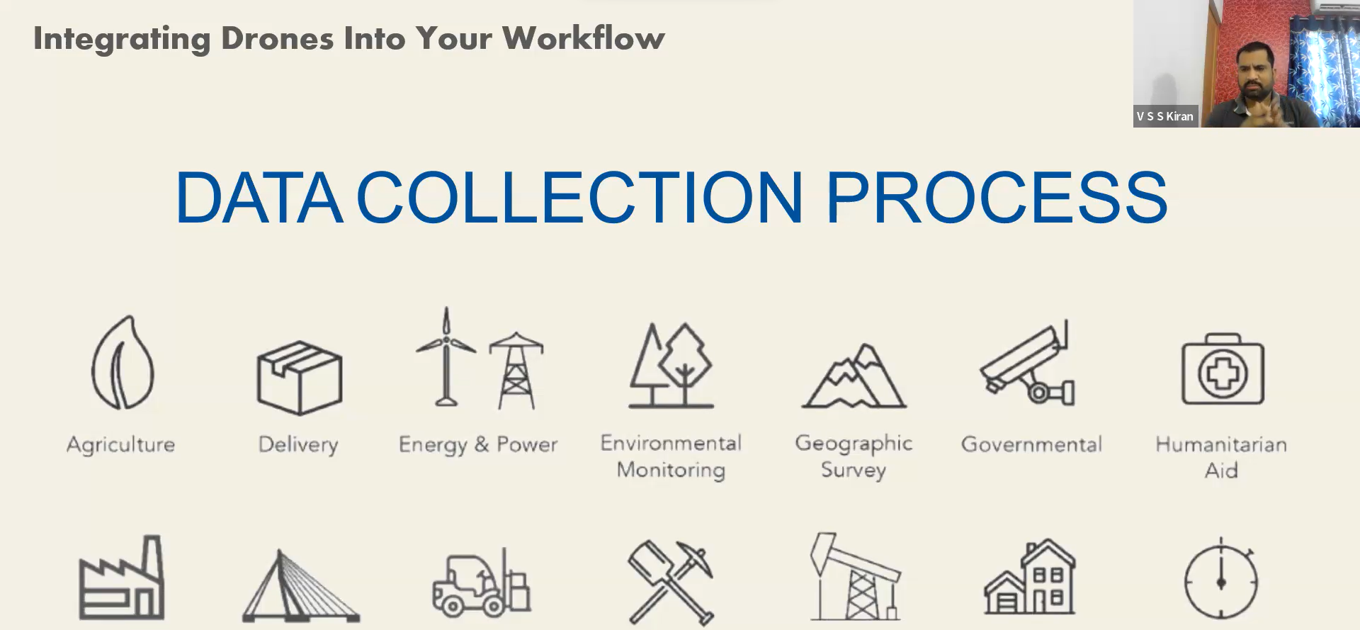

Dr. V S S Kiran, Garudalytics - Applications of Drones/UAVs in Smart cities

Mr. Shahrukh Wasay, Oracle 3D Data Management for Smart Cities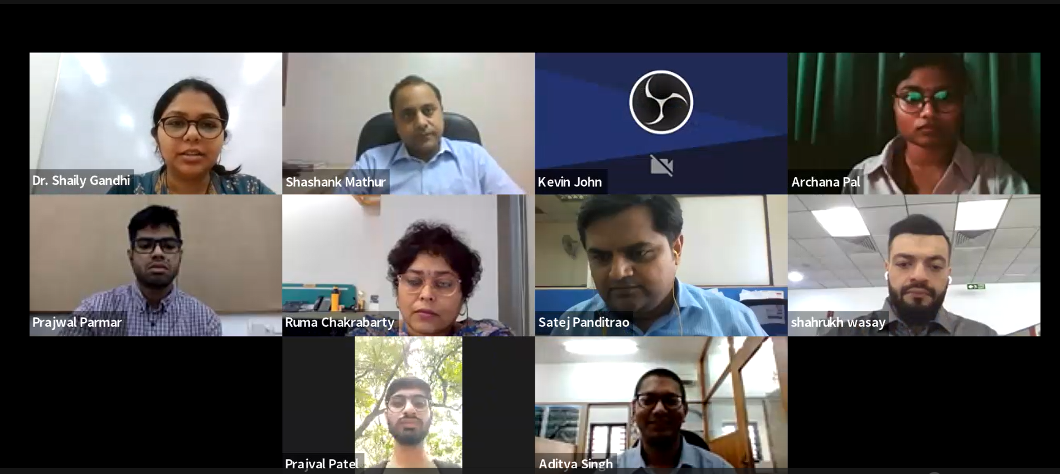

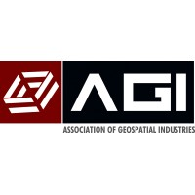

Speakers and Participants