**POSTER MAKING CONTEST ( ONLINE )**

The VCET-IEEE EMBS STUDENT BRANCH, Women in Engineering organized a Poster making contest under the theme "Women in Engineering" on 02. 07.2023 for the student's innovative ideas development through online mode. The enrollment was started on 29.07.2023. All the interested students were registered on time. All the students submitted their posters within the submission date of 02.07.2023.

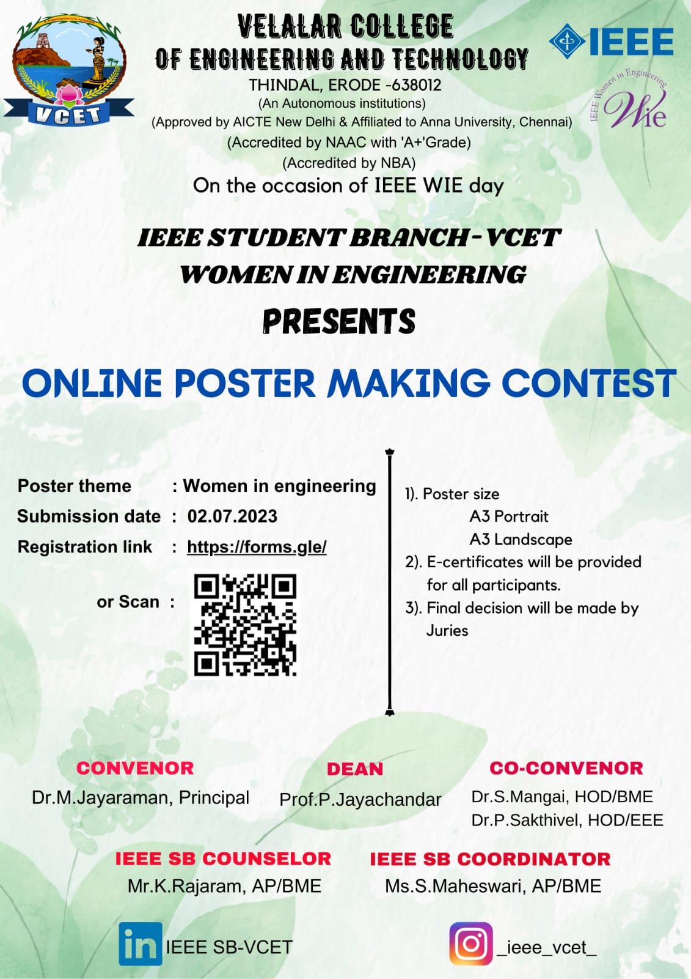

The final decision was made by juries after the submission. The first three places of this contest were announced by them . Nanmitha.M from 21IT4B has secured first place & Deepak Kumar. B from 21CSA secured second place in the poster-making contest conducted by IEEE -WIE cand the winners were congratuated. The e-certificate was provided for all the participants.

