

***IEEE IMS VIT Pune & TRY Engineering Android App Development Workshop***



*21st July 2023 09:00 AM*

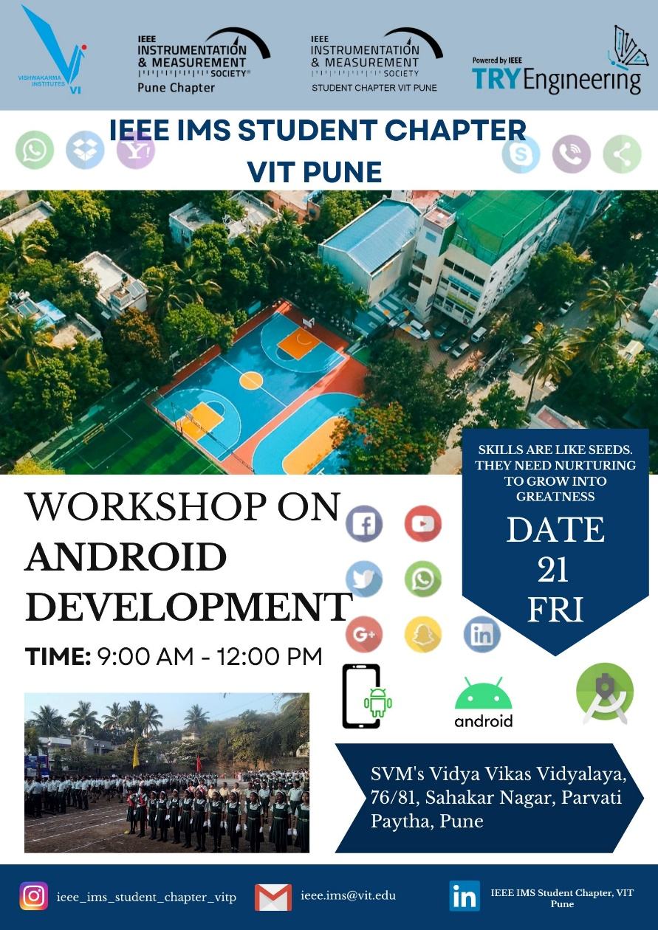***Overview***

The **IEEE IMS VIT Pune & TRY Engineering Android App Development Workshop** held on 21st July engaged 32 students and 7 volunteers. It began with an introduction by Neelema Patke ma’am, Principal (Vidya Vikas Vidyalaya) followed by informative sessions on the invention of the first telephone, Android basics, and types of apps. Hands-on practice in the computer lab included Android Studio installation and creating "Hello World" and Calculator Applications. The event concluded with a challenge to design a Stationery Application interface, leaving participants inspired and grateful to the organizers.

***Introduction***

On the auspicious day, the IEEE IMS Club in collaboration with TRY Engineering organized an exciting Android App Development Workshop at SVM’s Vidya Vikas Vidyalaya. The event witnessed an enthusiastic participation of 32 students, along with the support of 7 dedicated volunteers, including the Vice-Chancellor and the Secretary of the club.

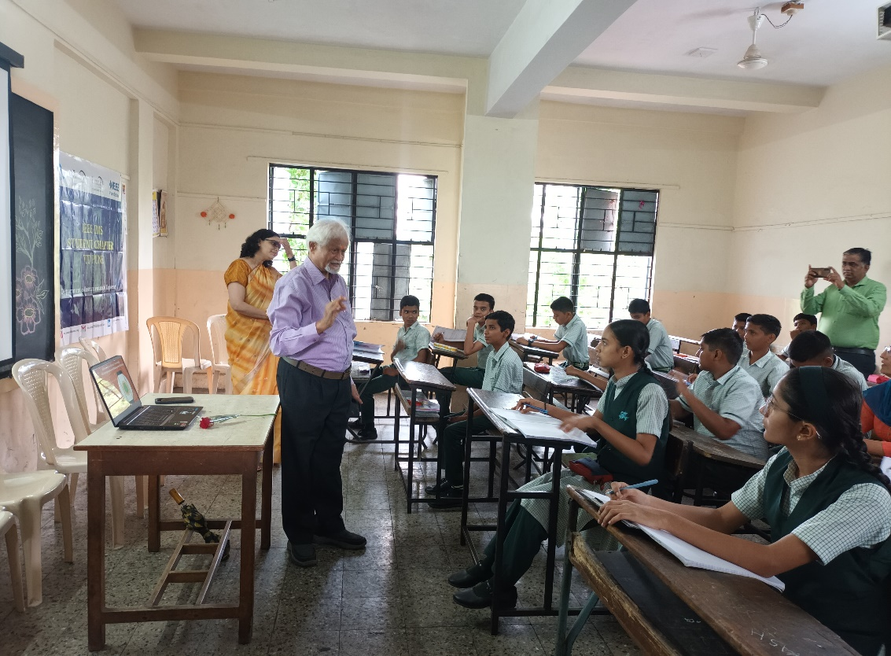The workshop commenced with an honorable introduction session where the attendees had the privilege of meeting the esteemed Principal of who graced the occasion with her presence. The Principal warmly welcomed everyone and expressed her enthusiasm for the innovative workshop.

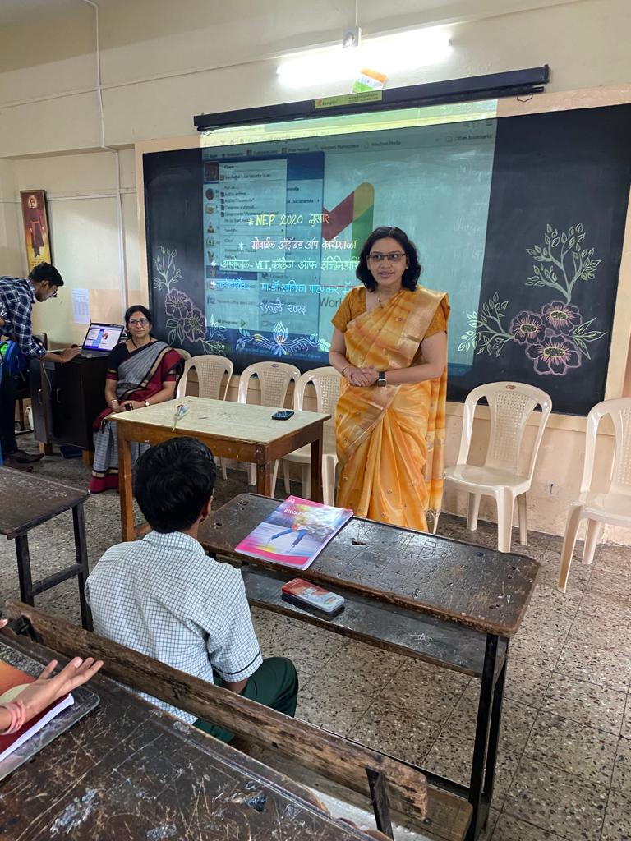The workshop's core speeches were delivered by two distinguished speakers - Prof. Khurjekar and Prof Dr. Sanika Patankar. Prof. Khurjekar took the stage first and captivated the audience with a captivating presentation on the invention of the first telephone. He shared valuable insights into the history of communication technology, which set the foundation for the day's Android App Development journey.

Following this enlightening historical perspective, Prof. Khurjekar dived straight into the basics of Android, enlightening the participants about the significance of mobile applications in today's world. He elaborated on the need for apps and their impact on various industries and daily life.

The session continued with an in-depth discussion on the different types of apps that are prevalent in the app market. From utility apps to gaming applications, the students gained a comprehensive understanding of the vast opportunities that the world of app development offers.

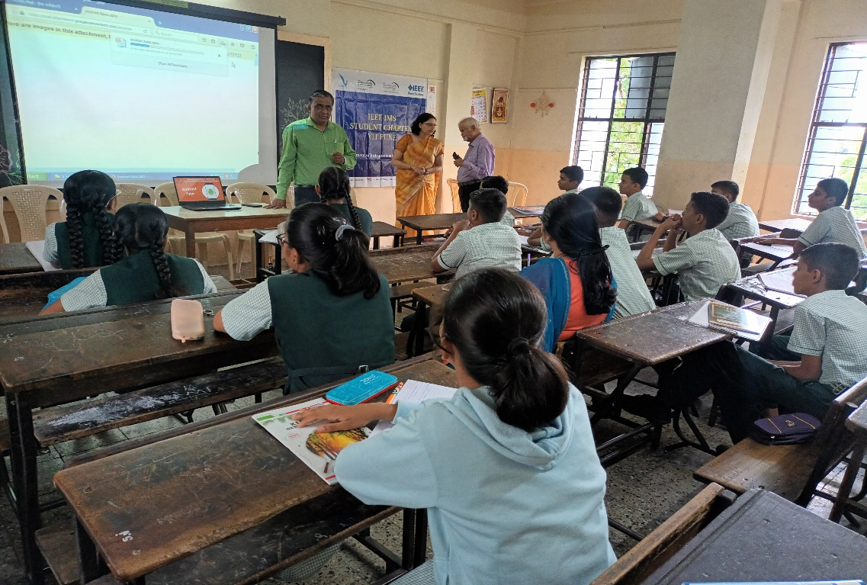In the later part of the workshop, participants were given a hands-on experience in the computer lab. The volunteers helped the students install Android Studio, the essential integrated development environment (IDE) for Android app development. The participants were then introduced to the interface of Android Studio, getting acquainted with the various tools and functionalities.

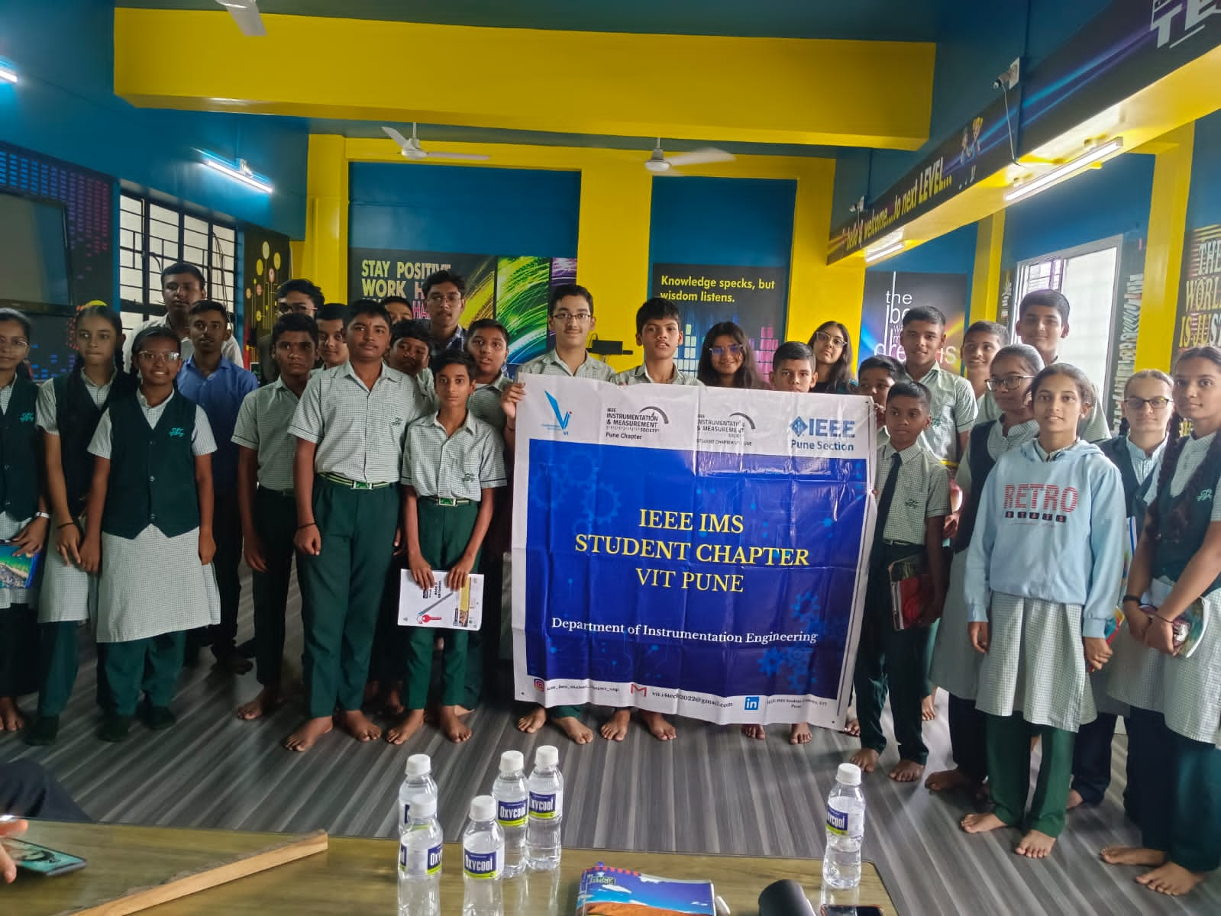***Hands on***

To provide a practical demonstration of the concepts covered, the workshop proceeded with the creation of a simple "Hello World" application, where the students successfully executed their first lines of code for Android development. Building on this foundation, they were guided through the development of a basic Calculator Application.

As the workshop drew to a close, Prof. Sanika, the second speaker, took the stage once again to recapitulate the essential topics covered throughout the day. Her engaging recap session reinforced the learning outcomes, ensuring that the students left the workshop with a solid understanding of Android app development.

The participants were then presented with an exciting challenge by the organizers. They were tasked to design a basic interface for a Stationery Application, encouraging them to put their freshly acquired skills into practice and fostering their creativity.

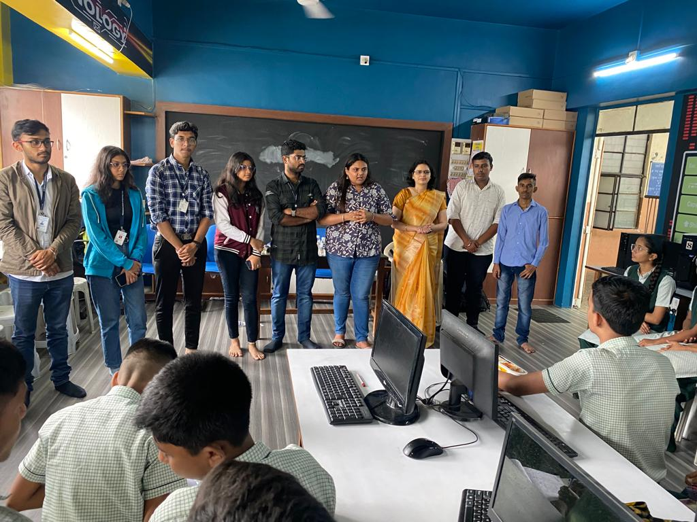***Conclusion***

The event concluded with a heartfelt vote of thanks from the staff and organizers. The students expressed their gratitude to the IEEE IMS Club and TRY ENGINEERING for arranging such an enlightening workshop that not only provided valuable insights into Android app development but also served as a platform for practical learning and exploration.

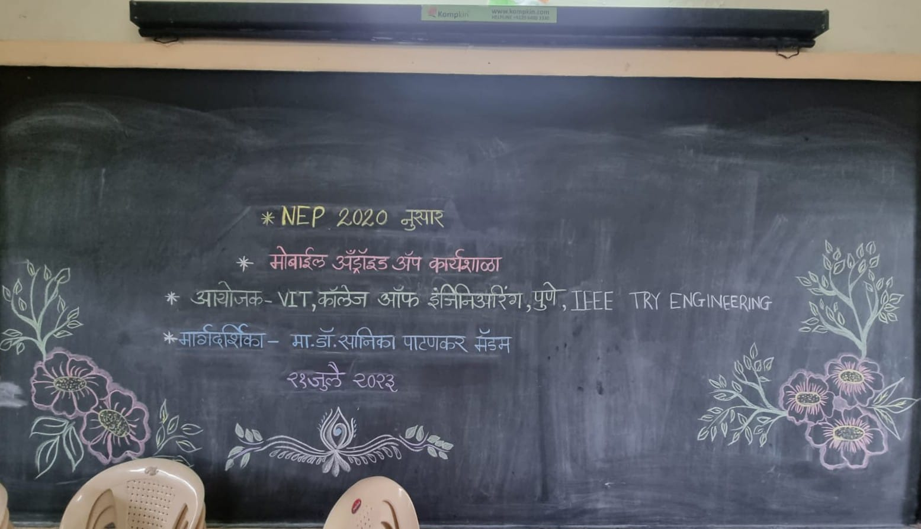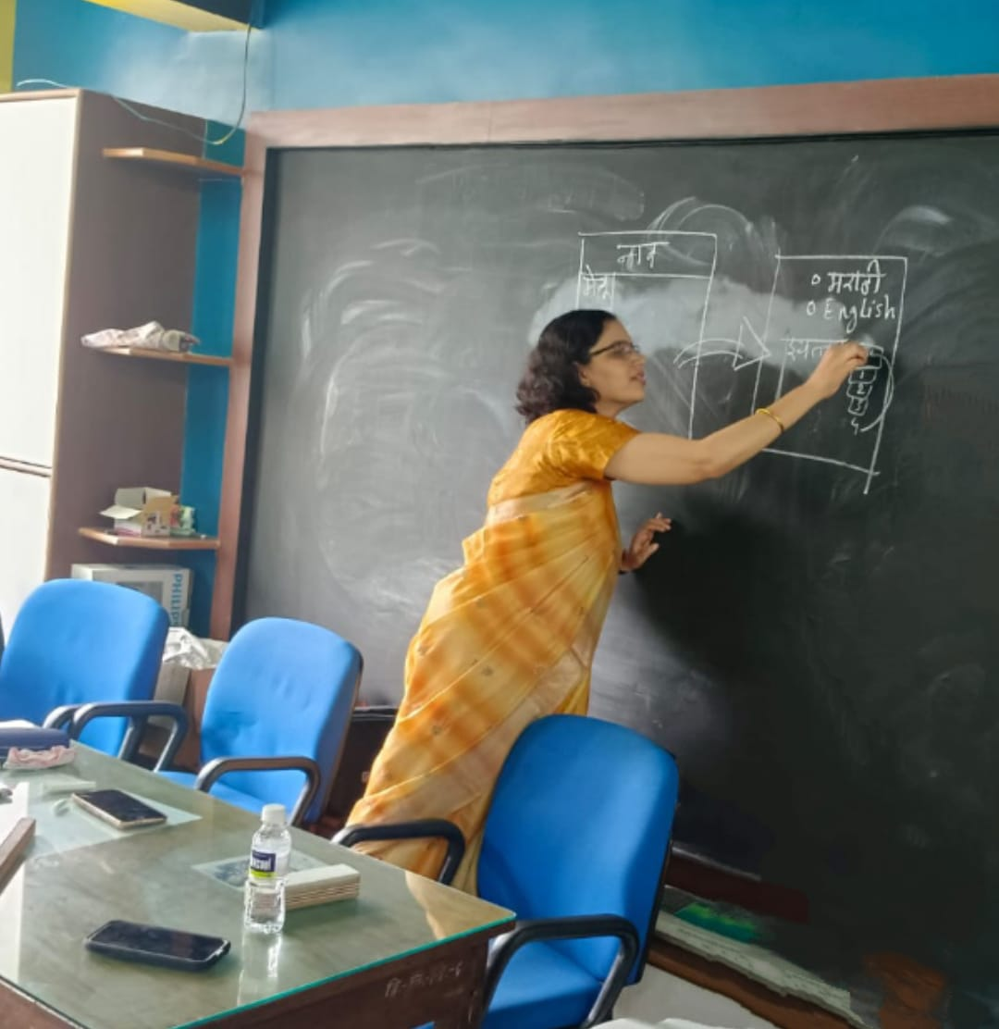

The "IEEE IMS VIT Pune & TRY ENGINEERING presents Android App Development Workshop" was undoubtedly a resounding success, leaving the participants inspired and eager to continue their journey into the dynamic world of mobile app development.

***Attendees List***:

1. सूर्या थोपटे
2. अनिरुद्ध घुगे
3. यश क्षिरसागर
4. अश्विन आगाशे
5. स्वराज पवार
6. सुविरा वैद्य
7. राधिका फाळके
8. सिद्धी डिंबळे
9. तनुजा लाड
10. आनंदी घोडेकर
11. साई अनारसे
12. शुभम आवचार
13. मेघा कांबळे
14. प्रणवी पवार
15. प्रताप शेंडकर
16. भूषण ओतारी
17. सार्थक नाईक
18. संचित घाणेकर
19. स्वराज गोळे
20. श्रेया मसवेकर
21. धनश्री कांबळे
22. चेतना शेंडे
23. कशीश चौधरी
24. प्रगती लोंढे
25. प्रणव हिवरकर
26. मयूर गुजर
27. अनिकेत जवळकर
28. जान्हवी धारणे
29. अनुष्का पवार
30. सार्थक नेवासकर
31. प्रणम्य सोनवतीकर
32. वैष्णवी बाराहते

***Volunteers List:***

1. Pankaj Kamble
2. Arundhati Giri
3. Piyush Chinchore
4. Mrunal Narwane
5. Pranav Shelke
6. Bhagyashri Joshi
7. Samarth Bhalake
8. Shaunak Yevatekar