**Report on Try Engineering Event on Aerospace Engineering conducted on 25/07/2023.**

IEEE-AESS Pune section organised an event on IEEE Try Engineering at the Department of Aerospace Engineering of MIT School of Engineering and Science, Pune on 25th July, 2023 from 1:30 pm - 3.00pm in the Aerodynamics and Propulsion Lab of the department. In the event 58 students along with their teachers (6 nos.) from two different school participated and attended the lessons delivered during the event. Out of the 58 students, 21 students were from MIT Gurukul School, Loni Kalbhor and 37 students were from MIT School, Kothrud. The theme of the event was to explain the students in local language (Marathi).

The event started with a welcome speech to the participants by Dr Amar Buchade, IEEE Vice-Chair, Pune section. He briefed the students about IEEE, its evolution and also about AESS and Try Engineering. All the communication was done in Marathi language. Followed by the speech of vice-chair, the content of the event was briefed by Dr. Devabrata Sahoo, Chair, AESS-IEEE, Pune Section. Further the lessons were imparted to the students in Marathi. Three lessons covered during the event as follows:

1. Hands-on in Wind Tunnel Testing
2. Working of a Jet Engine
3. Demonstration of Amateur Solid Rocket Propellant Firing

The students were given a demo of each of the lessons on the respective lab equipment. The Try Engineering Pune Section co-ordinator Dr. M J Khurjekar also visited the Aerospace Engineering Lab where the lessons were conducted.

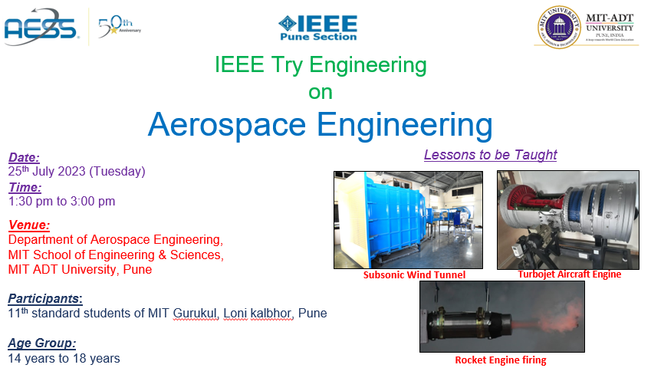The flyer of the event and photographs covered in the event are attached herewith. Furthermore, the video clips and the lesson plan (English as well as Marathi version) of the event are uploaded in the vtool.

***Event Flyer***

***Event Photographs:***

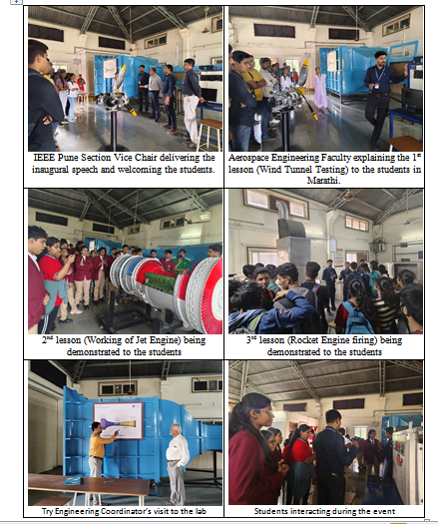

Prepared by, Submitted by,

Prof. Dinesh Kumar Bajaj, Prof. Dr. Devabrata Sahoo,

Treasurer IEEE AESS Chair IEEE AESS,

Pune Section Pune Section