**Report on Webinar by Mr. Adwait Karvirkar held on 22/07/2023.**

**Topic: Exploring India's role in global Space Industry: opportunities and challenges.**

IEEE-AESS Pune section organised the webinar at the Department of Aerospace Engineering of MIT School of Engineering and Science, Pune to Third Year and Final Year B. Tech Aerospace Engineering students on 22nd July, 2023 from 03.00pm -04.20pm in the Cisco WebEx platform.

Mr. Adwait Karvirkar is an experienced engineer with post-graduation education of Astronautics/Aerospace and graduate degree in Mechanical. Expertise in manufacturing and designing satellite, rockets and ballistic missiles. He is am amateur Aeromodeller and love to fly.

Currently working with CTO team (TRDDC) for space technology. His skills includes Generative AI · Prompt Engineering · GPT-4 · Market Analysis · Market Research · Business Strategy · Business Development · Business Analysis · New Business Development · Manual Testing · Advanced Astronautics · Spacecraft Propulsion · Spacecraft Systems Engineering · Spacecraft Structural Engineering · Spacecraft Instruments · Spacecraft Orbital Mechanics ·

67 B. Tech Aerospace Engineering students attended the lecture. The guest lecture was mainly focused understanding the about the Exploring India's role in global Space Industry: opportunities and challenges and recent trends in Aerospace industry. The Guest lecture concluded at 04.20pm and students were thankful to the Guest, Director, Dean-MIT SOES, Head-Aerospace Engineering, and Co-ordinator of the Guest Lecture. The coordinator thanked the guest Mr. Adwait Karvirkar for accepting the Invitation & delivering the lecture. The co-ordinator is thankful to the Guest and HoD-Aerospace Engineering for making this Guest Lecture possible.

The Photographs of the Guest Lecture are attached herewith.

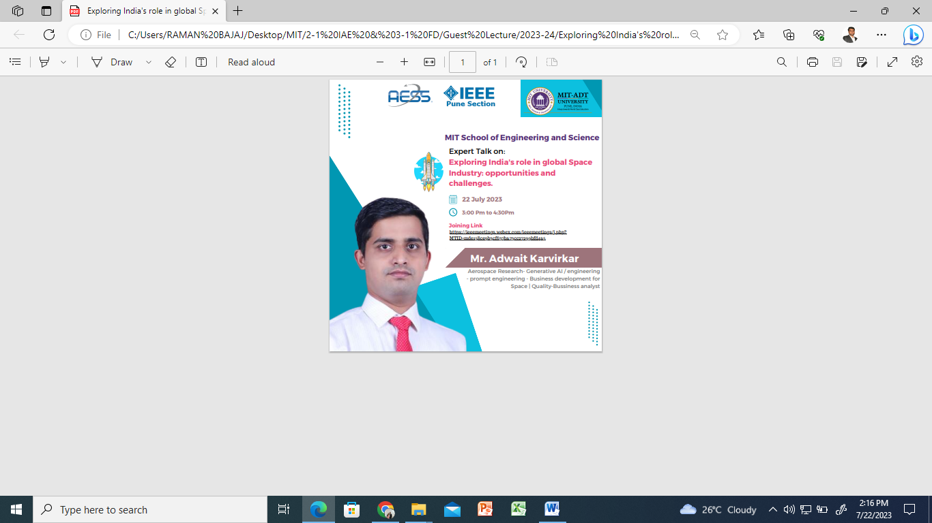

|  |  |
| --- | --- |
|  |  |
|  |  |
|  |  |
|  |  |
|  |  |
|  |  |
|  |  |
|  |  |

**Out comes:** Students are able understand about the Exploring India's role in global Space Industry: opportunities and challenges. Students were able to interact with the expert during Question- Answer Session.

Prepared by, Submitted by

Prof. Dinesh Kumar Bajaj, Prof. Dr. Devabrata Sahoo,

Treasurer IEEE AESS Chair IEEE AESS,

Pune Section Pune Section