**Report on Webinar by Mr. Joel Fernandes held on 20/07/2023.**

**Topic: Metal Injection Moulding (MIM) - Emerging Advanced Manufacturing Technology: Advantages and Applications**

IEEE-AESS Pune section organised the webinar at the Department of Aerospace Engineering of MIT School of Engineering and Science, Pune to Third Year and Final Year B. Tech Aerospace Engineering students on 20th July, 2023 from 03.00pm -04.20pm in the Microsoft Teams platform.

**Mr. Joel Fernandes is working as a Group Leader** in Sales and Marketing with a demonstrated history of working in the mechanical engineering industry. Skilled in Engineering, Strategic Planning, Customer Service and an expert in Six Sigma. He has completed his Bachelor of Engineering (B.E.) in Mechanical Engineering from St Joseph Engineering College Mangalore. He has more than 9 years of experience in MIM Technology. His roles and responsibilities include:

1. Account management of existing customers for South India, Japan, and Czech Republic

2. Business development activities to add new customers with requirements for MIM applications for the same regions.

3. Manage Exhibitions of all segments for Asia pacific.

4. Host webinars/ Seminars to educate about the advantages and applications of MIM technology.

57 B. Tech Aerospace Engineering students attended the lecture. The guest lecture was mainly focused understanding the about the Metal Injection Moulding (MIM) - Emerging Advanced Manufacturing Technology: Advantages and Applications evolution and recent trends in Aerospace industry. The Guest lecture concluded at 04.20pm and students were thankful to the Guest, Director, Dean-MIT SOES, Head-Aerospace Engineering, and Co-ordinator of the Guest Lecture. The coordinator thanked the guest Mr. Joel Fernandes for accepting the Invitation & delivering the lecture. The co-ordinator is thankful to the Guest and HoD-Aerospace Engineering for making this Guest Lecture possible.

The Photographs of the Guest Lecture are attached herewith.

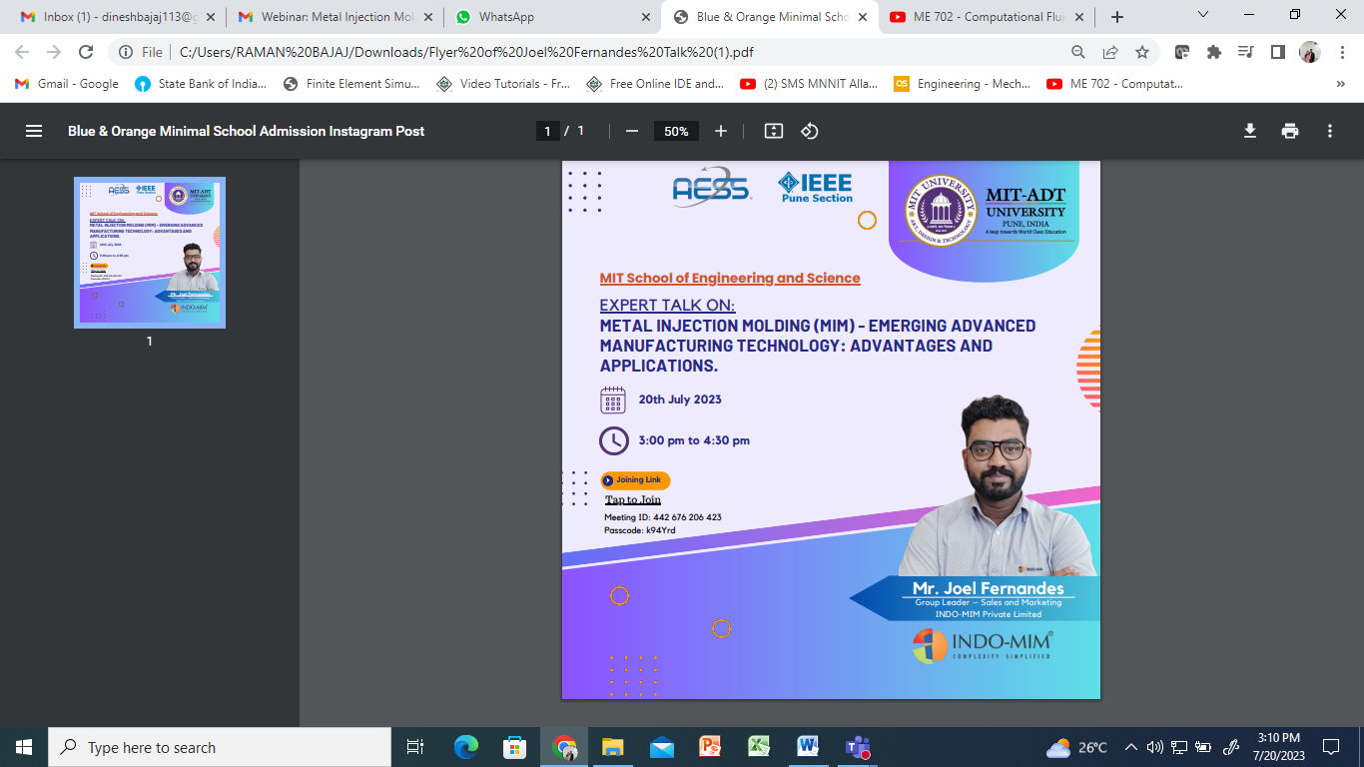

|  |  |
| --- | --- |
|  |  |
|  |  |
|  |  |
|  |  |
|  |  |
|  |  |
|  |  |

**Out comes:** Students are able understand about the Metal Injection Moulding (MIM) - Emerging Advanced Manufacturing Technology and different materials used in MIM: Applications evolution and recent trends, MIM Design Tolerances, MIM Part Features, Design Thinking and Case Studies. Students were able to interact with the expert during Question- Answer Session.

Prepared by, Submitted to,

Prof. Dinesh Kumar Bajaj, Prof. Dr. Devabrata Sahoo,

Treasurer IEEE AESS Chair IEEE AESS,

Pune Section Pune Section