MANGALYAAN: The Space Cart To MARS

India’s First Mars Orbiter Mission (MOM)

Conducted on: 11.08.2023 | 1700 hrs IST

National Remote Sensing Day on the 12th of August 2023 commemorating the birth anniversary of Dr. Vikram Sarabhai, Father of the Indian Space Program.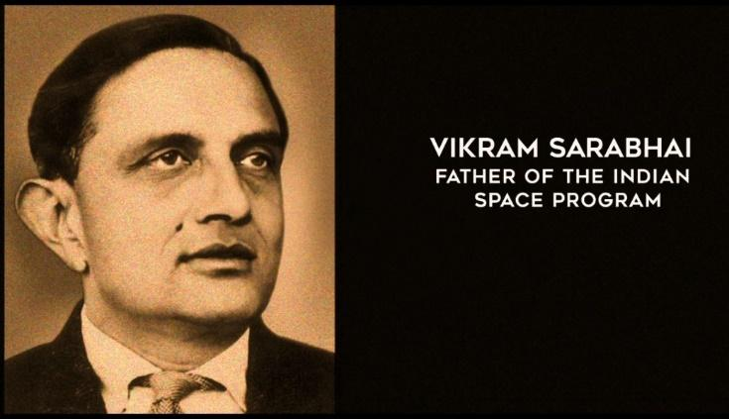

On this occasion, the M.Tech (Geomatics) Programme, Faculty of Technology at CEPT University, IEEE CEPT University Student branch, GRSS CEPT University Student chapter, and the Indian Society of Remote Sensing - Ahmedabad Chapter (ISRS – AC), jointly hosted the event of **MANGALYAAN: The Space Cart To MARS India’s First Mars Orbiter Mission (MOM)** on 11th August, 2023.

The Chief Guest for the event was Smt. Sampa Roy, a celebrated scientist and engineer who worked on the Mars Orbiter Mission project.

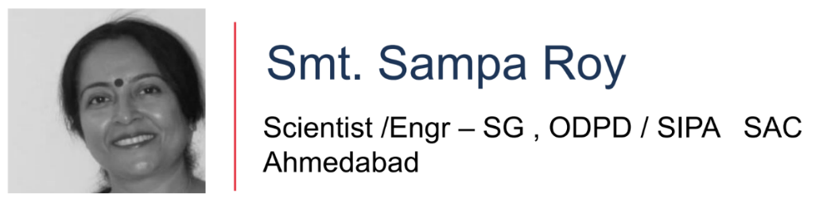

The participants in this event were from various domains and were able to connect with us through both in-person as well as virtual presence. The participants included the students of the CEPT University Geomatics program, CRDF, CAG, L. J. University, and many more fields.

Mars Orbiter Mission (MOM), also known as Mangalyaan, India's first interplanetary mission to planet Mars was launched on board PSLV-C25 on November 05, 2013. The objectives of this mission were primarily technological and included the design, realization, and launch of a Mars Orbiter spacecraft capable of operating with sufficient autonomy during the journey phase; Mars orbit insertion/capture, and in-orbit phase around Mars.

MOM carried five scientific payloads to study the Martian surface features, morphology, mineralogy, and the Martian atmosphere.

The proposed talk strives to present the technology behind this cost-effective mission, ever made in the world.

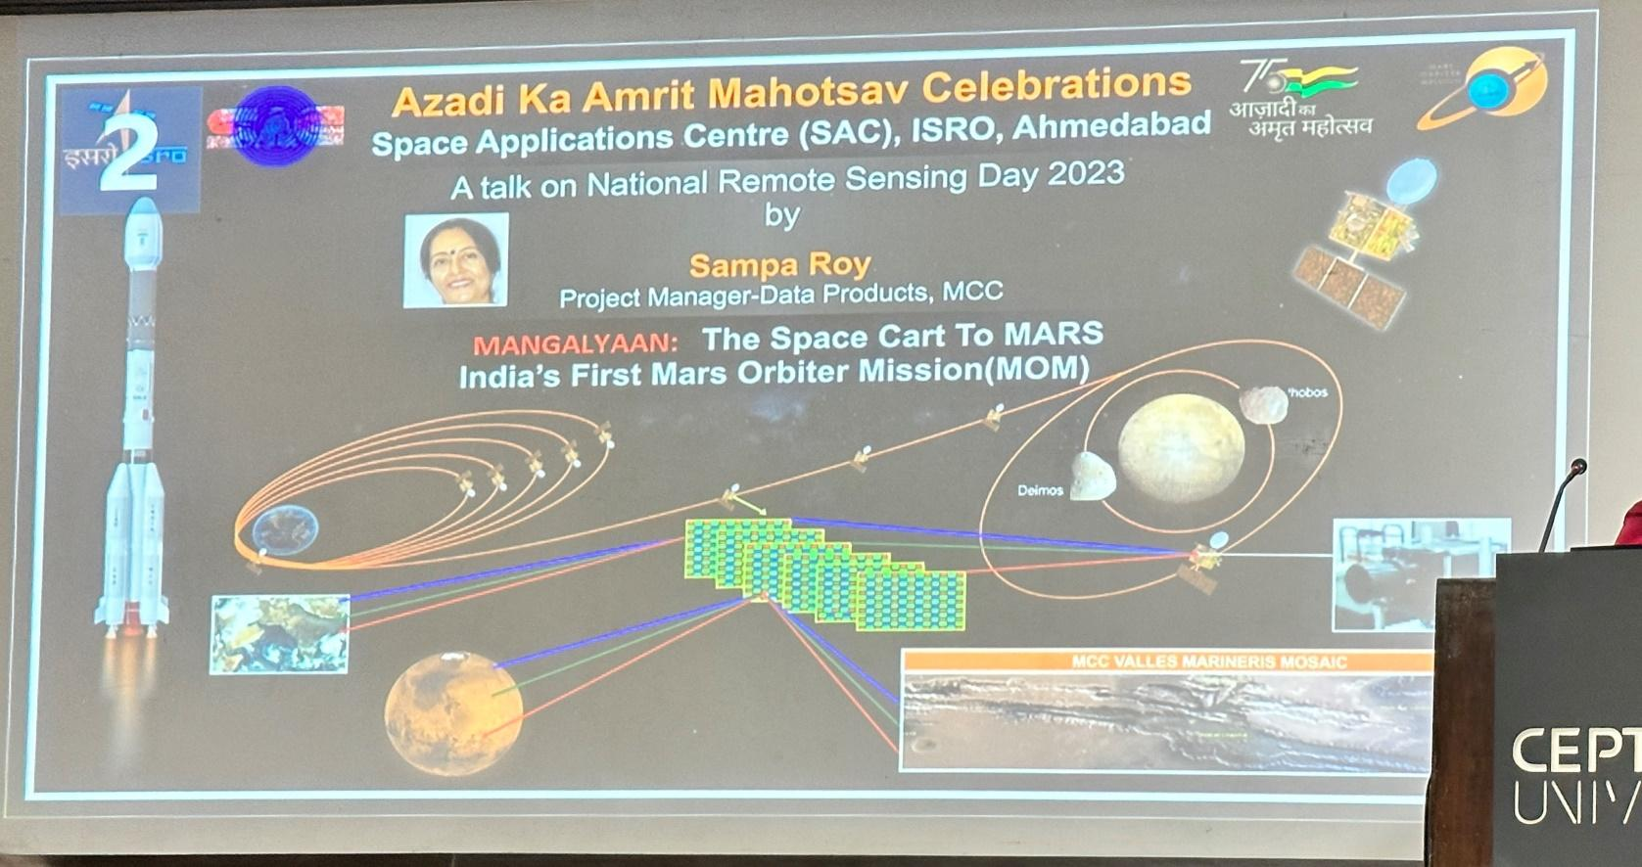

This event purely focused on the technical aspects, objectives, challenges, achievements, phases of the mission, and payloads that had all the instruments and sensors that were on the Mars Orbiter Mission: Mangalyaan.

The information and knowledge gained from this event helped us understand the abilities and varied applications of the instruments and sensors on the Mangalyaan for gathering information about the Martian Surface and atmosphere. It also helped us gain a broader aspect of how the usage of all the instruments and sensors and their applications with the datasets acquired.

We were also able to understand how the datasets help us to obtain a visualization from the same.

In conclusion, we saw how the visualization of the Martian Terrain using the Mars Colour Camera (MCC) Datasets helped distinguish between craters, valleys, and gorges on the Martian surface.

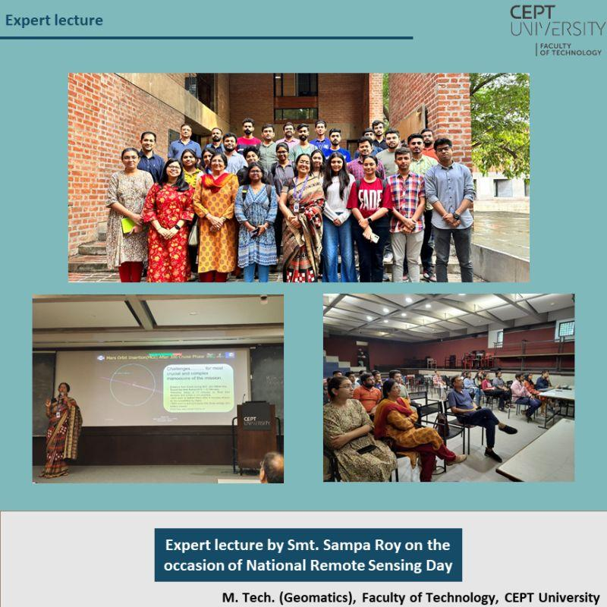

Event Type: Hybrid

Total Participants: Offline - 30, Online - 22

Venue : Kasturbhai Lalbhai Campus, University Rd, Navrangpura, Ahmedabad, Gujarat 380009

