**Event #2:**

**Signal Processing Society EVENT: 02**

**Event Name:** lectures on

**Session 1**: Tools and Techniques for Research Paper Writing and Where to Publish.

**Session 2**: Pedagogical Process for Identifying and Dealing with Complex Engineering Problems

**Date:** 12th August, 2023

**Time:** 10.30 AM to 12.30 PM

**Organized by:** IEEE SPS Hyderabad Section and IEEE EDS Hyderabad Section

**Venue:** Research and Training Unit for Navigational Electronics **(**NERTU), Osmania University, Hyderabad

**Overview:**

IEEE SPS Hyderabad Section and IEEE EDS Hyderabad Section organized lectures on “Tools and Techniques for Research Paper Writing and Where to Publish and Pedagogical Process for Identifying and Dealing with Complex Engineering Problems” supported by VNRVJIET SPS SB Chapter, MECS SPS SB Chapter & CBIT SPS SB Chapter on 12th August, 2023 at 10.30AM – 12.30PM for IEEE and Non-IEEE members of Hyderabad.

The speaker Dr. Abhishek Appaji is working as R&D Head and Associate Professor at B.M.S. College of Engineering, Bengaluru. He is also serving as Guest faculty at Maastricht University, the Netherlands. He is a graduate of the Massachusetts Institute of Technology Global Entrepreneurship Bootcamp specializing in new ventures leadership. He obtained his Bachelor of Engineering in Medical Electronics with University Rank from BMSCE, Masters of Technology in Information Technology, and a Masters of Engineering (M.E) in Bioinformatics from University Visvesvaraya College of Engineering, Bengaluru. His Ph.D. was in Mental Health and Neurosciences from Maastricht University, the Netherlands which received the best thesis award. Abhishek is a Senior Member of IEEE. He has served in various volunteering positions at IEEE. Currently, he is the Treasurer of the IEEE Bangalore Section, Vice Chair, IEEE SPS Bangalore Chapter, Treasurer of the IEEE Computer Society Bangalore Chapter, execom member of IEEE PES Bangalore Chapter and member of committees in R10 and IEEE SPS (PROGRESS/Diversity Committee, Associate Editor of Newsletter Magazine, Recruitment/retention committee). Abhishek has received various grants from Indian agencies like DST, DBT, BIRAC, and from abroad. Abhishek has also worked as a research associate at the Centre for Nanoscience and Engineering (CeNSE), Indian Institute of Science (IISc), Bengaluru. He has two patents filed in Medtech Space. He has more than 50 International/National journal publications and conferences to his credit. He has been a part of more than 150+ Invited expert talks at various conferences, forums, and events. He has renowned laurels including IEEE International Best Paper Award in Malaysia, MGH CamTech Jugadathon Awards, Best Nodal Coordinator award, Gandhian Young Technological Innovation Award 2016 at Rastrapathy Bhavan (President of India House) New Delhi, Elderly care Hackathon (the Netherlands), Winner of Class 5 Massachusetts Institute of Technology (MIT) Global Entrepreneurship Boot camp, IEEE MGA Young Professional Achievement Award, R10 YP achievement award, DST Inspire Award, etc.

Tools and Techniques for Research paper writing and where to Publish

Often researchers have difficulty in drafting good technical papers and identifying appropriate journals to publish their research paper. This talk gave an overview of the contents of a technical paper and requires tools and techniques to write paper more easily so that it gets published in a good journal. At the end of the talk and demo, attendees were able to identify appropriate journals to publish and also differentiate between predatory and good referred journals to publish their research. The talk covered the following:

1. Anatomy of the manuscript.

2. Identifying SCIE/Wos and Scopus journals and avoiding predatory journals

3. Demo of tools for research

4. Journal and researcher metrics tools for profile building

The speaker has delivered the tools and techniques used for research paper writing in session1. In this paper writing, start from the title selection, abstract, keywords, introduction, methodology, importance of result and discussion, references. The speaker gave various examples of papers from scopus and web of science journals. Next, he explains where this paper will be published in Scopus/ Web of science journals. He gave a brief about Q1,Q2,Q3 and Q4 ranking’s in scopus and JIF(Journal Impact Factor). He gave various sites that are used in journal finding like wiley and springer. The speaker also requested the audience to get an ORIC**ID** and a very useful ID that will be the future reference for a researcher.

Session2 discusses the selected complex engineering. In this session, the speaker has explained with some practical examples for formation of complex engineering problems.

Most of the Graduate attributes and program outcomes defined by the National Board of Accreditation deals with Complex Engineering Problems. Often the faculty members in engineering education find difficulty in dealing with the process of deriving complex engineering problems and also measuring the outcomes based on the complex engineering problems. This session deals with various teaching techniques and assessment processes for the Complex Engineering Problems. It also gives some of the examples and case studies on how to frame and assess complex engineering problems. It also provides some resources and references to understand and implement techniques related to complex Engineering Problems.

**Achievements and Values:**

**Support from Section:** Yes

**Number of participants:** 22

**IEEE Members-**15

**Non- IEEE Members-**09

**Collaboration with student Branch:** VNRVJIET SPS SB Chapter, MECS SPS SB Chapter & CBIT SPS SB Chapter

**Any other information:**

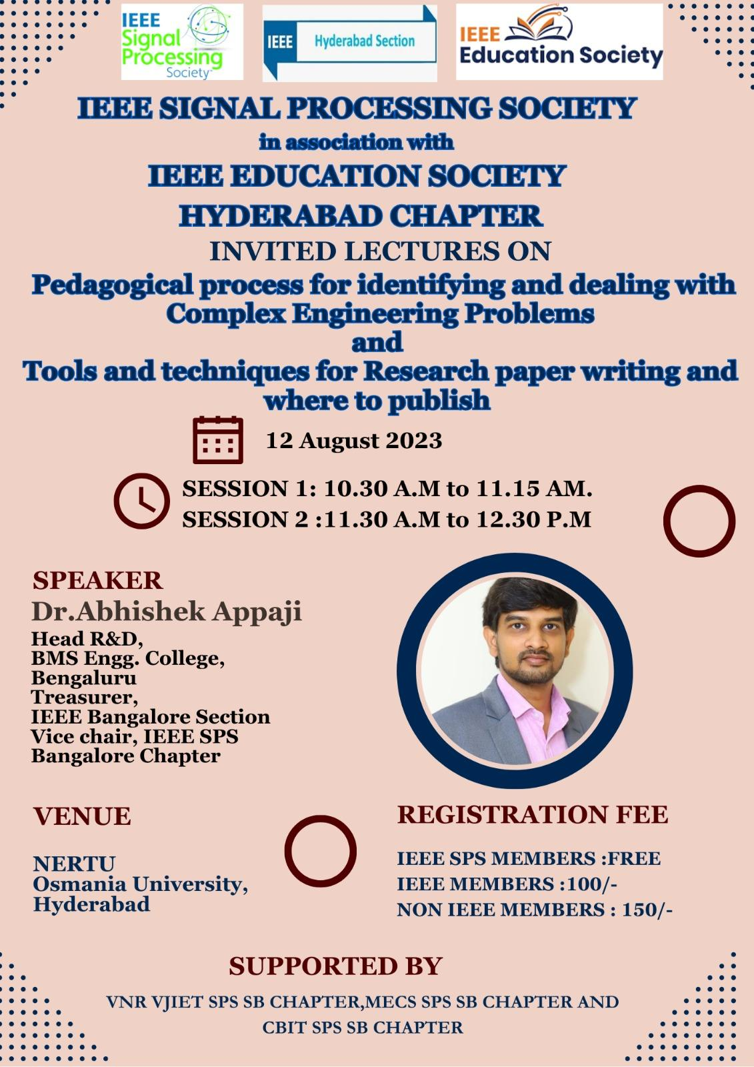

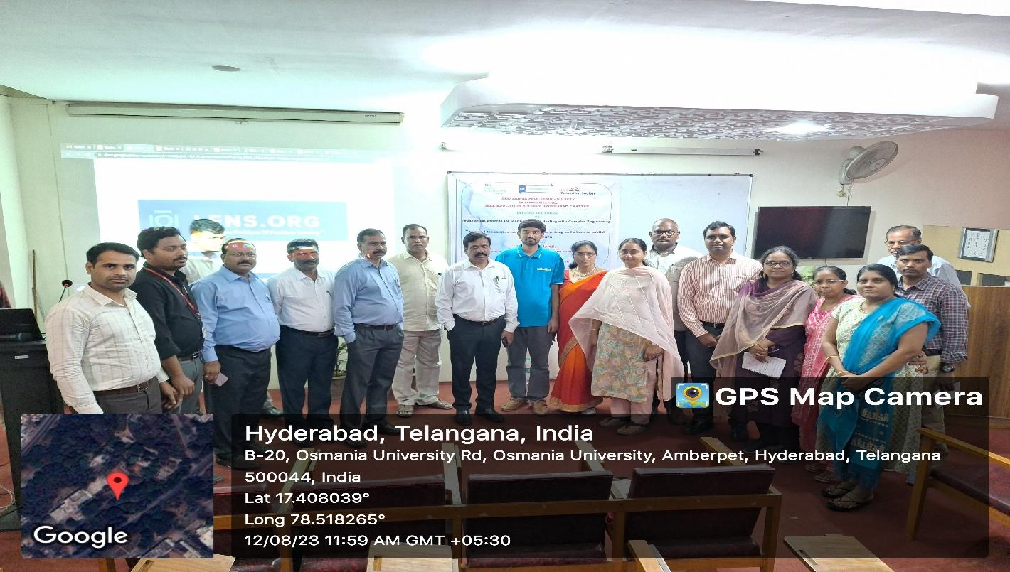

Chief guest Prof. D. Ravinder, Vice chancellor, OU and the Guest of Honors, Prof.P.Lakshmi Narayana, registrar, OU, Prof Sriram venkatesh, Principal, UCE, OU, Dr. Abhishek Appaji, Speaker, Prof.P.Lakshmi Narayana, Chair, IEEE SPS Hyderabad Section, Dr.Yarlagadda.Padma Sai, Vice Chair, IEEE SPS Hyderabad Section, Mrs T. Sandhya, Secretary, IEEE EdSoc Hyderabad Section, Dr. I. Sharath Chandra, Treasurer, IEEE SPS Hyderabad Section, Dr T. Aravinda Babu, Member, IEEE SPS Hyderabad Section.

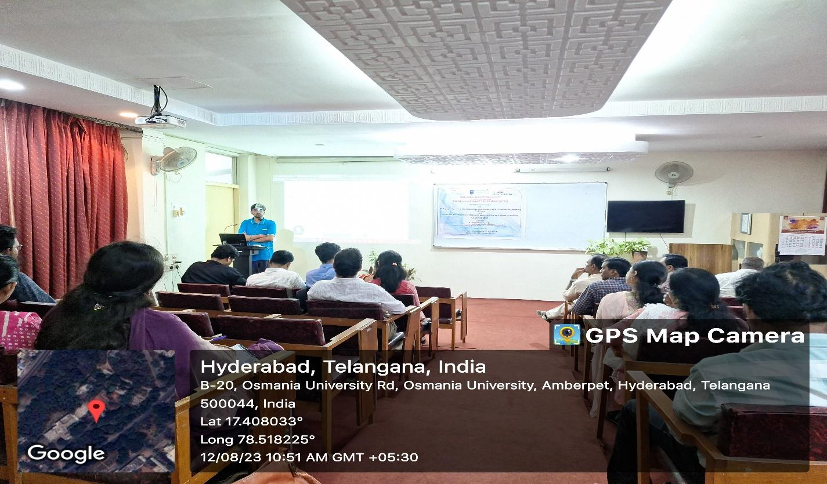

Resource Person, Dr. Abhishek Appaji, delivering the lecture to audience

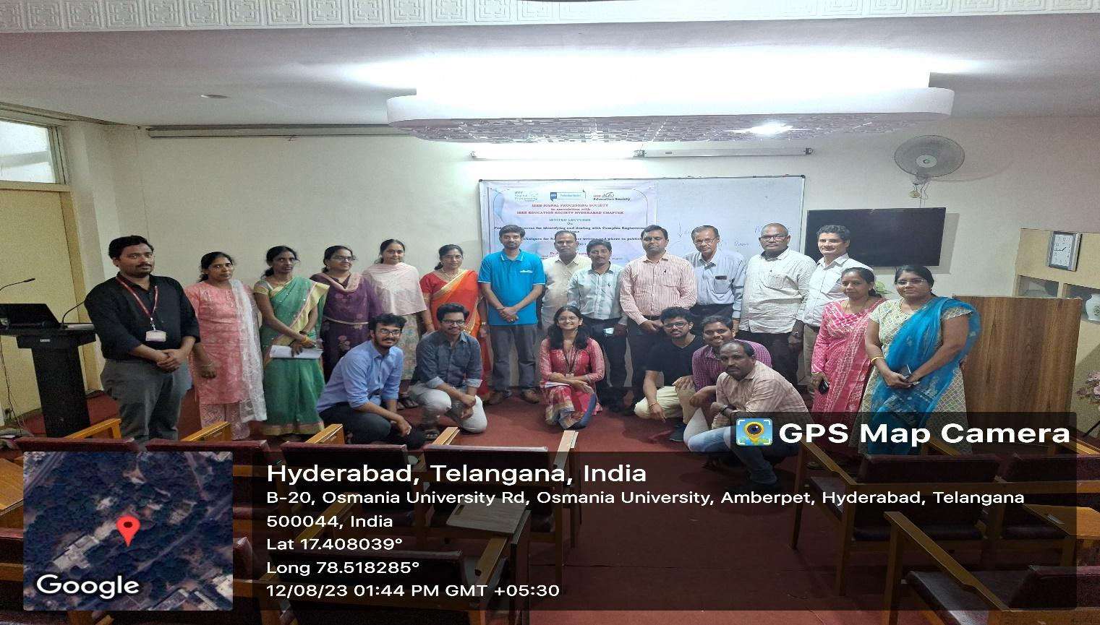

Dr. Abhishek Appaji, resource person, IEEE SPS Execom team with participants

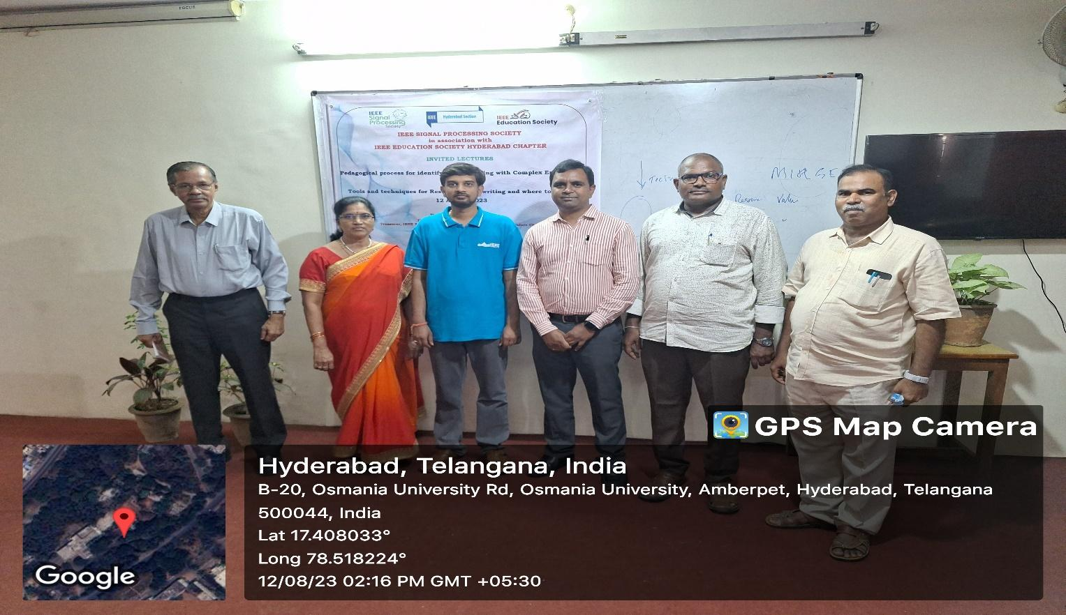

Dr. Abhishek Appaji, resource person, K. Chakrabarti, Former Director, DLRL with IEEE SPS Execom members