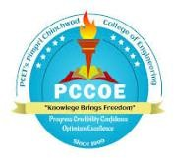 | Pimpri Chinchwad Education Trust’s  Pimpri Chinchwad College of Engineering  Department of Electronics and Telecommunication | 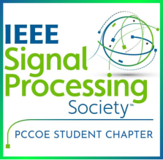
Workshop on ‘Industrial Fault Indication System with SMS alert’

Name of the Event: Workshop on ‘Industrial Fault Indication System with SMS alert’ using 8051 microcontrollers.

Date: 23rd August to 25th August 2023

Schedule:
DATE | First half (9am-1pm) | Second half (2pm-5pm)
23|8|23 | What is microcontroller? | LED and switch interfacing
24|8|23 | LCD interfacing | GSM interfacing
25|8|23 | UART and EEPROM | Final project

Venue: Computer centre, Mechanical building, PCCOE

About the Event:
A workshop on the topic ‘Industrial Fault Indication System with SMS alert using 8051 microcontrollers’ was conducted by IEEE SPS, PCCOE in association with Team Vector, India. The speakers for the session were Chandramouli sir and Prasad sir. In all 76 participants from second and third year of EnTC department participated in this workshop. The workshop aimed at developing an Industrial Fault indication system project by dividing it into smaller tasks which were completed during the 3 days.
Day 1:
In the first half, following points were discussed:
- Introduction to microcontrollers in general and their need in everyday lives.
- 8051 microcontrollers and its specifications.
The second half included:
- Introduction to interfacing of different electrical components with microcontroller.
- Use of Keil software to execute the programs and FlashMagic software to load programs in the microcontroller.
- Practical implementation of interfacing of LEDs and switch with the microcontroller.
Hence, in the first day students could interface basic electrical devices like LED and switch with the 8051 microcontrollers.
Day 2:
First half included:
- Theoretical aspects like pins of LCD and commands associated with it.
- LCD interfacing with 8051 microcontrollers. Students displayed a few characters on the LCD.
Second-half included:
- GSM module interfacing
- Commands to send and receive messages and calls.
Hence, in the second day students were able to send and read data from LCD and also send and receive messages using GSM module.
Day 3:
First half included:
- Understanding the concepts related to UART, UART interrupts and use of EEPROM.
- Interfacing sensors to detect smoke and temperature individually.
Second half included:
- Final project
- Detect smoke which was tested by using incense sticks. Temperature sensor to measure temperature.
- Send an alert message to the user’s mobile phone once the temperature rose above the set point.
Hence, students were demonstrated the use of all the electronic components they studied in the previous days to build a complete project. The project interfaced all the components like LCD, smoke and temperature sensors and gsm module.
At the end Dr. Varsha Harpale thanked the speakers for their presence.
In all, students had a hands-on experience about interfacing of different electrical devices with the 8051 microcontrollers to develop a real-life project.
Faculty Co-ordinators: Dr. Varsha Harpale, Mrs. Archana Bhamre.
IEEE Co-ordinator: Mrs. Ashwini Shinde
Student Co-ordinators: IEEE SPS members.

Glimpses of the Event:

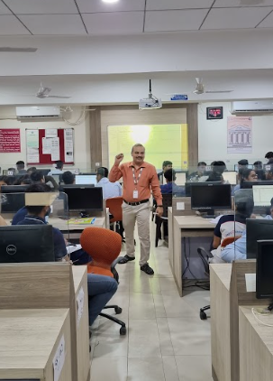 | 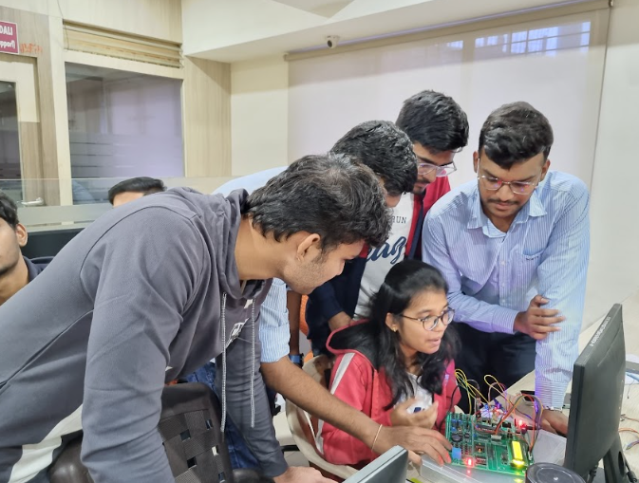
Speaker Mr. Chandramouli | Students performing on the hardware
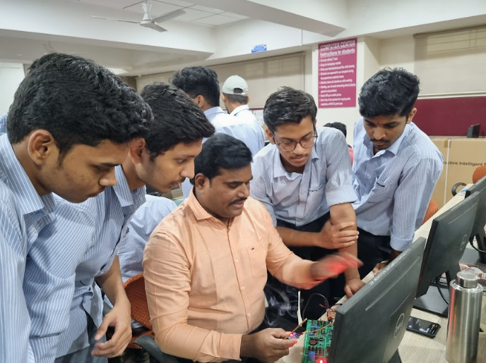 | 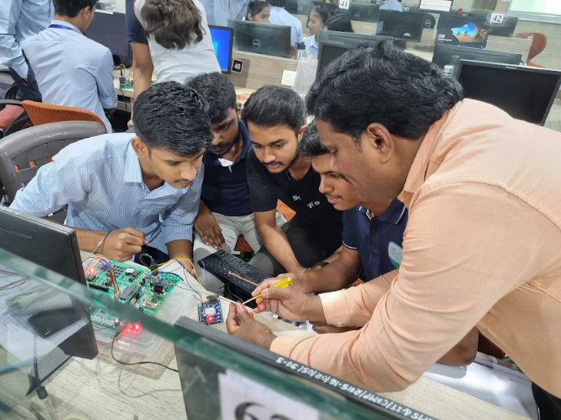
Mr. Prasad demonstrating students | Mr. Prasad demonstrating students
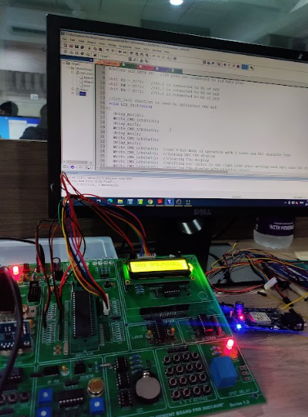 | 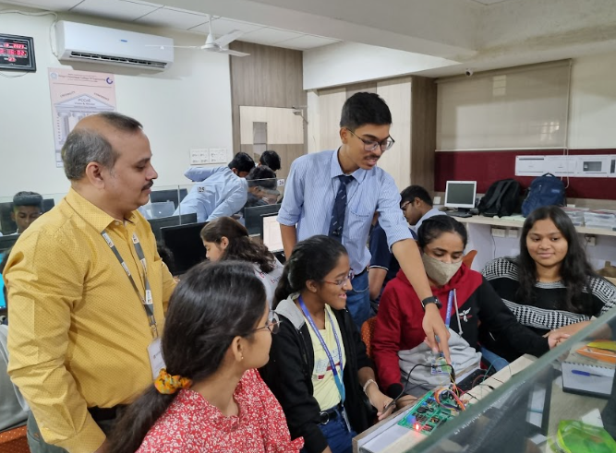
Software and Hardware | Students engaged in interfacing
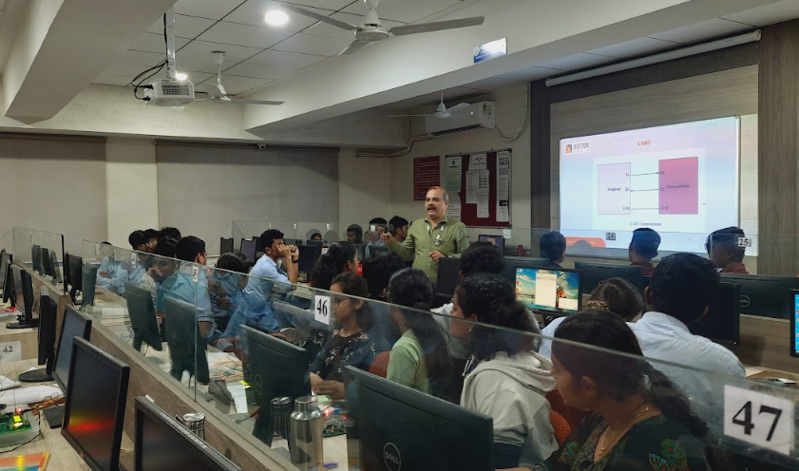 | 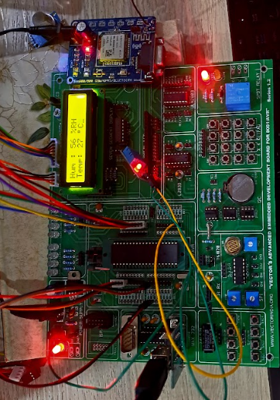
Theorotical guidance | LCD and sensor interfacing
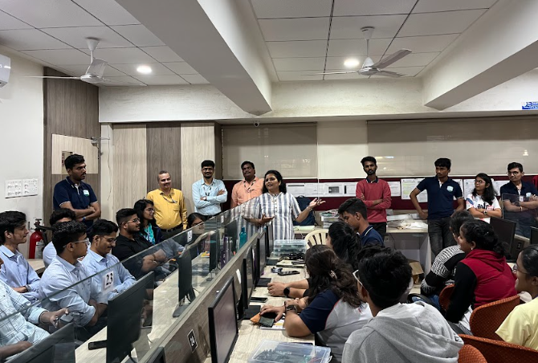 | 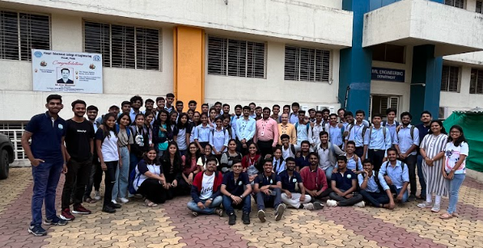
Dr. Varsha Harpale thanking speakers | Participants of the workshop
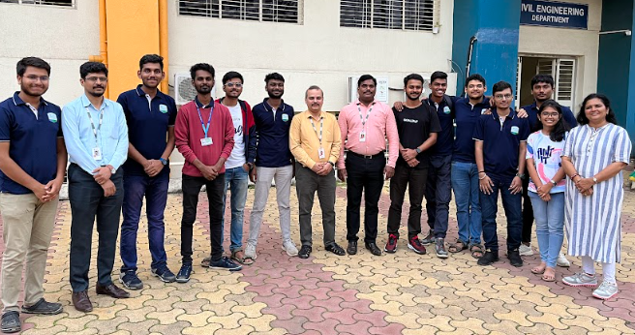 | 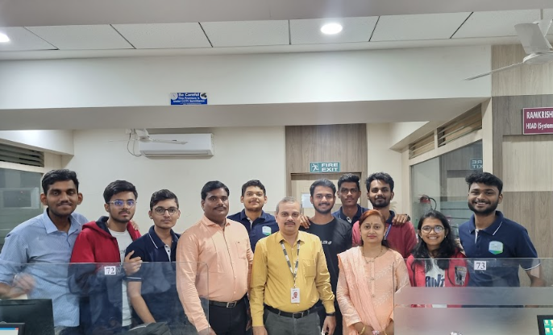
Speakers with student and faculty coordinators | Speakers with student and faculty coordinators

