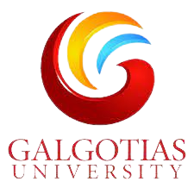 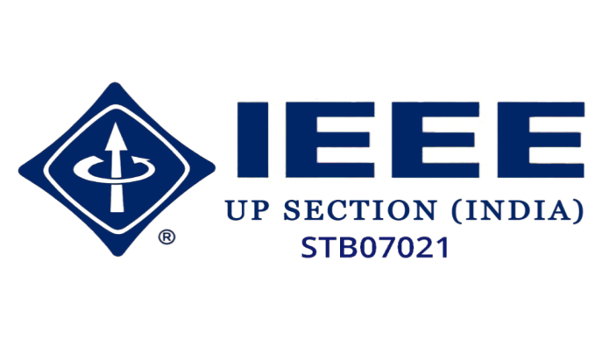

**A**

**Report**

**On**

**EVENT**

***Poster - Making Competition***

(21 May 2023)

*(On the occasion of Anti-Terrorism Day)*

Reported by: Editorial Team

Extreme Club and STB07021

Galgotias College of Engineering and Technology(SBT07021)

**ABOUT THE EVENT**

**Poster Making Competition**

***Protect Life, Destroy Terrorism!***

*(On the occasion of Anti-Terrorism Day)*

Date: 21 May 2023

Venue: Google Forms

The C.S.E department and STB07021 organized an event of Poster making competition, having theme “destroy terrorism” in the light of Anti-Terrorism Day.

On the occasion of Anti-Terrorism day, students actively participated in the poster making competition, under the theme “destroy terrorism”. This event was conducted to emphasize the importance of peace and spread a message about Anti-terrorism.

The participants created artistic posters and submitted their entries through Google Forms and three winners were declared whose posters were the best among all the entries.

**Smita Nagar – 1st**

**Shrinika Gupta – 2nd**

**Shyam Kumar – 3rd**

Posters are an effective medium of conveying messages in a creative way.

With that, the event succeeded in observing Anti-Terrorism day and in giving all the participants an opportunity to show their creativity through meaningful posters.

**Learning Outcomes**

**LO 1:** To think of meaningful messages about Anti-Terrorism.

**LO 2:** To showcase creativity by making a poster.

**LO 3:** To observe Anti-Terrorism day and respect the power of peace and harmony.

**Event Pictures**

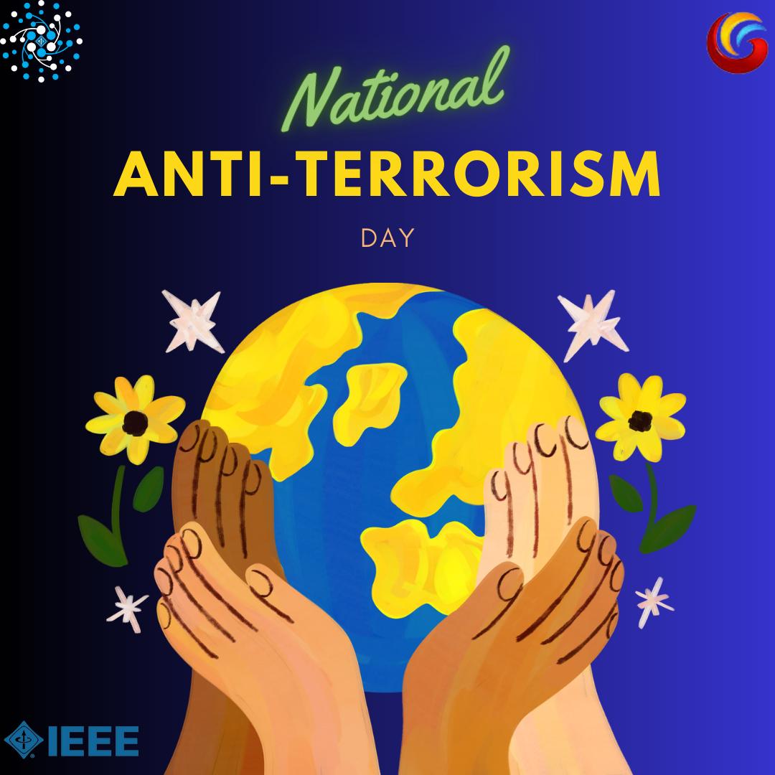

 

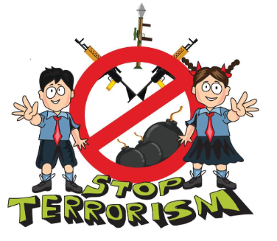

**Event Summary**

|  |  |
| --- | --- |
| **Title of the event** | Poster making competition: *Protect lives,*  *destroy terrorism!* |
| **Date** | 21 May, 2023 |
| **Category of the event** | Non-technical |
| **Sub category of the event** | Creative |
| **Time zone** | India |
| **Primary Host Organization**  **Unit** | Galgotias College of Engineering and  Technology (STB07021) |
| **Primary Host Contact**  **Event** | [vishnu.sharma@galgotiacollege.edu](mailto:vishnu.sharma@galgotiacollege.edu) |
| **Platform** | Google Forms |
| **Physical Address** | Galgotias College of Engineering and  Technology, Knowledge park-2, Greater Noida  Uttar Pradesh, India |
| **Registration Starts/Date** | - |
| **Registration Ends/Date** | - |
| **Participants** | Students of CSE department, GCET |
| **No. of participants** | 26 |