**Galgotias College of Engineering and Technology (STB07021)**

**A**

**Report**

**On**

**“Awareness for Tiger conservation**

* **Online Seminar”**

**On the Occasion**

**of**

**(*WORLD TIGER DAY*)**

**Reported By: Editorial team,**

**Extreme Club and STB07021**

**Online Meet**

**About**

**“TIGER CONSERVATION”**

**On the Occasion**

**of**

**“World Tiger Day”**

|  |
| --- |
| **DATE: 29 July,2023**  **VENUE: Google Meet**  **TIME: 1:00 PM to 2:00 PM** |

**About the Event**

On Global Tiger’s Day (29 July,2023), the C.S.E Department of Galgotias College of Engineering and Technology organised an “Online Tiger Conservation Awareness Drive” through Google meet for raising awareness about the decreasing tiger population globally and preserving the natural habitat of tigers. A lot of students participated in the virtual drive and learnt to ensure maintenance of a viable population of Tigers in India for scientific, economic, aesthetic, cultural and ecological values, and to preserve for all times, areas of biological importance as a national heritage for the benefit, education, and enjoyment of the people. July 29 has been identified as the day to commemorate the Global Tiger Day in 2010. The strategies for tiger conservation were put forward by the students and discussed about the possible ways in which we can protect our biodiversity. To gauge the success of conservation efforts as well as to have a finger on the pulse of tiger populations and their ecosystems some volunteers were also appointed. Students finally understood that, their survival is in our hands.

**Learning Outcomes:**

**LO1:** The centrality of tiger agenda is an ecological necessity for the sustainability of our environment.

**LO2:** To protect the endangered species.

**LO3:** The event also invokes the feeling of kindness towards animals.

**Event Pictures:**

** (Poster of the Event)**

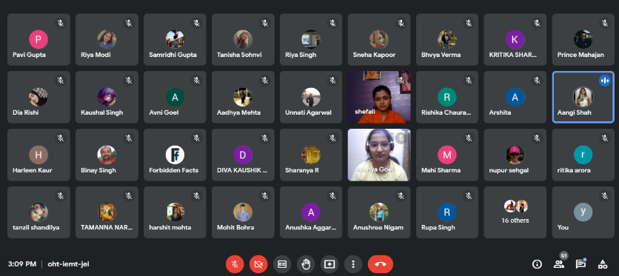

**(Event Pictures)**

|  |  |
| --- | --- |
| **Event Summary** | |
| **Title of the event** | Online Tiger Conservation Awareness Meet |
| **Start time** | 1:00 pm |
| **End Time** | 2:00pm |
| **Category of the event** | Non-Technical |
| **Sub- Category of the event** | Social |
| **Time Zone** | India |
| **Primary Host Organization Unit** | Galgotias College of Engineering and Technology (STB07021) |
| **Primary Host Contact Event** | [vishnu.sharma@galgotiacollege.edu](mailto:vishnu.sharma@galgotiacollege.edu) |
| **Platform** | Google Meet |
| **Physical Address** | Galgotias College of Engineering and Technology, Knowledge park-II, Greater Noida, Uttar Pradesh, India. |
| **Registration Starts/Date** | 27/07/2023 |
| **Registration Ends/Date** | 29/07/2023 |
| **Participants** | Students of CSE, GCET |
| **Number of Participants** | 101 |

**Co Ordinator**

Ms. Ritu Dewan