

**A**

**Report on**

**ANTI-TOBACCO DAY**

**Slogan writing competition:**

**Choose health, not tobacco**



**Reported By : Editorial Team**

**Extreme Club and STB0702121**

GALGOTIAS COLLEGE OF ENGINEERING AND TECHNOLOGY

**SLOGAN WRITING *COMPETITION***

## ***on***

**Anti – Tobacco Day**

|  |
| --- |
| Date: **31 May, 2023**  Venue: **E-004 (Galgotia’s College of Engineering and Technology)**  Time: **11:00 am to 12:00 pm** |

**About the Event:**

The C.S.E department and STB07021 organized Slogan writing competition on **“Anti – Tobacco Day: Choose health, not tobacco”.**

World No Tobacco Day is observed on May 31st ,2023 to raise awareness about the damage caused by consuming tobacco. Consuming tobacco kills over 80 lakh people across the world every year. Besides the human cost, consuming tobacco also causes the environment to degrade.

Students from all the sections participated in the competition and submitted their entries for the above-mentioned topic. The slogans were submitted in English and in Hindi. All the entries were submitted till 12:00 pm.

**Learning Outcomes**

* **LO 1:** To enable creative thinking for writing slogans.
* **LO 2:** To raise awareness about the harms caused by the consumption of tobacco.
* **LO 3:** To observe Anti-Tobacco Day and understand the significance of the day.
* **LO 4:** Pledge to reduce the usage of tobacco and eventually stop using it.

**Event Poster**

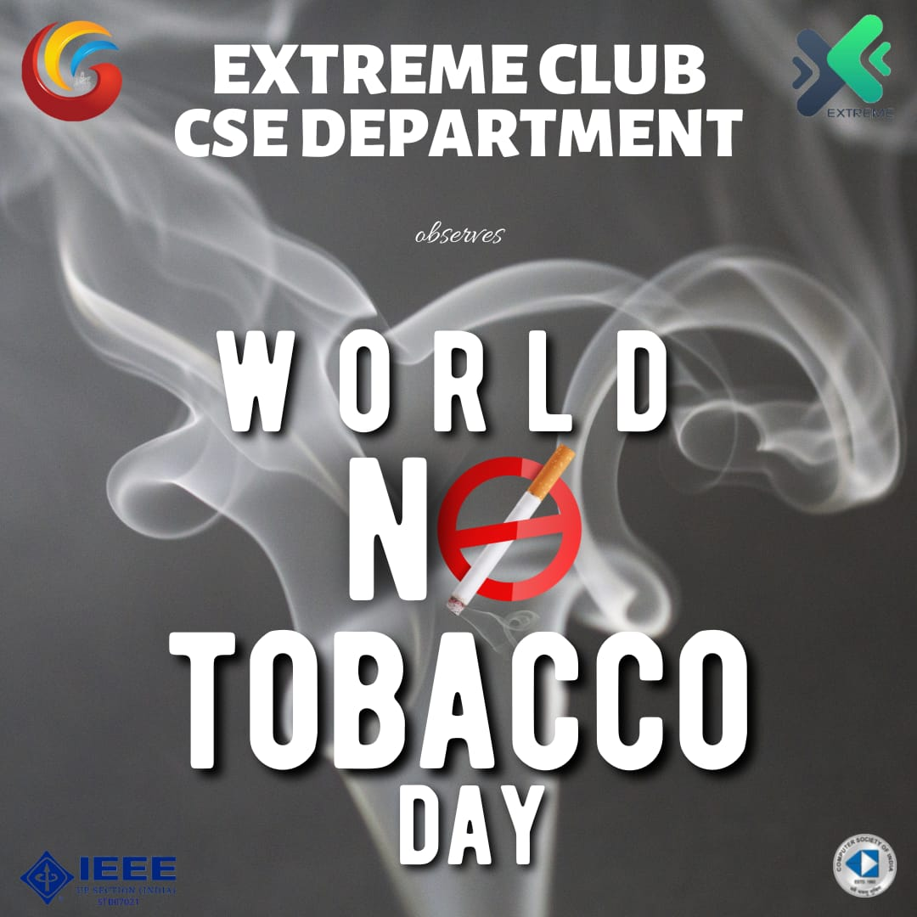

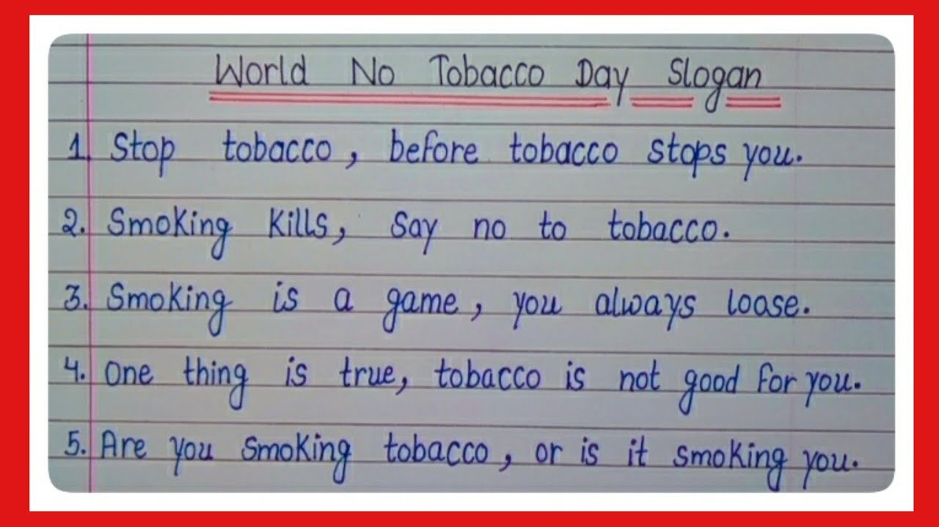 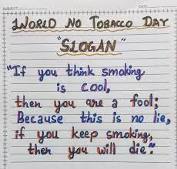

|  |  |
| --- | --- |
| **EVENT SUMMARY** | |
| **Title of the event** | Slogan writing for Anti-Tobacco Day |
| **Start time** | 10:00 am |
| **End Time** | 12:00 pm |
| **Category of the event** | Creative |
| **Sub- Category of the event** | Informative |
| **Time Zone** | India |
| **Primary Host Organization Unit** | Galgotias College of Engineering and Technology (STB07021) |
| **Primary Host Contact Event** | [vishnu.sharma@galgotiacollege.edu](mailto:vishnu.sharma@galgotiacollege.edu) |
| **Platform** | Offline, E-004 |
| **Physical Address** | Galgotias College of Engineering and Technology, Knowledge Park-2, Greater Noida, Uttar Pradesh, India |
| **Registration Starts/Date** | 25/05/2023 |
| **Registration Ends/Date** | 30/05/2023 |
| **Participants** | Students of GCET |
| **Number of Participants** | 37 |

|  |
| --- |
| **Co-ordinator:**  **Dr. Ritu Dewan** |