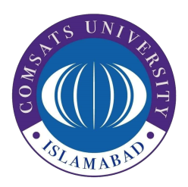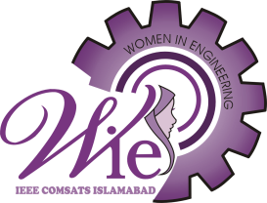

# IEEE WiE CUI

# Ice – Breaking Session

# Event Report

# Held on 6th March, 2023

# Summary:

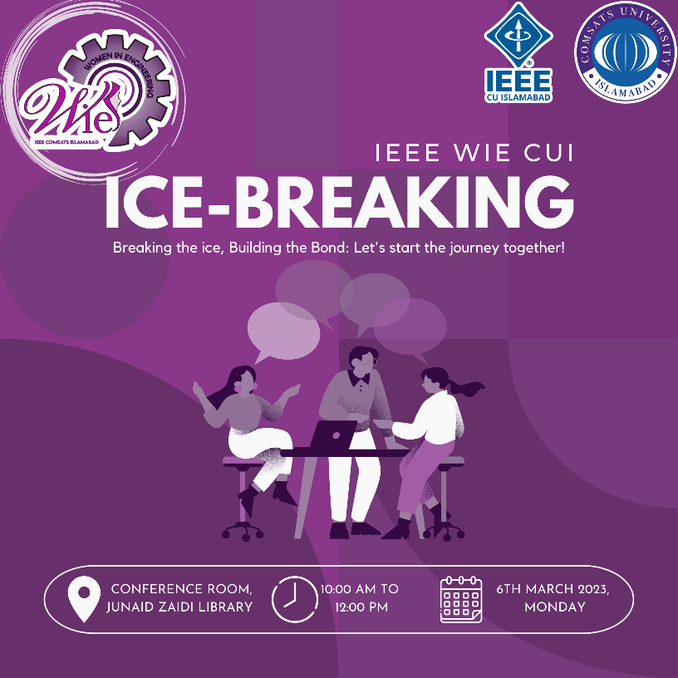

1: Ice-Breaking Session Poster

On March 6, 2023, an ***ice-breaking session for IEEE Women in Engineering (WiE) CUI*** was held at the video conference room located in the basement of the library. The event commenced promptly at 10:00 am and was attended by a maximum of 20 volunteers. The event started with the recitation of the Quran. During the event, the volunteers were given a comprehensive overview of the structure of IEEE and its sub-chapters. The excom members and volunteers were introduced to one another.

In order to welcome and motivate the new volunteers, the session included fun activities and friendly conversations, which helped to build a sense of camaraderie among the attendees. The session concluded with a group photo to commemorate the addition of new volunteers.

We were privileged to have the presence of excom members, Chairperson of Student Branch Noor Fatima, Chairperson of RAS Hamza Nadeem and Chairperson of CS Ahmed, and excom from other chapters, which added to the significance of the event. The session was deemed a success and we would like to extend our special thanks to the excom and volunteers for their participation and support.

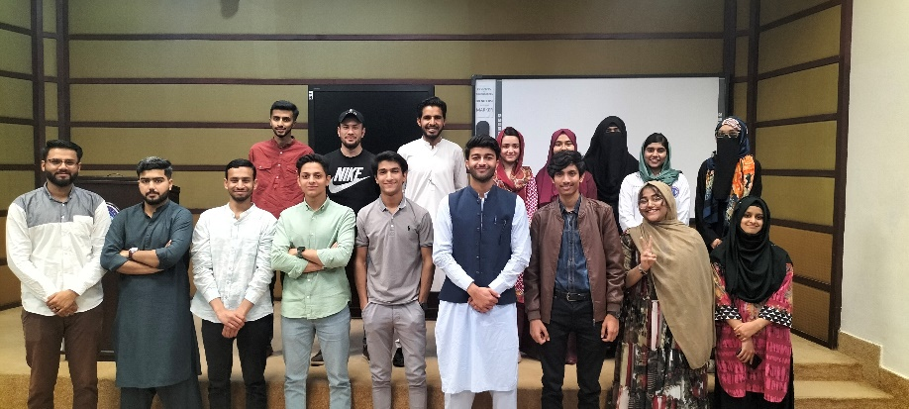

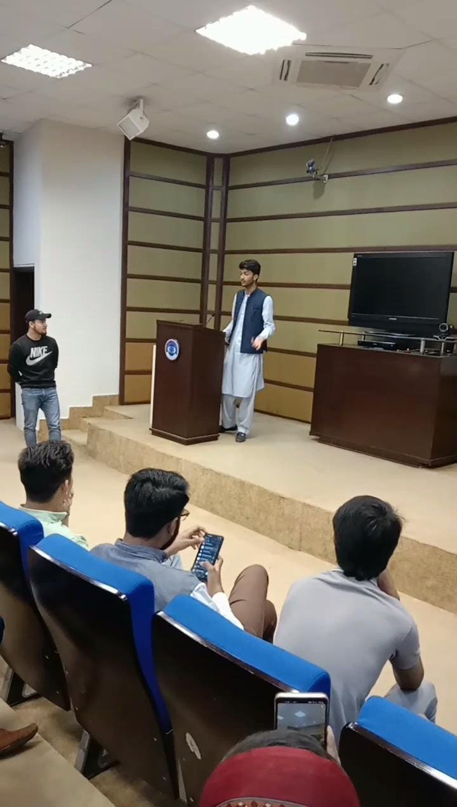

2: Ice Breaking Group Photo

3: During Event Photo