**Name of the Event : Epic Edits – Unleash Your Imagination**

**Moderator of the event : Mr. D. Jayanarayana Reddy**

**Mrs. Dr. Syeda Jeelani Basri**

**Mode of Conduct : Offline**

**Venue / Link : Seminar Hall, GPCET**

**Date of the Event : 13 October, 2023**

**Number of Attendees : 150**

**About the Event :**

IEEE CIS/WIE Student Branch Chapters in association with GPCET CIS SBC/GPCET WIE SBC has been conducted “Epic Edits – Unleash Your Imagination on October 13, 2023 and Mr. D. Jayanarayana Reddy and Mrs. Dr. Syeda Jeelani Basri are the Moderators for this Event.

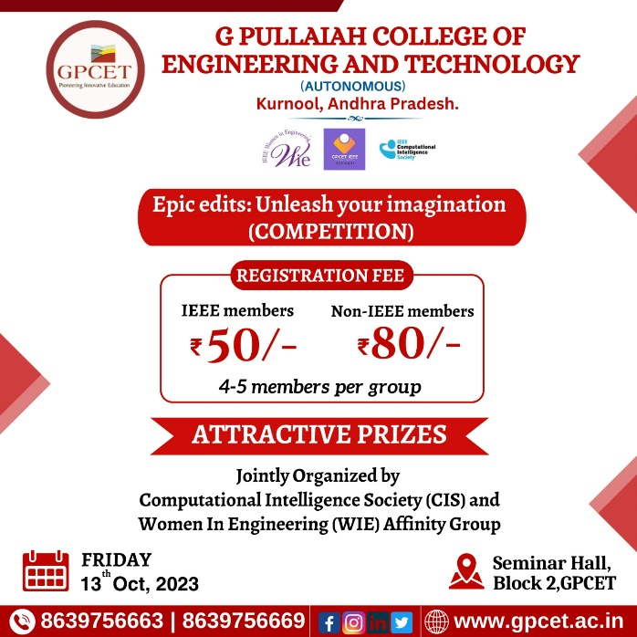**Photo Gallery : EVENT POSTER**

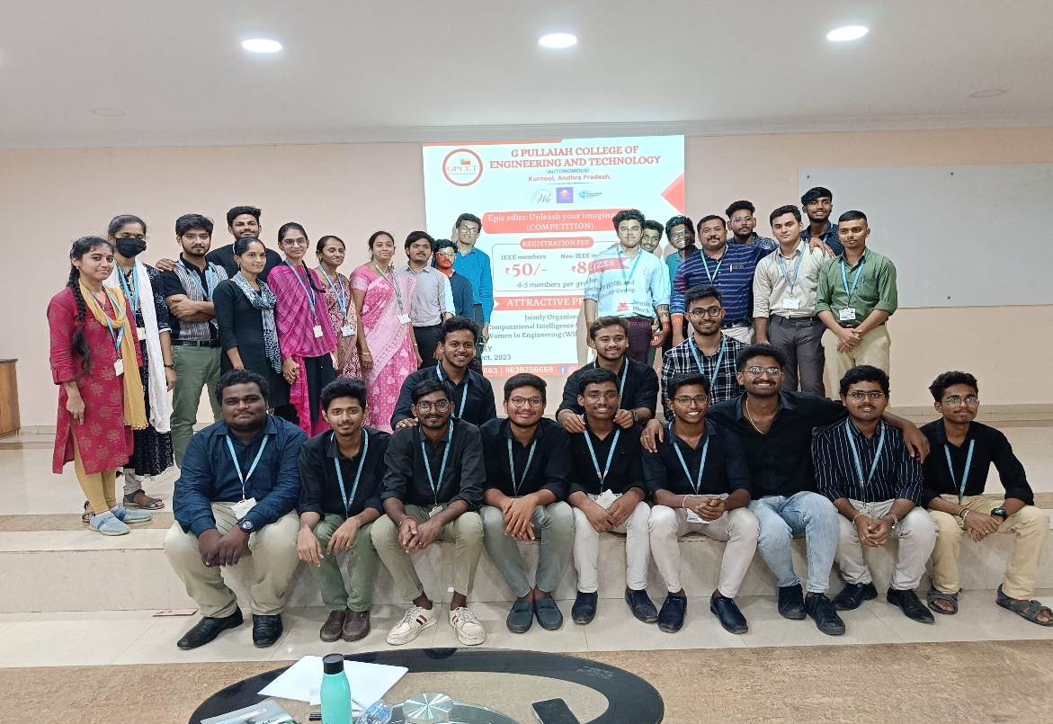 **PARTICIPANTS**

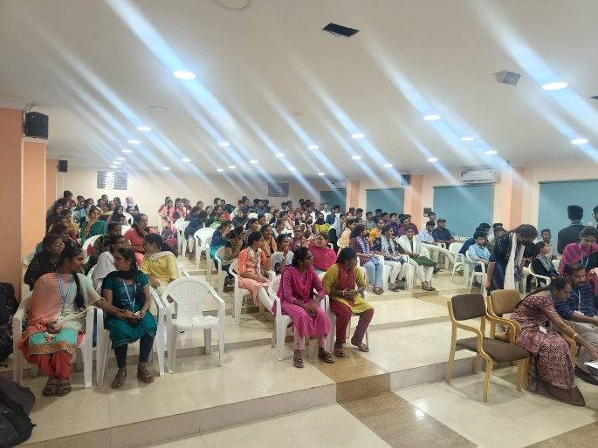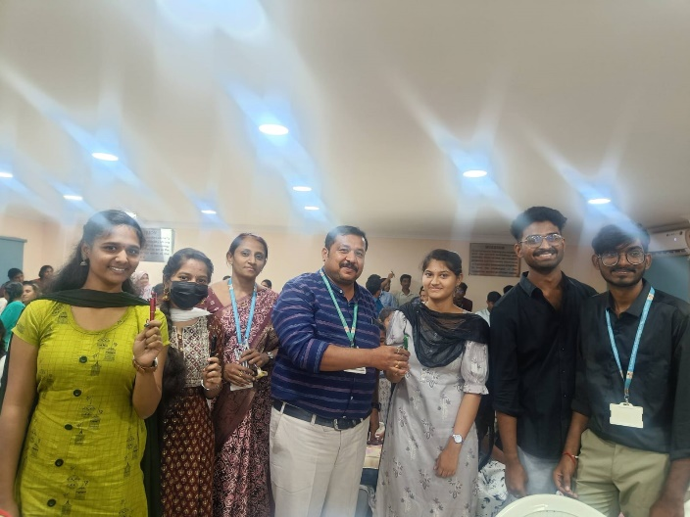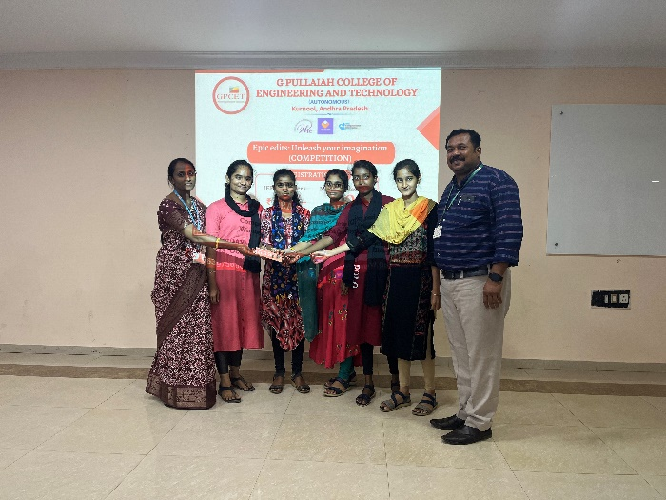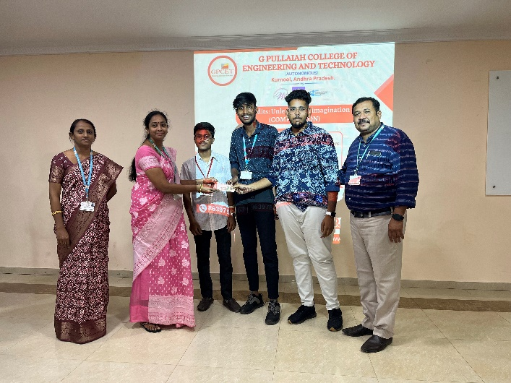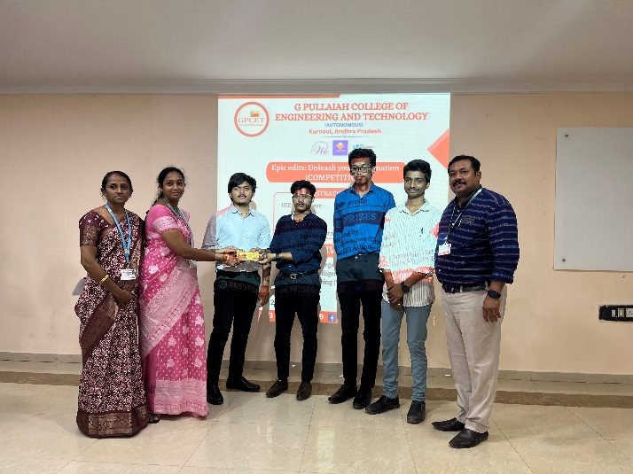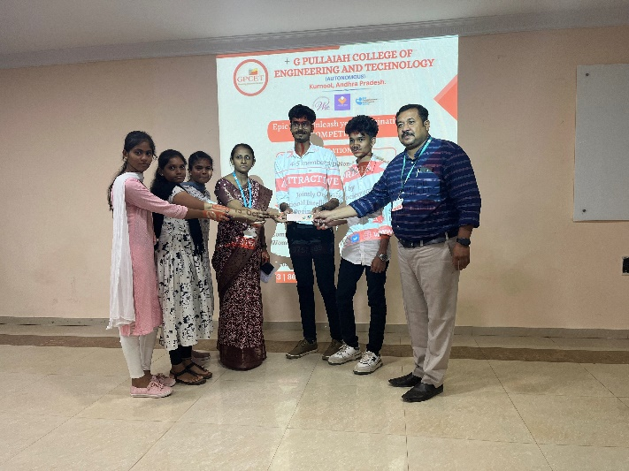

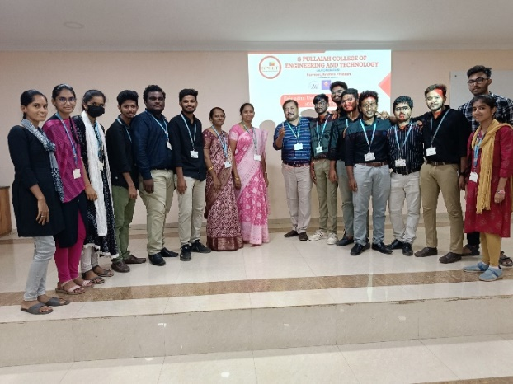

**Brief Report :**

The contest was inaugurated by esteemed advisors for the CIS and WIE chapters, Mr. D. Jayanarayana Reddy and Mrs. Syeda Jeelani Basri, who also served as moderators for the event. It was a positive atmosphere at the venue with all the participants. It was a wonderful speech delivered by Mr. D. Jayanarayana Reddy, the esteemed advisor to the CIS Chapter. The esteemed advisor for WIE Chapter, Mrs. Dr. Syeda Jeelani Basri, then addressed the students with a motivational speech. A total of 37 teams took part in this event, and it was a great success. Both society advisors were involved in the judging process for the student video competition held during the event. We were really blown away by some of the videos. As part of the judging process, the videos are rated based on three factors: the message presented in the video, the duration of the video, and the presence of participants within it. During the presentation of the video, the judges assigned marks to each video based on the feedback from the judges, while all participants were watching the video at the same time.

Upon the completion of the evaluation, gifts were distributed to all participants. We invited Dr. M.Srilakshmi who was the esteemed advisor of CS Chapter and the HOD of CSE Department to award the prizes to the winners. The winners have been announced by one of the volunteers. The prizes have been distributed by Dr. M.Srilakshmi, Mr. D. Jayanarayana Reddy, and Mrs. Dr. Syeda Jeelani Basri to all the winners. As part of the contest, a virtual photo session was organized at the end of the contest, and the event was concluded with D. Jayanarayana Reddy congratulating all the winners and the participants, and the student volunteers for their dedicated efforts and cooperation in making the contest a success.

Mr. D. JAYANARAYANA REDDY

ADVISOR

IEEE GPCET CIS

Mrs. Dr. SYEDA JEELANI BASRI **ADVISOR**

**IEEE GPCET WIE**

Dr. M. RAMA PRASAD REDDY

GPCET SB COUNSELOR

IEEE GPCET SB