“Seminar on Futuristic Learning and Life Skills unleashed ”
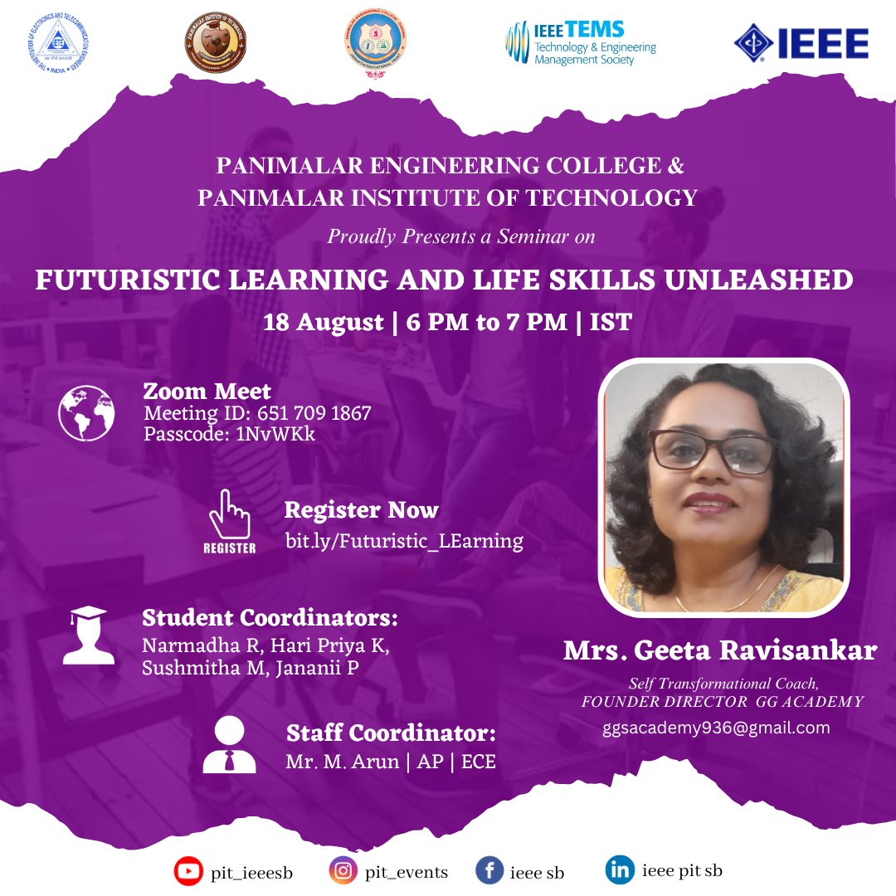
IEEE SB Panimalar Engineering College & Panimalar Institute of Technology together in association with IETE, TEMS and IEEE presented a seminar titled Futuristic Learning and Life Skills unleashed by Mrs. Geeta Ravisankar, Self Transformational coach Founder director of GG Academy on 18.08.23 from 6 to 7 PM (IST). Ms. Geeta Ravisankar shared insights into the significance of adaptability and resilience in facing challenges. Strategies for managing change and building emotional strength were discussed to empower women to overcome obstacles. She delved into essential skills for the future of work, including critical thinking, creativity, collaboration, and communication. Participants gained insights into how these skills can contribute to career advancement. Around 20 participants attended. The Student Coordinators Narmadha R, Hari Priya K, Janani P and Sushmitha M coordinated the event along with the Staff Coordinator Mr. M. Arun, AP/ECE.
