“Webinar on Balancing Act: Women in Engineering Work-Life Harmony ”

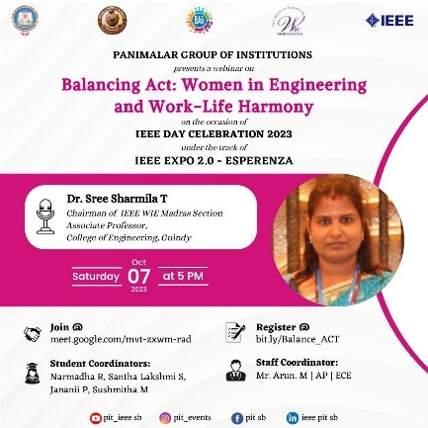

IEEE SB Panimalar Engineering College, Panimalar Institute of Technology in association with IEEE WIE SB chapters, organized a webinar on Balancing Act: Women in Engineering and Work - Life Harmony on the occasion of IEEE Day Celebration 2023 under the track of IEEE Expo 2.0 - Esperanza by Dr. Sree Sharmila T, Chairman of IEEE WIE Madras section, Associate Professor, College of Engineering, Guindy on 07.10.23 at 5 PM (IST). Dr. Sree Sharmila discussed the challenges and opportunities for women in engineering while also addressing the crucial topic of achieving work-life harmony. Around 80 participants attended the webinar, gaining profound insights into the role of women in engineering and the strategies for achieving a balanced work-life integration. The Student Coordinators Narmadha R, Santha Lakshmi S, Janani P, and Sushmitha M coordinated the event along with the Staff Coordinator, Mr. M. Arun, AP/ECE.

