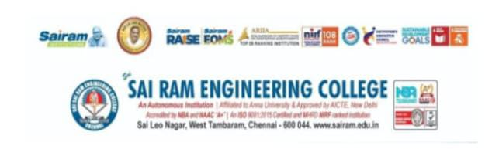

Tech Talk
On
Microwave Filter Design

MTTS OFFICE BEARERS
Shalini P – Chair person
Amritha Varshini M – Vice Chair
Harsha K – secretary
Selvakarthick K – web Master
Sajesh Narayanan R – Treasurer

Coordinators
Ms. V. Remya, IEEE SEC MTT-S Chapter Advisor

Date:18.11.23 Timing: 12.00pm – 2.00pm
Platform: Online

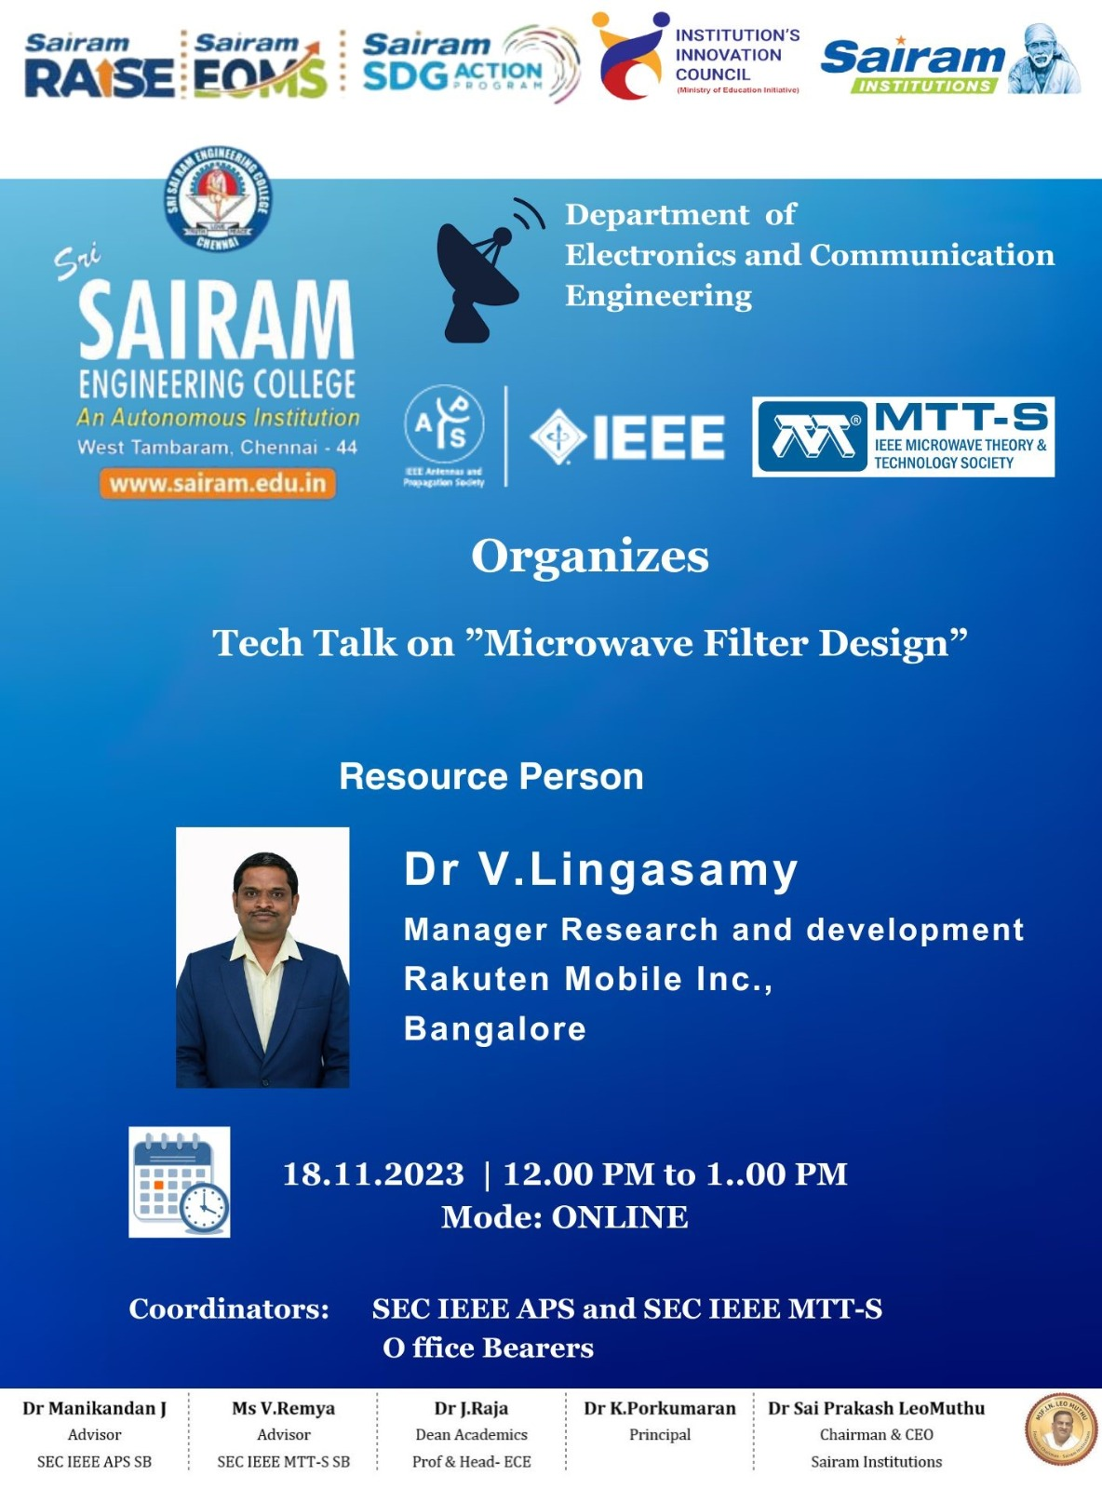

Tech Talk on “Microwave Filter Design”
A tech talk on “Microwave Filter Design” was organized by IEEE Microwave Theory and Techniques Society, Antennas and Propagation Society SBin association with Department of Electronics and Communication of Sri Sairam Engineering College. The event took place in Virtual Platform through Zoom meet.
The tech talk was given by Dr. V. Lingusamy, Manager, research and development, Rakutan Mobiles, Bangalore. His experience and contributions in antenna design and communication systems have made him the best choice to give a webinar on this particular topic.
The Welcome address was given by Dr. S. Brindha, Vice chairman of IEEE, SB, Madras chapter.
Students were highly benefitted on this tech talk, especially for IV year ECE Students which was mandatory for them and it has been a wonderful exposure for every student who have given their participation in the meet.
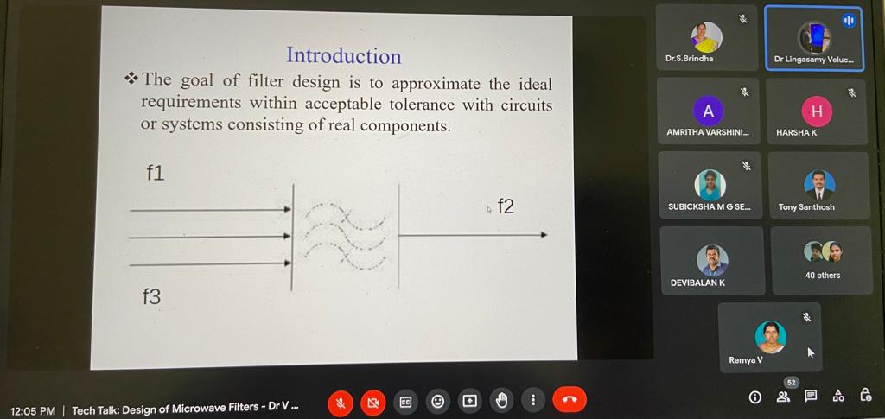
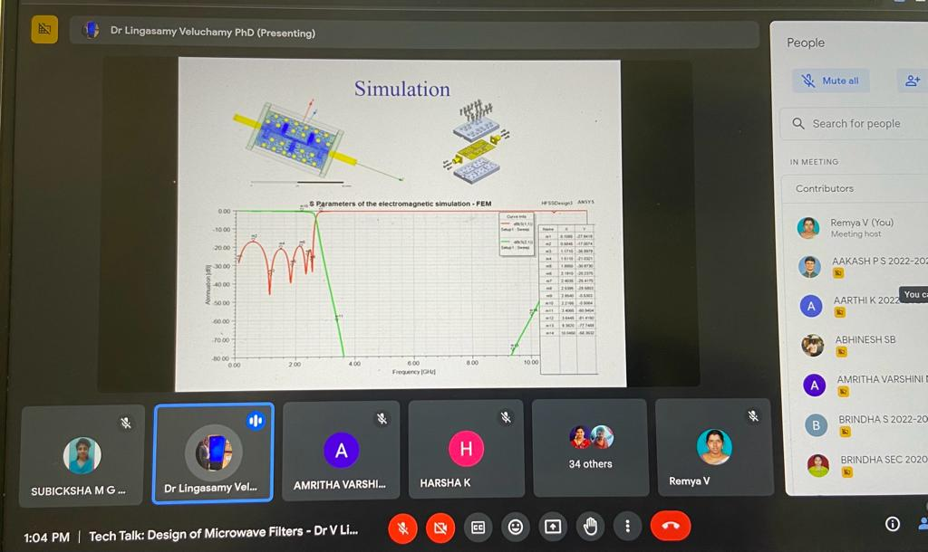
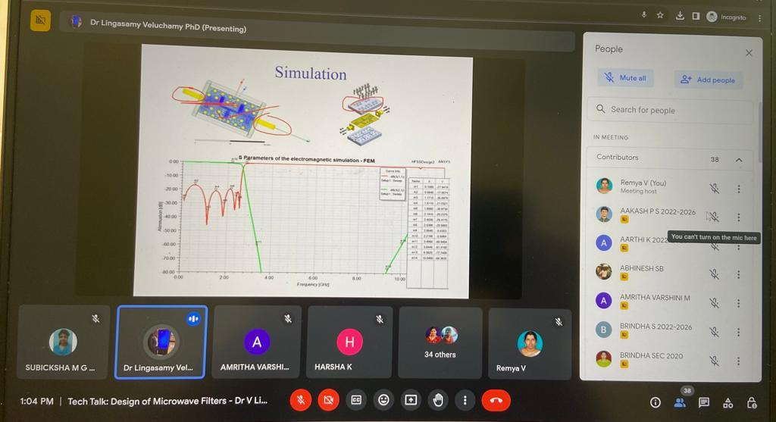
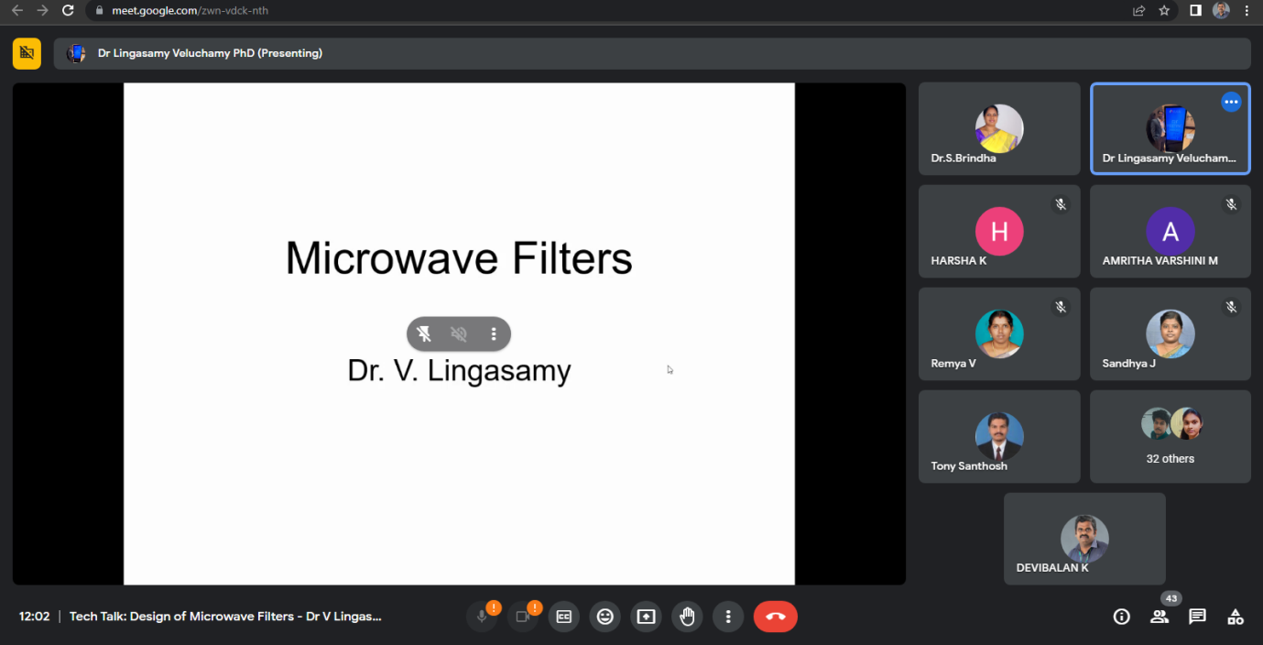
The event was conducted in an efficient manner straight for 2 hours and around 100 students got benefited. Each and every student who took participation in the event was given E-certificate to appreciate their participation.
