



**PLUG INTO SAFETY: UNVEILING THE BEST PRACTICES IN ELECTRICAL AWARENESS**

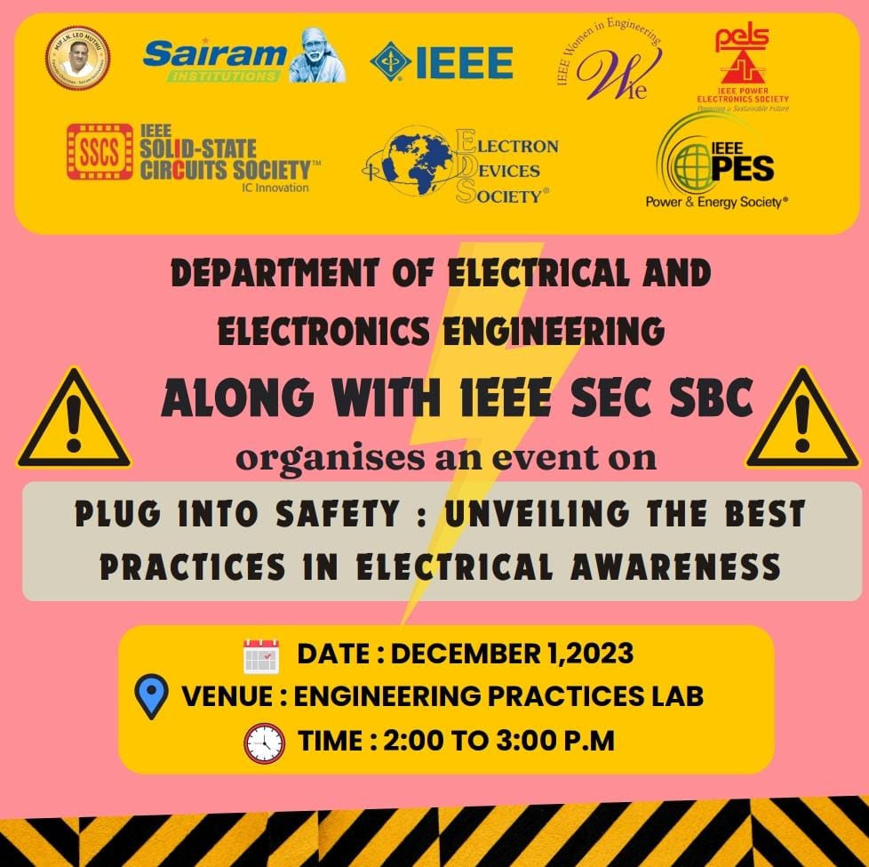

**Event:** Plug into Safety: Unveiling the best practices in ELECTRICAL AWARENESS

**Date:** 1-12-2023

**Time:** 2:00pm-3:00pm

**Venue:** Engineering Practice Laboratory, Sri Sairam Engineering College

**SPEAKERS:** Dr. L. Kurinjimalar , Dr. B. Meenakshi

**About the Event:**

In our commitment to fostering a safe and secure work environment, an Electrical Safety Awareness campaign was initiated on 1st December 2023, from 2:00pm-3:00pm at Engineering Practice Laboratory to educate and empower individuals on the importance of electrical safety. The primary objective was to raise awareness about potential electrical hazards, promote safe practices, and reduce the risk of accidents within our workplace.

A comprehensive discussion on common electrical hazards, such as faulty wiring, overloading, and unsafe practices, was conducted. Real-life examples were shared to illustrate the risks involved. Participants were educated on safety procedures, including proper usage of electrical equipment, the importance of GFCIs, and guidelines for handling electrical emergencies. Practical demonstrations were incorporated to reinforce learning.

**Dr. L. Kurinjimalar**, Chapter Advisor of the SSCS SEC Student Branch Chapter and the professor of Sri Sairam Engineering College in the Department of Electrical and Electronics who has vast experience in power electronics.

The core of the event was a puzzle competition designed to challenge the students' intellect while incorporating key concepts of electrical safety. Teams competed head-to-head, solving puzzles that tested their understanding of safety measures, electrical circuitry, and emergency response.

To recognize the efforts and achievements of the participants, prizes were awarded to the winning teams. The recognition served as an incentive for students to actively engage in the learning process and promote a culture of electrical safety within their academic community.

**CONCLUSION:**

The event on electrical safety, centered around a puzzle competition, successfully combined education with entertainment. By engaging students in a fun and challenging environment, the event achieved its goal of promoting awareness and understanding of electrical safety practices. The positive response from participants indicated not only the success of the competition but also the potential for similar initiatives to contribute to a safer and more informed community.

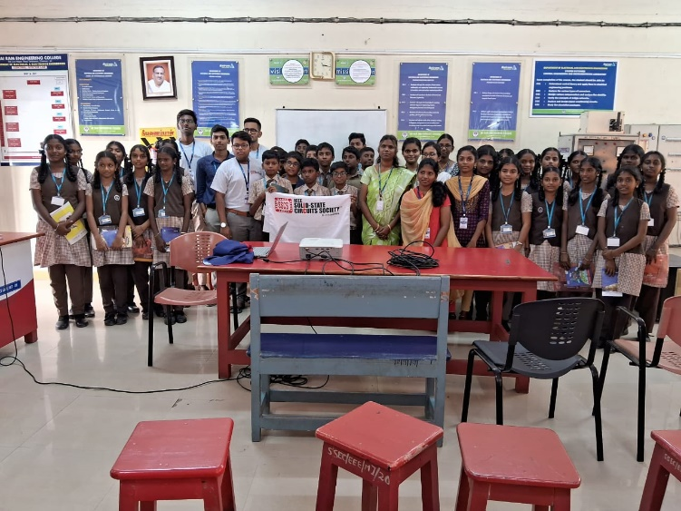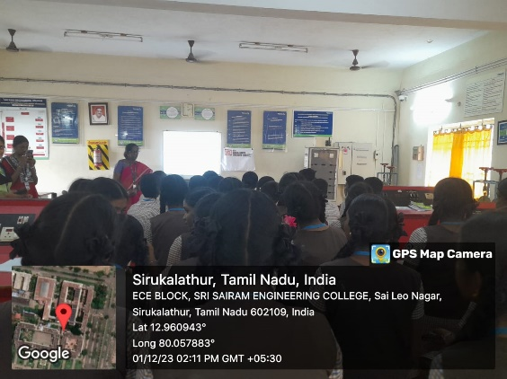**EVENT** **GALLERY:**

