IEEE |  | IEEE student branch summit 2023

Held at:
ANNA UNIVERSITY, GUINDY  14-010-23  SATURDAY  TIME: 9.30 AM TO 7.30 PM    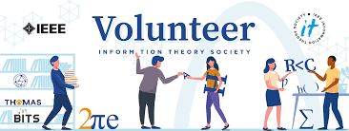    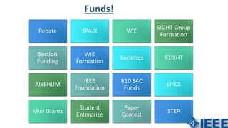 |  | The IEEE Student Summit 2023 is a significant event organized by the Institute of Electrical and Electronics Engineers (IEEE), a renowned global professional organization. This summit's goal is to give students a thorough understanding of how IEEE operates as well as exposure to various events and beneficial training opportunities. This summit is a great venue for students studying electrical engineering, electronics, and related topics because IEEE is known for focusing on these fields.  Specific IEEE student summits and conferences, such as the IEEE Power and Energy Student Summit 2023 and IEEE-Eta Kappa Nu's Student Leadership Conference, offer students the chance to engage with like-minded peers, participate in competitions, and gain insights into industry trends and career development. These events are usually hosted by universities and institutions, allowing students to experience a blend of academic and practical knowledge.  IEEE Student Summit 2023 and related events play a crucial role in fostering the development of future engineers and professionals by providing them with networking opportunities, educational resources, and exposure to the latest advancements in their respective fields.  So, for this event many of the student branches in the Madras section are attended in Anna University to witness the summit. Approximately , 150 student branches attended to witness this event along with their student branch counsellors and student branch chairs. Also , IEEE Indian Council members attended for this event .  And Dr.Porkumaran ,the chief of madras section gave some valuable insights regarding IEEE and their future enhancements.  Initially, Mr. Aravindan started the session with his valuable speech on IEEE and during his presentation ,he shown some of the images and asked us to interpret them to improve interaction between a speaker and a listener.He shown pictures like a clock, joyful people, putting hands together and earth,moon,sun to interpret inner meaning of them, he also distributed pens if we interacts with him actively.Most of them are participated actively which is a very good trait for an IEEE member. By participating in these interactions we can improve our communication skills to develop our career and move a step ahead without any fear. With his speeches , he always inspires us very much. And gives enthusiasm to learn more about IEEE.  So, after that Mr. Prasanth Mohan who is an IEEE member and Volunteer gave an amazing speech regarding volunteering. He discussed the importance of volunteering and the benefits we get by participating volunteer activities in IEEE. And he shared his volunteering experiences and some of his personal experiences he got during volunteering such as the conferences he attended by volunteering himself . After listening his talk we realized that there is research much deeper about IEEE. He also shared about the events and what he did from 2013 to 2023.Overall, he mainly concentrated on importance of IEEE volunteering.  Then, followed by Mrs. Ramalatha mam gave a wonderful speech regarding Sustainable Development Goals (SDG).She discussed about SDG framework where it includes of 17 goals like No poverty, Zero hunger, Quality education , Good health and Well being and so on. Also she discussed about the targets of Sustainable Development Goals like education. Also she discussed on the connection between SDGs. Followed by she explained about climate change and impact of climate change on different aspects like on human health,agriculture as women also considered as one of the aspect who are affected by the climate change.  Next, for a short while Dr.Brindha Saminath mam shared some of the competetions like Yesist12 International Project Competetion and Returning mother program.  Then Mr.Arun shares very valuable information with us i.e., regarding IEEE student branch fundings which are very important to improve and enhance the student branch. He shared information about benefits of student branch section like section based paper contests,website contests, participation in SB officers meet, Travel support to attend the meets, sponsorship to attend R10 YP and WIE congress,rebate,participation in IEEE annual meet,Monthly free technical meetings,participation in IEEE day celebrations.
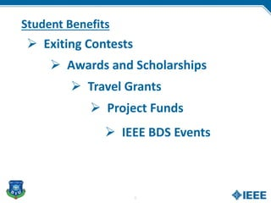 |  | A sum of 10,000 rupees will be given as travel grant for a member.He also shared regarding student project funding ,where it gives a fund of Rs.15000 and SPAC wiil give funds upto $500.And also different fundings are there like SIGHT,Step,WIE R10 SAC FUNDS .  Also,he mentioned about student scholarships and student awards like Richard E Merwin,Upsilon pi epsilon and lance stafford Larson student award and many more.And discussed regarding societies also, includes of Microwave theory and techniques society,Power and energy society,Nucleo energy society,IEEE electronic devices society and so on.There is a also a IEEE event finder to find meetings and events to know what is going on in your local area.To get fundings for a newly started branch, these 3 are very necessary conditions:  1.Student Branch Annual plan  2.Student branch officer reporting  3.Student branch activity/meeting/Event reporting[4 per year]  All this information is very valuable to improve our student branch.  Then,Mr.Ashvanth B introduced some of the tools in online which are very helpful for online editing,website designing etc.They are 1.Grammarly  2.Townscript  3.Canva  4.Doodle  5.OU analytics  6.V tools  7.Wordpress  Atlast ,Dr.Porkumaran sir gave a speech how our Madras section was moving forward in different aspect and also the importance of IEEE.And how to be responsible towards our goals,which is very inspirable for all of us. Overall, it is a very well-planned IEEE student summit which gives us an immense amount of knowledge.

