

**Northern Virginia Section (**[**http://sites.ieee.org/nova/**](http://sites.ieee.org/nova/)**)**

**Executive Committee**

**Meeting Agenda for February 13, 2019**

**LOCATION:** [**Providence District Office and Community Center**](https://www.fairfaxcounty.gov/neighborhood-community-services/providence-community-center/location) ←Click the Link for more info

**3001 Vaden Dr, Fairfax, VA 22031**

It is in close proximity to Vienna Metro South: walking distance

**Meeting URL (**518220**):** <https://ieeemeetings.webex.com/ieeemeetings/j.php?MTID=m644cc22e6ae5f3b703fa9ba87723c7de>

**Meeting number (access code):** 592 091 871**; Meeting password**: JHxPSAe5

You can also dial 173.243.2.68 and enter your meeting number. To dial from an IEEE Video Conference System: **\*1 592 091 871**

**Join by phone:** +1 866 282 7366 (US Toll Free) **or** +1 210 606 9466 (US Toll) **- Access code:** 592 091 871

**CALL TO ORDER: 07:00 pm (30 minutes later than before) QUORUM*:** Yes| No (__/__ voting members)

*\*Quorum is defined as 51% of elected Executive Committee members with voting rights.*

|  |  |  |
| --- | --- | --- |
| **Item** | **Estimated Time** | **Cumulative Ending Time** |
| **Introductions (All)**  **Voting Members:**  **Guest IEEE Members**: | 5 min | **7:00 pm**  **-7:05 pm** |
| **Last Minute Proposed Changes and Additions to the Agenda (All)** | 3 min | -7:08 pm |
| **Vote to Approve Previous (January-09-2019) Ad.Com. Minutes** | 2 min | -7:12 pm |
| **NoVA Leadership Team Reports**   * Chair (Mike Olex) * Treasurer (Barry Douglass) * Vice Chair (Michaela Iorga) * NoVA 2018 Chair (Chandra Curtis) * Secretary (Dmitry Cousin)   **Committee, Chapter, and Affinity Reports (NOTE: We cover only reports that cover next few weeks 4-8)** | 8 min | -7:27 pm |
| **Old Business**   * Call for Brainstorming ideas for 2019 activities (Mike Olex) – will come back to this issue February Ad.Com. meeting * Member’s elevation reference solicitation (Marty Schulman/Mike Olex) – will come back to this issue next meeting * 2019 WIE Forum Co-sponsoring (see Appendix 1: titled “2019 WIE Forum”) Mike Olex previous comment: The discussed financial commitment to support WIE cannot be made until we know what 10% means in terms of dollars. | 3 min  3 min  3min | -7:36 pm |
| **New Business**   * **Sponsorship for Chantilly High School robotics team.** Historically in late 2017 $500 was given to Oakton HS team, and in June $200 for each Oakton and Chantilly HS. The June funds were to support teams travel to competition. Also, R2 has already given $1000 via NoVA accounts transfer; hence, we may consider limiting NoVA-only support to Chantilly this time. * **Acquire projector for NoVA use -** Motion by Bill Schieble (see Appendix 2) Resource to be managed by the NoVA secretary and price not to exceed $600 with all the peripherals. * Motion by Harry R. Sauberman to **transfer the parent of NPS from the Washington Section to the NoVA Section**. * Motion by Mike Olex to **support local NoVA student members in their attendance of the Student Activities Conference 2019 (SAC2019)**. SAC2019 will be held at West Virginia University, in Morgantown, WV on April 5-7, 2019 * Motion by Chandra Curtis to **sponsor DCCEAS Luncheon and Banquet ticket or tickets with consideration that NoVA has a laureate**. | 3 min  3 min  3 min  3 min | -7:38pm |
| **What’s on Your Mind?**   * What’s Working, What’s Not, Where do you see Focus being Needed, Ideas for Improvement Member Leader or Volunteer Referrals | 5 min | 7:55 pm |
| **Action Item Review (Secretary)**   * Review actionable meeting notes | 5 min | 8:30 pm |
| **Deferred Topics:** | N/A | N/A |

**ADJOURNMENT: 8:30 pm**



# Northern Virginia Section 2019 Calendar (Tentative)

|  |  |
| --- | --- |
| **Item** | **Date** |
| Officer Reporting | Jan 9, 2019 (ADCOM @ P. Henry Library, Vienna, VA) |
| 2018 Financial & Section and Chapter Meeting Reporting | Feb 23, 2019 |
| IEEE Officer Leadership Training, South Area | Feb 9, 2019 (@ Vienna Community Center) |
| DCCEAS Luncheon (Engineer’s Week) | Feb 20, 2019 |
| DCCEAS Banquet (Engineer’s Week) | Feb 23, 2019 |
| Region 2 Winter Section Meeting |  |
| NoVA Awards Banquet |  |
| Science & Engineering Festival |  |
| Summer Picnic | TBD – Will be planned about month in advance |
| Region 2 Student Activities Meeting | April 5-7, 2019 at WVU |
| Officer Elections |  |
|  |  |

Notes:

1. Chapters and Affinity Groups need two meetings per year, so the Section receives credit for them.
2. Section AdCom Meeting held typically on the second Wednesday of each month.

# Northern Virginia Section 2018 Calendar

|  |  |
| --- | --- |
| **Item** | **Date** |
| Officer Reporting | January, 2018 |
| 2017 Financial & Section and Chapter Meeting Reporting | February, 2018 |
| DCCEAS Luncheon & Banquet (Engineer’s Week) | February 21 (luncheon) February 24 (Banquet), 2018 |
| Region 2 Winter Section Meeting | February 24-25, 2018 |
| NoVA Awards Banquet | May 5, 2018 |
| Science & Engineering Festival | May, 2018 |
| Summer Picnic | July 21, 2018 |
| Region 2 Student Activities Meeting | TBD |
| Officer Elections | November/December, 2018 |
|  |  |

# IMPORTRANT INFORMATION:

***Communication with all AdCom members*** *(NoVA AdCom – see list below - & Wash ExCom):*  [NOVA-ADCOM@listserv.ieee.org](mailto:NOVA-ADCOM@listserv.ieee.org)

***PROJECTOR*** (Note from Harvey Newman): MTT17 has a new very bright 1080p projector that is excellent in large rooms.  The unit is in a travel case, with every needed adapter and extension cord, and is kept at ARL with the MTT chair Bob Benoit. The other ARL folks (Charles Dietlein, Tony Ivanov) can always retrieve it from his office.  We just need to make advance arrangements with one of them.

# 2019 NoVA Committee Appointments

**Executive Committee:**

*Chair:* Michael Olex

*Vice Chair:* Michaela Iorga

*Treasurer*: Douglas Barry

*Secretary:* Dmitry Cousin

*Past Chair:* Chandra Curtis

**Directors:**

**2018 - 2019:**

Joel Goodman

Arye Ephram (relocated) – *Vacant* (unexpired term that needs to be filled in.)

Iram Weinstein

Martin Schulman

**2019 - 2020:**

Uday Krishna

Bhaskara Moole

Nadim Haddad

Kiki Ikossi

**Ad-Hoc Committee Chairs:**

*Student Activities:* Martin Schulman

*Professional Activities:* Vacant

*Membership Development:* Marc Apter

*Awards and Recognition Committee*: Kiki Ikossi

*Picnic Committee Chair:* Vacant

*Banquet Committee Chair:* Vacant

**Chapter Chairs:**

*Signal Processing:* Penny Hix

*Communications*: Kafi Hassan

*Control Systems*: Chiman Kwan

**Joint Chapter Chairs (NoVA Lead)**

*Computational Intelligence*: Joel Goodman

*Computer* : Jerome Gibbon

*Social Implications of Tech:* Murty Polvarapu

*Nanotechnology:* Nadim Haddad

*Power and Energy:* Yonel Teklu

*Education:* Melissa Stange

**Affinity Group Chairs:**

*WIE:* Chandra Curtis

*Life Members:* Marc Apter

*Youth Professionals:* Raghav Thanigaivel

*Consultants Network:* Vacant

**Joint Sections Chapter Chairs:**

*Nuclear and Plasma Science:* Harry Sauberman

*Microwave Theory and Technique:* Robert Benoit

*System Council*: Barry Douglas

*Vehicle Technology*: Karl Berger

# 2019 Washington Section Officers (invited to NoVA AdCom):

*Chair:* Charles Dietlein ([charles.r.dietlein@ieee.org](mailto:charles.r.dietlein@ieee.org))

*Vice Chair:* Roger Cutitta ([rcutitta@ieee.org](mailto:rcutitta@ieee.org))

*Treasurer:* Roger Cutitta (though he is looking for a replacement)

*Secretary*: Olivera Kotevska ([kolivera@ieee.org](mailto:kolivera@ieee.org))

*Directors:*

|  |  |  |  |  |
| --- | --- | --- | --- | --- |
| **2018-2019:** | |  | | |
| Brian | Riely | brian.riely@gmail.com | | |
| Harvey | Newman | h.s.newman@ieee.org | | |
| James | Christian | jchristian@wmata.com | | |
| Vijayanand | Kowtha | vckowtha@gmail.com | | |
| **2019-2020:** | |  | |
| ~~Mary~~ | ~~Tobin~~ | ~~mtobin@ieee.org~~ | |
| ~~Douglas~~ | ~~Holly~~ | ~~dougholly@ieee.org~~ | | |
| ~~Roger~~ | ~~Kaul~~ | ~~r.kaul@ieee.org~~ | | |
| ~~Zhuosen~~ | ~~Wang~~ | ~~zhuosen.wang@nasa.gov~~ |

# 2018 Committee Appointments

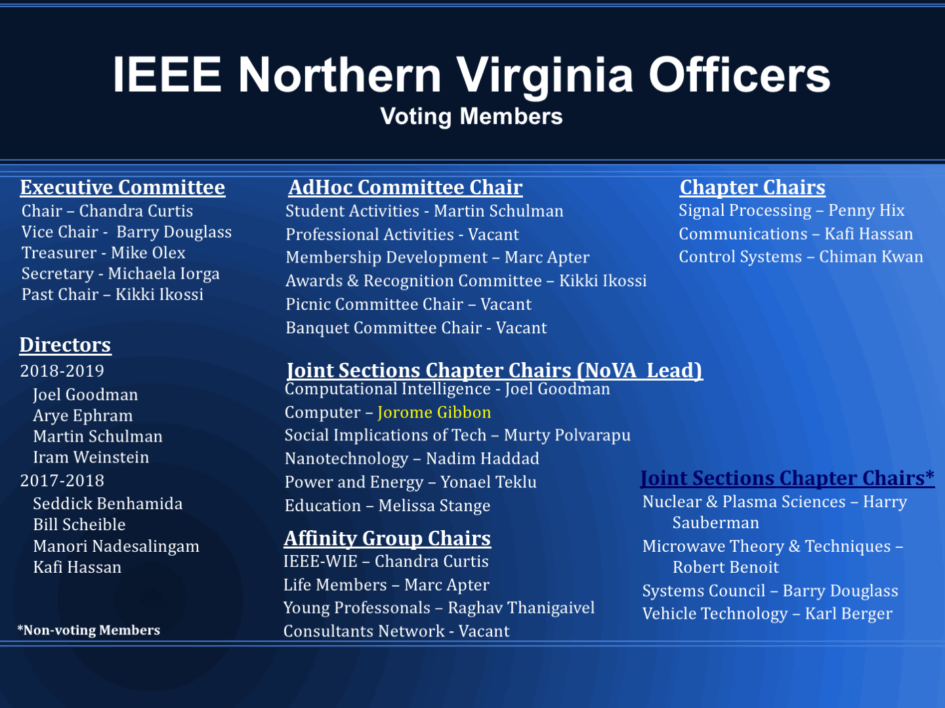

# Appendix 1: 2019 WIE Forum (Old Business)

The 2019 WIE Forum will be coming to your section this year.  We are doing site selection right now.  This is the 5th year anniversary since we have revived this conference and Neeta Basantkumar (from Baltimore Section) and I are co-chairing again as we did in 2017 in Baltimore (It alternates between R and R2).

You can see previous years programs here: <http://sites.ieee.org/wie-forum-usa-east/>

We traditionally ask the local section to cosponsor about 10% and the hosting region to cosponsor about 30% (WIE 30% and non hosting Region and IEEE-USA make up the rest) and both to help us promote and find speakers and patrons/supporters.  As soon as we select a venue (late next week we will be visiting) we will do this officially with a budget and ICX application but I wanted to give you a bit of background first before we formally submit.

Since we revived this conference in 2015 we have always had a healthy surplus and we have had about 200 attendees per year.

I'll reach back out once we have a venue and budget but I would appreciate a tentative consideration and decision by your committee (pending an approved budget) so we can get the ICX application in and approved as soon as possible after we have these items completed.

Thanks for your consideration and let me know if you have questions.

Felicia Harlow ([fharlow@ieee.org](mailto:fharlow@ieee.org))

# Appendix 2: 2019 Funds Allocation for Projector (New Business)

Whereas the NoVA IEEE chapter AdCOM is required to utilize borrowed facilities for its monthly chapter meetings, and that those meetings always require the digital projection of PC or MAC based documents, it is moved that funds be allocated for the purchase of a portable video projector, with the following requirements:

1. The projector supports current video/audio interfaces such as HDMI, USB as well as conventional SVGA/VGA.
2. Remote control is required.
3. Wireless support would be an added benefit and suggested
4. Projector provides at least 120” display from 15 feet. Bigger is better.
5. The projector comes with carrying case and all necessary cables
6. A PORTABLE STAND adequate to support the weight of the projector is also to be acquired
7. A 50-100 ft. 110V extension cable is also to be acquired
8. 25 ft. HDMI and SVGA/VGA cables (one each) is also to be acquired
9. Any necessary software to allow for either PC or MAC use is also to be acquired.
10. Said projector, cables, stand and software to be the responsibility and care of the AdCOM secretary who shall be responsible for bringing or getting the projector/cables/stand to each AdCOM meeting and offering it to IEEE NoVA committees for their use as appropriate.
11. If required, a spare/replacement projector bulb should be also acquired.
12. The proposed projector and equipment cost is not to exceed $600.

# Appendix 3: 2019 Leadership Training

We are into the new year and we should schedule the Leadership Planning meeting if we plan to hold it this year. As previously discussed, the NOVA section was going to handle meeting logistics (location, meals) and I will manage pulling together the presentation.

I would like about 4 weeks before the session to allow time to put together the agenda and line up the presenters. So, I would suggest we consider Feb 9 or 16th. (Note: Feb 16th is the E-Week Family Day)

**Also, I see that Region 2 is asking for budget requests and this program qualifies. I will send him a note and suggest $1000 which is about 35 people at $20 each for food and $300 for the location.**

Since both sections are having meetings this week do you think we can establish the plans.

Best Regards,

Doug Holly

# Appendix 4: Motion to award cash prizes at the 2019 Fairfax, Loudoun, Northern Virginia, and Prince-William regional STEM fairs

    The 2019 regional STEM fairs are held in March and it’s likely the registration deadline for several will be over by the February AdCom.  If we want to provide organizational awards to winners (and inviting them to the banquet) again this year please add to this month’s agenda:  
    
 “Move we fund up to $250 in cash prizes for the best projects with strong IEEE-related content in each of the 2019 Fairfax, Loudoun, Northern Virginia, and Prince-William regional STEM fairs - up to $1000 total."  
  Submitted: Marty Schulman, Second: Marc Apter

**UPDATED MOTION** proposed by Marc Apter, second by Marty Schuman: “*Move we fund up to $250 in cash prizes for the best projects with strong IEEE-related content in each of the 2019 Fairfax, Loudoun, Prince-William, Clarke and Frederick Counties, and the Cities in Northern Virginia holding STEM fairs - up to $1500 total*.”

# Appendix 5: Motion to fund scholarships for the Camp Invention

Though they do not have deadlines, Camp Invention has also begun their 2019 fundraising campaign.  If it wouldn’t be controversial consider adding this additional motion, but otherwise it can be left as a budget line item:  
    
 “Move we fund $1000 in scholarships for Camp Invention’s week-long summer sessions for students who live or attend in our section’s territory."

**UPDATED MOTION** proposed by Marc Apter, second by Marty Schuman: “*Move we fund $1000 in scholarships for Camp Invention’s week-long summer sessions for students who live or attend school in our section’s territory*.”

    Note that after last year’s fairs I learned the IEEE passed new guidelines for events with minors.  After reviewing their webpage, it does not appear to apply to either of these activities, but I wrote the attached interpretation of how we meet or will try to meet the guidelines anyway, or whether we cannot.  Please let me know if you see anything differently.  
  