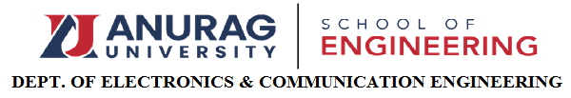
IEEE-CAS-CHAPTER-ACTIVITY REPORT
Name of the activity: Quiz
Title /Topic Quizzy Buzzers
Date: 19/12/2023
Coordinators: Dr.G.Renuka, Dr.M.Santhosh
Participants: III year students of ECE
No. of participants: 61(5-IEEE &56- Non IEEE)
Summary: This event is conducted on 19/12/2023 from 1.30pm to 4.00pm.
Total 28 teams with each team is of 2 members had participated in the event. Conducted 2 rounds, first round is of current affairs and technical questions, and second round is about Verilog coding. Here the students gained a practice over existing knowledge and they are refreshing their previous semester subjects. They are able to understand at what level they are need to coup with their subjects. It helped them to boost their confidence. They got the opportunity to share the knowledge with their friends in a team, in this way they can improve their team work skills.
Pictures:
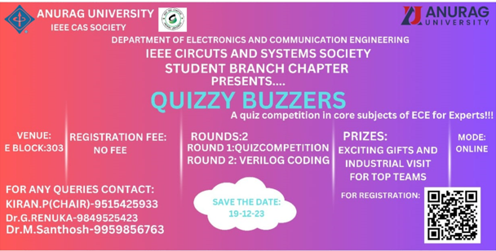

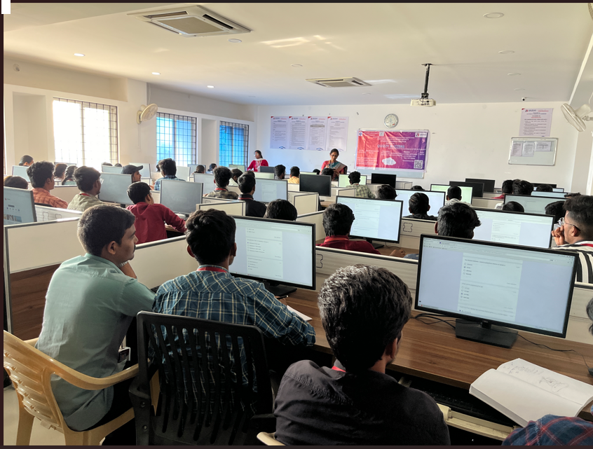
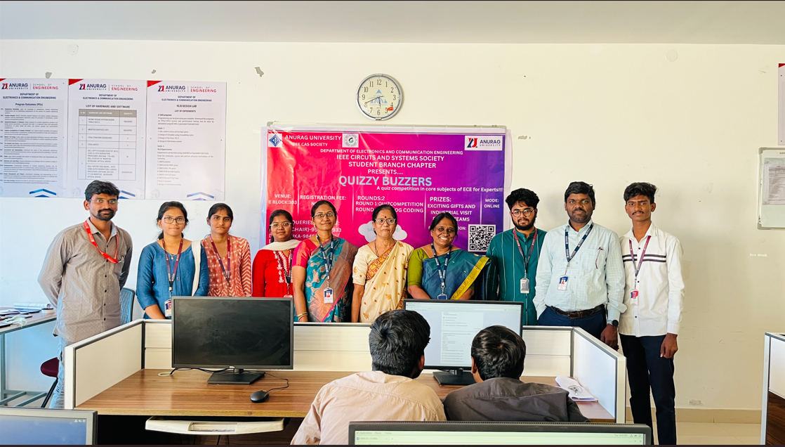
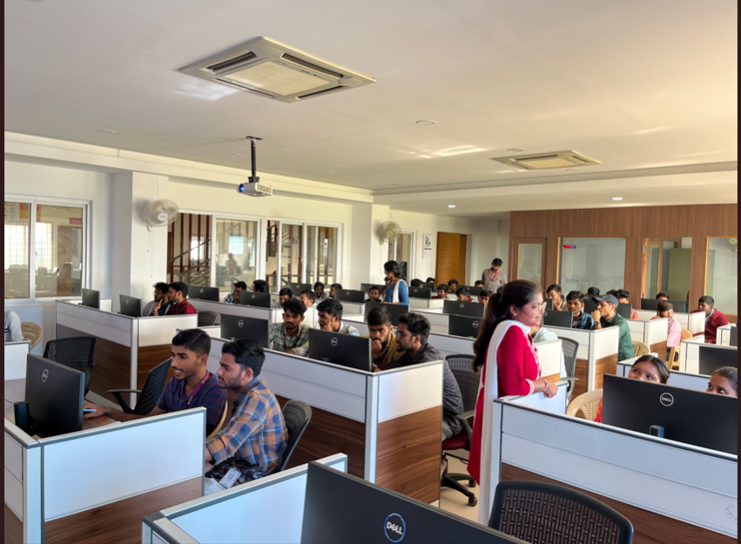

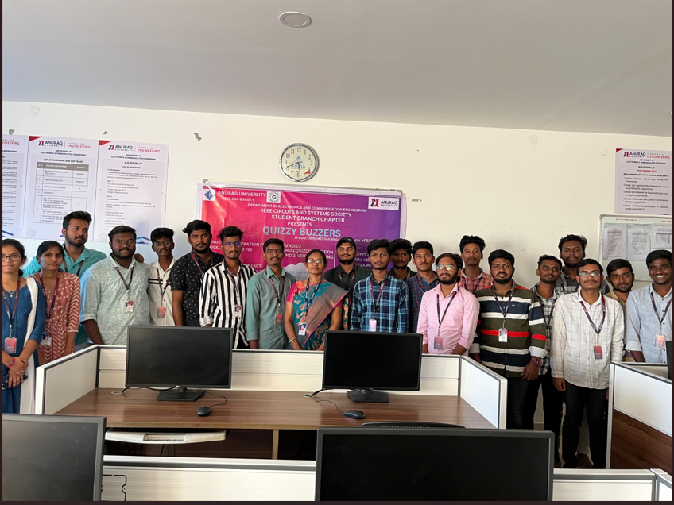

Report prepared by: Dr.G.RENUKA

