

**CONERGENCE 2k23R**

**SPOTLIGHT**

**DATE:** 14th December 2023

**Timings:** 11:00 am – 1:30 pm

**Venue:** D BLOCK -APJ ABDUL KALAM AUDITORIUM

**Student Coordinator:** Sahithya , Avighna

**Faculty coordinator:** Dr.Nageswara Rao

SPOTLIGHT is an event conducted under the theme SAARADHI in the annual technical symposium conducted by IEEE, ACM and IUCEE. SPOTLIGHT is an event which focusses on providing the students valuable insights in the world of latest technologies.

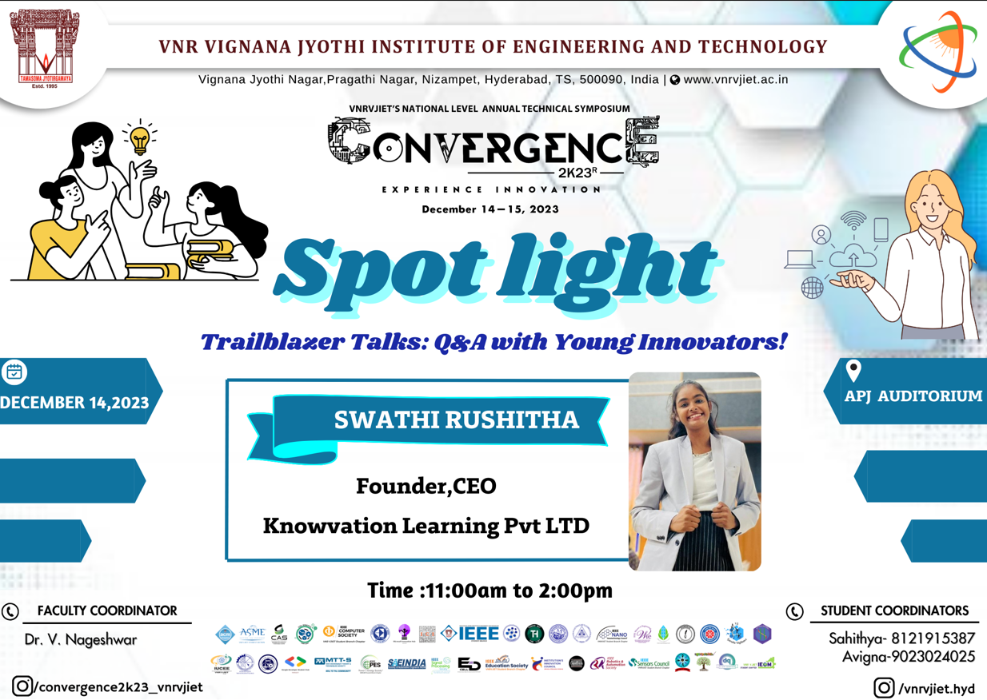

The speaker for the event was Miss. Swathi Rusheetha , CEO and Founder of Knowvation Technologies PVT.LTD. Being a Passionate women about shaping the future of education, she leads Knowvation Learnings as its CEO. With a vision for revolutionizing learning experiences, they are on a mission to empower learners with revolutionized courses on the latest technologies. They believe that knowledge is the ultimate catalyst for growth, and through Knowvation Learnings, they are dedicated to creating a dynamic and engaging learning environment which caters collaborative learnings, networking, entrepreneurial development and boosts the spirts of youngsters to come out with passion filled with knowledge and innovation.

During the session she provided the students with wonderful insights on latest technologies covering the topics like enterprenurship and its importance, importance of innovation , best coding methods to be followed along with she discussed with students regarding the market condition and demand of technologies like CyberSecurity , Artificial Intelligence, Machine Learning , 5G technology, Quantum Computing , Python , Blockchain etc.. and many others.

Students expressed their questions and queries which she clarified in the most enlightening , encouraging and interactive way. She installed a huge amount of confidence, knowledge , faith , belief and optimism in students with her interactive talk. We show our immense gratitude towards her in spending her precious time for us , inspiring and motivating the students to towards their goals.

**No of Participants : 103**

