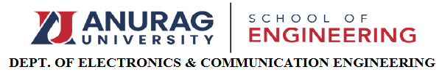

**IEEE-CAS-CHAPTER-ACTIVITY REPORT**

**Name of the activity:** IEEE Inauguration

**Title /Topic:** IEEE Chapters Inauguration & IEEE Student branch website launch

**Judge/ Resourse person with designation, company name, location:**

**Dr Fakhrul, Zaman Rokhani**,Vice President Education and Communications, IEEE CAS Society

**Dr Sudharshan Jayabalan**, IEEE RAS Chair, Hyderabad Section

**Prof. P A Govindacharyulu**, IEEE CASS Chair, Hyderabad Section.

**Dr SVNL Lalitha**, IEEE PES Chair, Hyderabad Section

**Dr. Santhosh Sivasubramani,** Founding Chair - IEEE Nanotechnology Council,Hyderabad Section Chapter.

**Dr. VijayaLatha**, Chairman, IEEE Hyderabad Section

**Prof Saikumar Tara**, Chairman , Student Activities Committee

**VSK Murthy Balijepally**, Chair, Industry Relations, IEEE Hyderabad Section

**Date:** 14/12/2023

**Coordinators:**  Dr.G.RENUKA, Dr.M.Santhosh

**Participants: S**tudents of all departments**.**

**No. of participants**: 140

**Summary:** IEEE Inauguration and IEEE student branch website launch are conducted on 14th Dec 2023. The students are able to know what are the different types of events to be conducted, what are benefits of IEEE such as research grants, travel grants, scholar ships, awards and positions in IEEE. They came to IEEE is a knowledge sharing platform where they can present their ideas or concepts. They came to know different chapters in IEEE and their advantages and how they can be volunteers in the activities of IEEE, how the current technology is useful to us through these IEEE chapters.

**Pictures:**

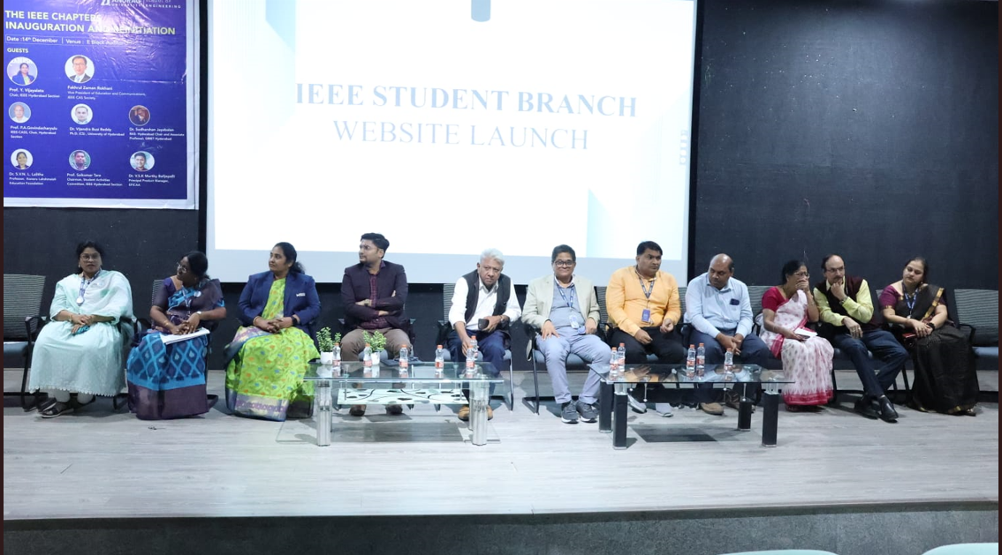

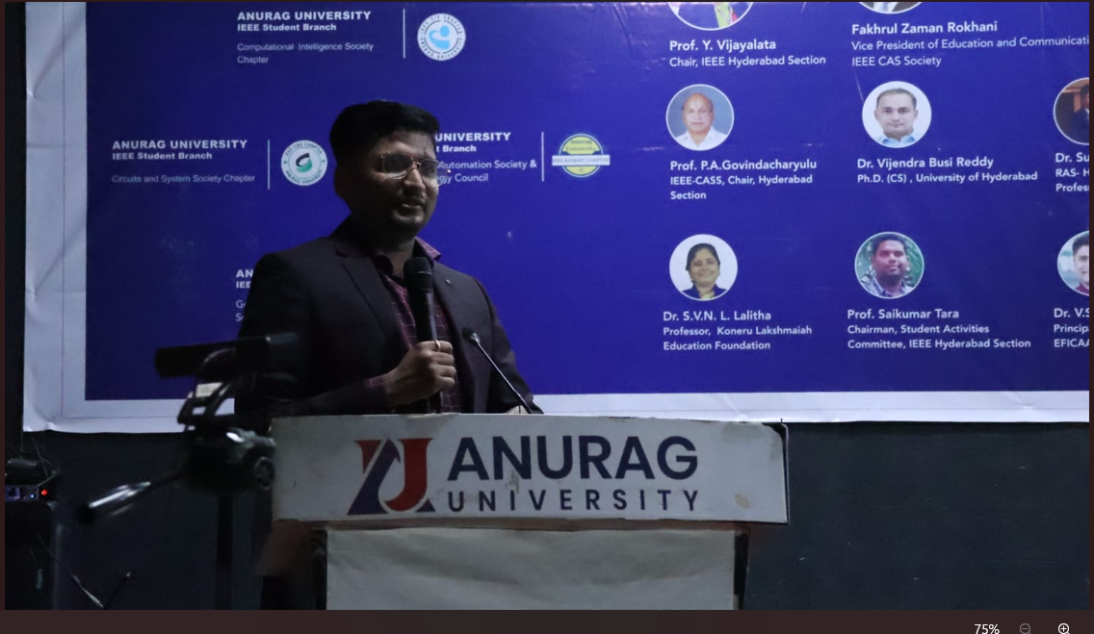

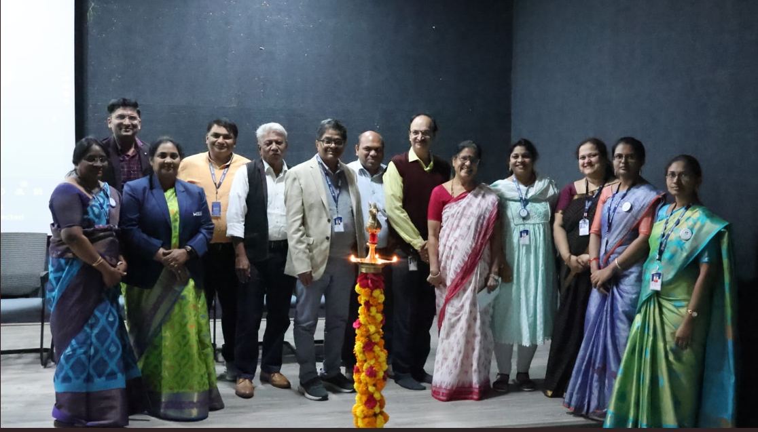

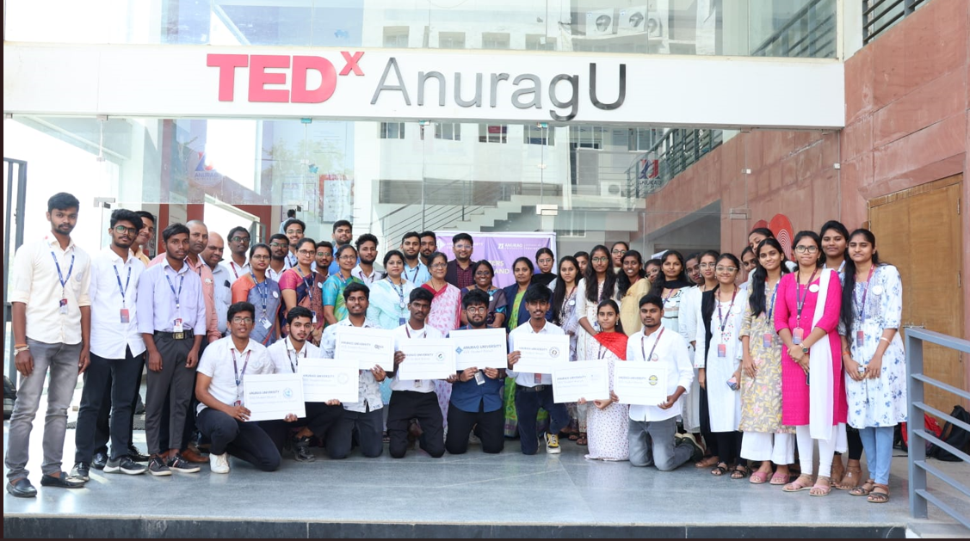

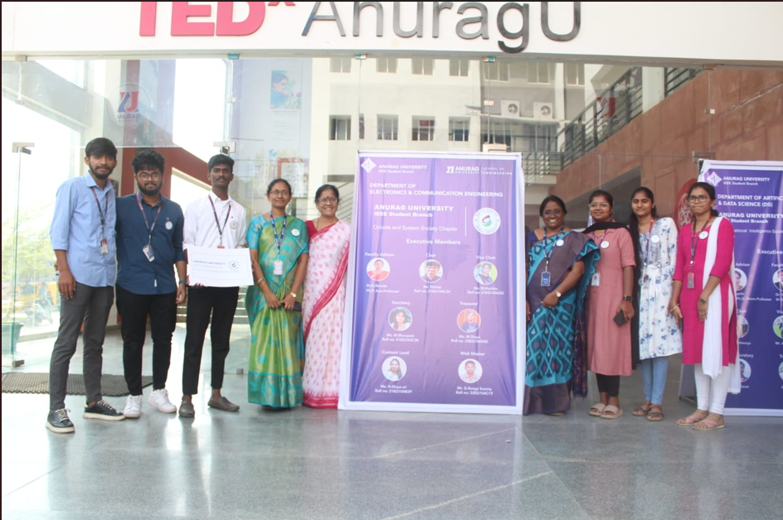

**Report Prepared by : Dr.G.RENUKA**