**General Body Meeting**

**Event Report**

|  |
| --- |
| **Event Information** |
| **Event Type:** Meeting |
| **Event Title:** General Body Meeting |
| **Event Dates:** 21st September, 2023 |
| **Organized for:** IEEE MPSTME RAS Members |
| **Organized by:** IEEE MPSTME RAS |
| **Engagements:** 35 |

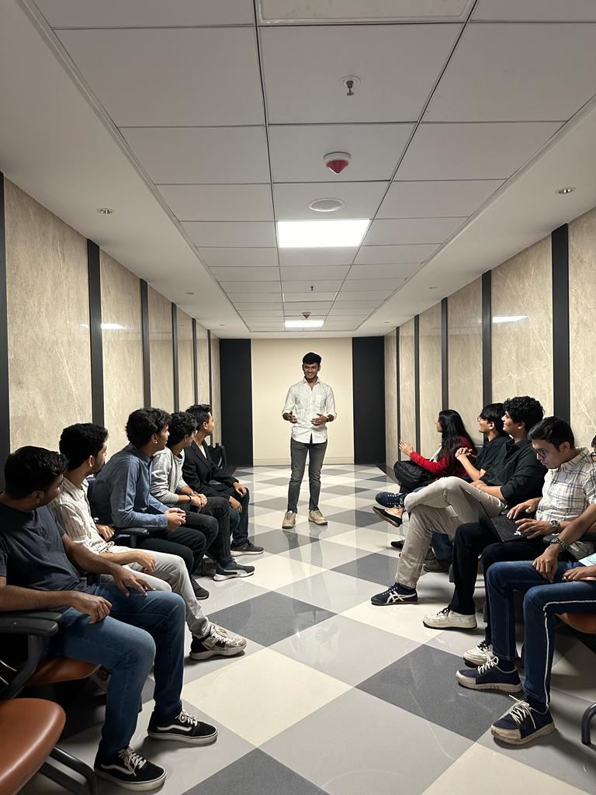

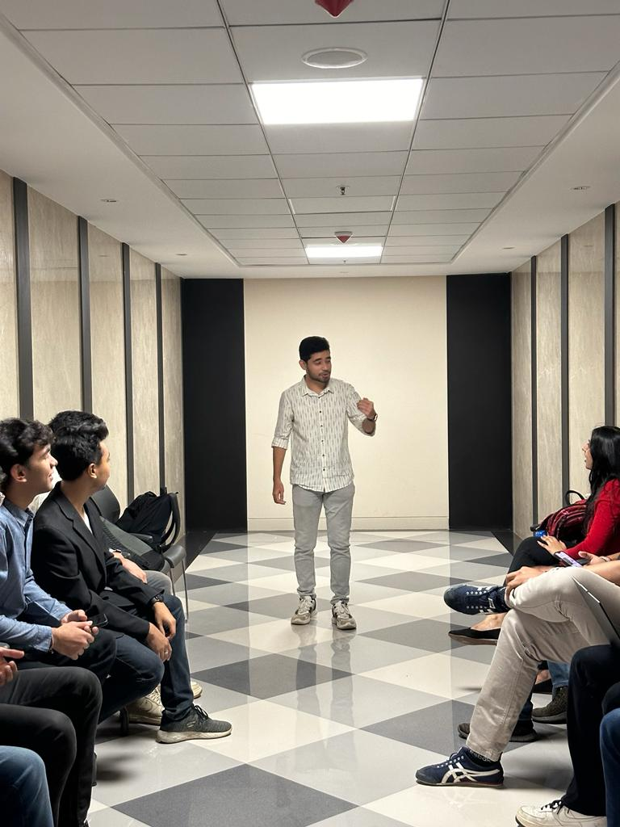

The GBM kicked off with a warm welcome from the committee chairperson, Chinmay Bhurke who briefly introduced the agenda for the evening. The first part of the meeting focused on a recap of the committee’s recent activities, including the highly successful inaugural event, Tech-No-Logic. Members shared their positive experiences and highlighted the event's positive impact on promoting interest in robotics among students.

Following the Tech-No-Logic recap, the GBM transitioned to brainstorming future event ideas centered around robotics. Members enthusiastically proposed various possibilities, with a focus on providing engaging and educational experiences for all skill levels. Some of the most popular ideas included:

* Robotics Competitions: Organize robotics building contests, robot races, or obstacle courses to encourage creative problem-solving and technical skills development.
* Advanced Robotics Workshops: Offer workshops focusing on specific areas like AI, coding for robots, or 3D printing for robot parts, catering to members who want to delve deeper into the technical aspects of robotics.
* Guest Speaker Series: Invite industry experts or renowned roboticists to share their knowledge and experiences with the club members, providing exposure to real-world applications and career opportunities in the field.

The GBM dedicated a significant portion of its discussion to formulating strategies for attracting new members, conducting effective interviews, and increasing the committee's visibility among potential recruits. Being a new and upcoming committee, we needed to mark out presence on the map. We discussed several strategies to maximize our reach:

* Digital Presence: Leveraging social media platforms like Instagram and LinkedIn emerged as a prime strategy. Creating engaging content showcasing past projects, events, and member achievements was proposed to spark interest and attract potential recruits.
* Incentive Programs: Offering benefits such as mentorship opportunities, discounts on workshop fees, or early access to events was discussed as a potential method to attract and retain new members.
* Open Recruitment Events: Hosting informal gatherings or information sessions during college breaks were suggested to provide a platform for interested students to learn more about the club and its activities in a relaxed setting.

Overall, the GBM discussion demonstrated a proactive and engaged approach towards expanding the committee’s membership and outreach. The proposed strategies addressed various aspects of attracting new members, assessing their suitability, and effectively communicating the club's value proposition to a wider audience. Implementing these suggestions alongside continued brainstorming and adaptation will likely contribute to the club's sustained growth and success in attracting passionate and talented individuals. Moreover, new event ideas and recruitment related strategies were formulated.

