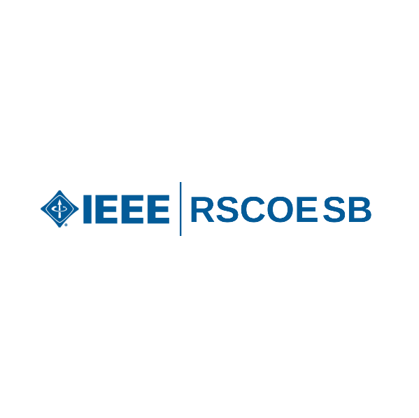**Investiture Ceremony**

**Session Name : Investiture Ceremony**

**Mode of session : Offline**

**Date : 3rd November 2023**

**Number of Attendees : 20**

On November 3, 2023, the IEEE RSCOE Student Branch (SB) held its first-ever investiture ceremony for new members. The event, organized by the core members, started at 8:30 am and turned out to be a big success.

Siddhesh Malekar kicked off the program with a simple talk, introducing new members to IEEE and RSCOE SB. He talked about the many opportunities the SB offers and explained the technical stuff about IEEE. After that, there was a fun part where new members watched clips from past events and behind-the-scenes moments. They seemed to enjoy it.

Then, there was a light and fun activity. Each student shared three things about themselves, and the others had to guess which one was false. This helped everyone get to know each other better and strengthened the team spirit.

Later, Shailaja Patil ma'am addressed the new members with excitement. She encouraged them not just to join SB activities but also to be part of broader IEEE projects. She talked about making the most of IEEE membership, and her talk left the students feeling motivated.

The ceremony wrapped up with a cake-cutting moment with Dr. Shailaja Patil ma'am and the team. The event ended at 9:30 am, followed by a quick photo session to capture the memories.

In a nutshell, this first investiture ceremony was a mix of informative talks, fun activities, and motivation, showing the unity and commitment of IEEE RSCOE SB. It was a warm welcome for new members and set the stage for a friendly and collaborative journey within the IEEE community.

**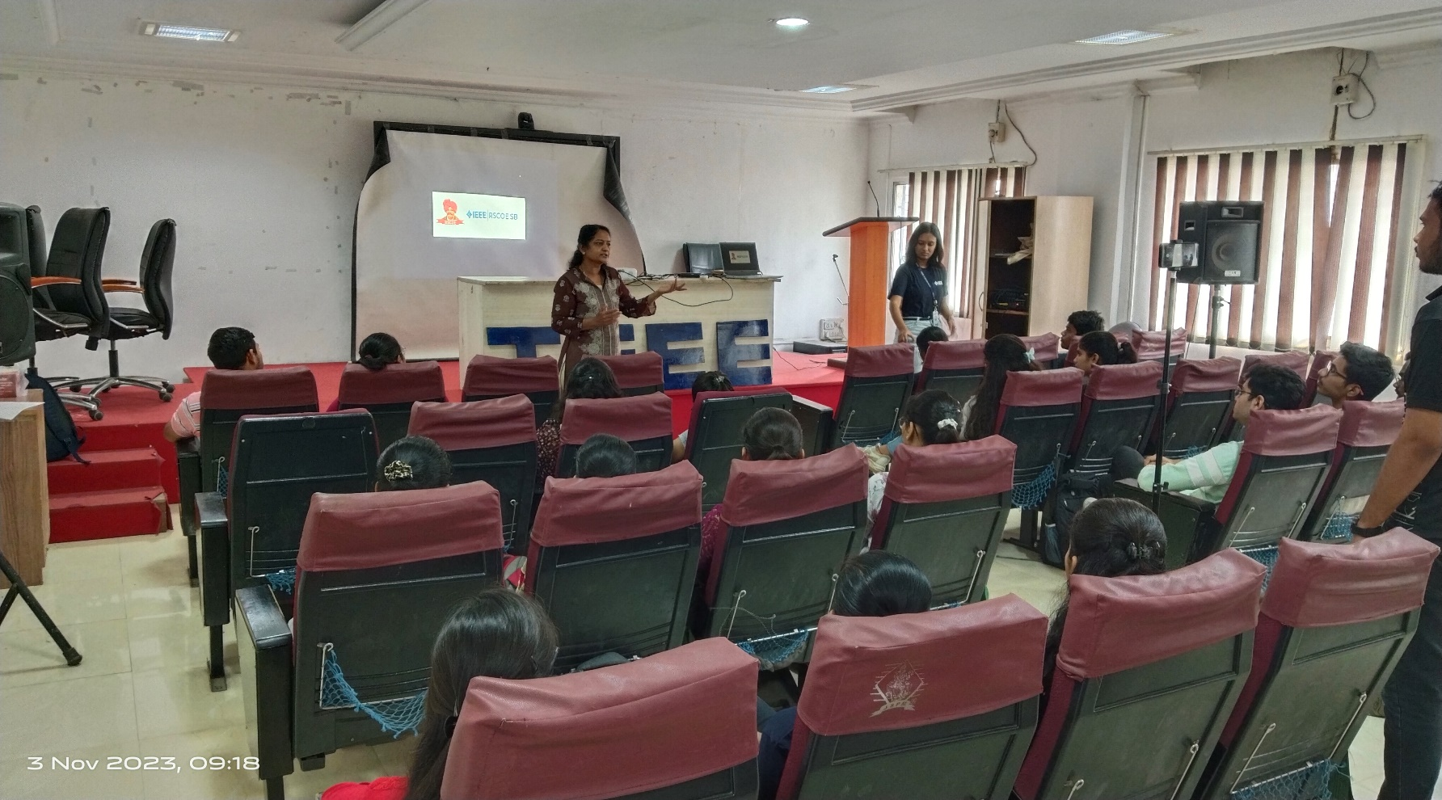****Few glimpses of Investiture Ceremony**

