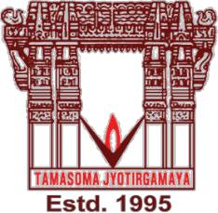**VALLURUPALLI NAGESWARA RAO VIGNANA JYOTHI**

**INSTITUTE OF ENGINEERING AND TECHNOLOGY**

An Autonomous, ISO 9001:2015 & QS I-Gauge Diamond Rated Institute, Accredited by NAAC with ‘A++’ Grade

NBA Accreditation for B.Tech. CE,EEE,ME,ECE,CSE,EIE,IT,AME, M.Tech. STRE, PE, AMS, SWE Programmes Approved by AICTE, New Delhi, Affiliated to JNTUH, NIRF (2023) Rank band:101-150 in Engineering Category

College with Potential for Excellence by UGC,JNTUH-Recognized Research Centres:CE,EEE,ME,ECE,CSE Vignana Jyothi Nagar,

Pragathi Nagar, Nizampet (S.O.), Hyderabad – 500 090, TS, India.

Telephone No: 040-2304 2758/59/60, Fax: 040-23042761

E-mail: [postbox@vnrvjiet.ac.in,](mailto:postbox@vnrvjiet.ac.in) Website: [www.vnrvjiet.ac.in](http://www.vnrvjiet.ac.in/)



**WILL YOU BE MY TEACHER**

Will You Be My Teacher is an event of Saaradhi organised by Team NSS as the part of CONVERGENCE 2K23 that aims to inspire young minds that are ready to dream and set their goals. This event is conducted to instil knowledge in school children. As a part of this event we approached the nearby schools which had students who were required to be moulded in a proper way. We aimed to give them sufficient knowledge about education and its importance to reduce dropouts and teach them values so that they can choose their future. Having all the permissions granted from the schools end, we started this event by picking up 10th class students from ZPHS Mallampet school in our college buses at 9:30 am..

The students were brought to VNRVJIET and were firstly given the experience of our college tour for 2 hours. They started exploring our college from PEB, Sports block along their way to rest of the blocks. Our technical fest environment and stalls were shown to them to create exposure. They were also entertained by some fun activities conducted by NSS volunteers. As said, we provided proper food and water to the school children for their lunch. They were taken into a classroom where they were guided about their career, scholarships and entrance exams and were educated about moral values and ethics. Few interested students also took part in I am Not a Hero where they were given a chance to listen to the valuable words and journeys of unsung heroes. They also took part in the interactive sessions. They were given chocolates, printouts of scholarship guidelines and other important information along with the bookmarks which educate them about the 17 Sustainable Development Goals. Later we carefully dropped them back in their schools by our buses by 4:30 pm.

This guidance made them realise the importance of their next stages of life. The students were greatly enthusiastic, excited and welcoming. We were overwhelmed by their response to our event. We hope we could be a small part of their change and they could avail all the opportunities to achieve their dreams.

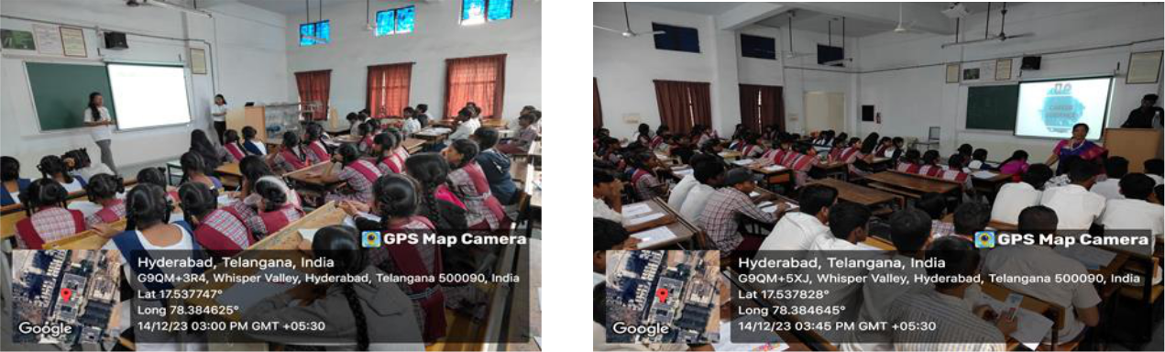

**Students actively participating in career guidance session**

**VALLURUPALLI NAGESWARA RAO VIGNANA JYOTHI**

**INSTITUTE OF ENGINEERING AND TECHNOLOGY**

An Autonomous, ISO 9001:2015 & QS I-Gauge Diamond Rated Institute, Accredited by NAAC with ‘A++’ Grade

NBA Accreditation for B.Tech. CE,EEE,ME,ECE,CSE,EIE,IT,AME, M.Tech. STRE, PE, AMS, SWE Programmes Approved by AICTE, New Delhi, Affiliated to JNTUH, NIRF (2023) Rank band:101-150 in Engineering Category

College with Potential for Excellence by UGC,JNTUH-Recognized Research Centres:CE,EEE,ME,ECE,CSE Vignana Jyothi Nagar,

Pragathi Nagar, Nizampet (S.O.), Hyderabad – 500 090, TS, India.

Telephone No: 040-2304 2758/59/60, Fax: 040-23042761

E-mail: [postbox@vnrvjiet.ac.in,](mailto:postbox@vnrvjiet.ac.in) Website: [www.vnrvjiet.ac.in](http://www.vnrvjiet.ac.in/)



No of Participants: 109

Venue: B-215

Timings: 10:20 am to 04:00 pm

Faculty Coordinators: Dr.P.Padmavathi, Assistant Professor, Humanities & Science

Dr.B.Ashok, Assistant Professor, Humanities & Science

Student Coordinators: A. MANIDEEPAK - 21075A0519

M. RITHIKESH - 21071A66F5

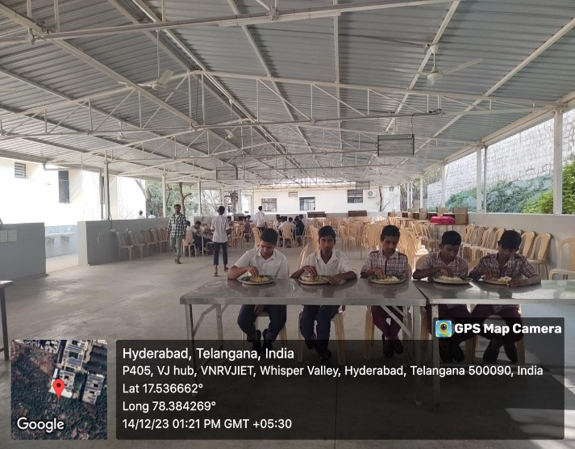 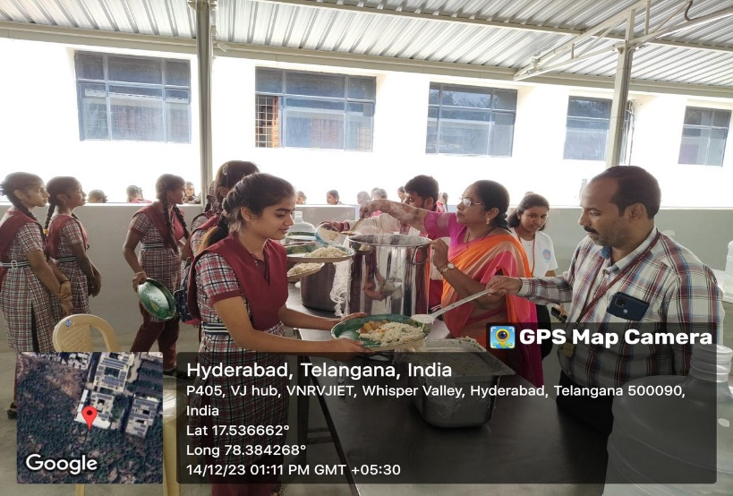

**Food was provided to children**