**CASS BLITZ Test REPORT**

**Report of the CASS BLITZ Test at APCCAS-23**

**Date: 2023-11-21**

**Time: 2:00PM-3:40PM**

**Venue: T-Hub, Amphitheatre**

**The CASS BLITZ Test 2023, hosted at T-Hub in Hyderabad was seamlessly integrated into the Asia-Pacific Conference on Circuits and Systems (APCCAS) 2023, serving as a valuable component of this international conference. The collaboration allowed for the convergence of academia, industry, government, and research organizations on a global scale**

**Dr. Fakhrul, the head of the IEEE CASS education initiative organized this test Coordinated by the faculty from Anurag University and supported by enthusiastic volunteers, the competition drew the participation of 158 students from IITs, universities, and reputed engineering colleges.**

**The competition comprised two main tracks, focusing on specific domains: Analog Signal Processing and VLSI System Applications. Participants faced the challenge of answering 20 questions within a strict 45-minute time frame, testing their knowledge and proficiency in these specialized areas**

**All attendees were acknowledged for their participation with a Certificate of Attendance, recognizing their commitment to advancing their skills in circuits and systems. To add a competitive edge, the top 5 winners from each track were honored with a cash prize of $15 along with a Winning Certificate, acknowledging their outstanding performance.**

**List of Colleges Represented**

**1 Anurag University**

**2 G Narayanamma institute of technology and science**

**3 Geetanjali college of engineering and technology**

**4 Guru Nanak institutions of technical campus**

**5 IIT Guwahati**

**6 IIT Roorkee**

**7 Indian Institute of Technology, Jodhpur**

**8 Kagashima University**

**9 Methodist college of engineering and technology**

**10 MVSR ENGINEERING COLLEGE**

**11 Osmania University**

**12 Stanley College of Engineering and Technology for Women**

**13 University College of Engineering osmania University**

**14 VNR Vignana Jyothi Institute of Engineering And Technology**

**PHOTOS**

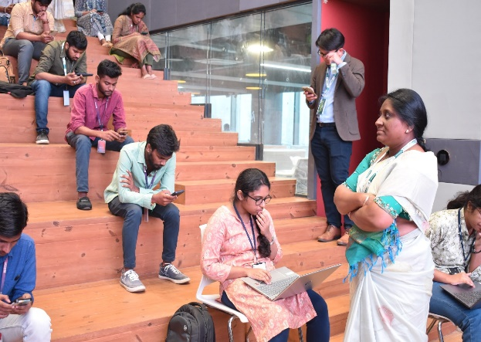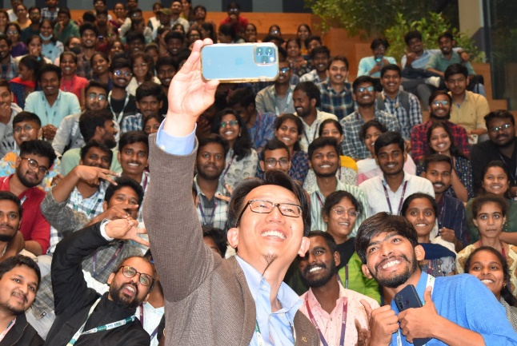

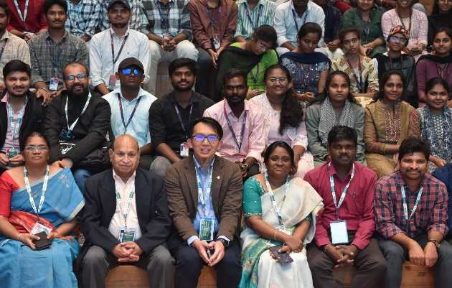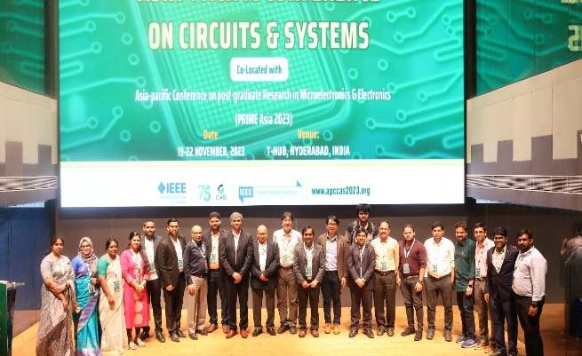

**CONCLUSION**

**The CASS BLITZ Test 2023, hosted at T-Hub in Hyderabad and organized by Dr. Fakhrul and the team from Anurag University, was an integral part of the APCCAS 2023 international conference. It stands as a testament to the commitment to advancing education and research in circuits and systems. The event not only provided a competitive platform for students but also connected professionals and researchers worldwide, contributing to the collective growth and development of the field**