**Report on Expert Lecture**

**Date** – 9th March, 2024

**Topic** - Hyperspectral Remote Sensing: Indian and Global Perspective

**Expert name** - Dr. Bimal K. Bhattacharya, Group Director, Agriculture, Forestry, Ecosystem Sciences and Applications Group (AESG), Earth Ocean Atmosphere Planetary Sciences and Applications Area (EPSA), SAC, ISRO, Ahmedabad

**Organisers** - IEEE GRSS Gujarat Section, IEEE GRSS CEPT Student Branch and M. Tech (Geomatics) program, CEPT University, Ahmedabad.

**Brief**

The session was conducted between 11 to 12pm at U01-201, CEPT University. The was initiated and anchored by Ms. Shraddha Shende, IEEE GRSS CEPT Student Branch Chair. The session started with the welcome address to all guests, students, professionals, faculties and distinguish speaker. The speaker, a distinguished and knowledgeable expert in his domain was welcomed to the dias. A brief introduction is mentioned below:

Dr. Bimal K. Bhattacharya is the Group Director of the Agriculture, Forestry, Ecosystem Sciences and Applications Group (AESG), of the Earth Ocean Atmosphere Planetary Sciences and Applications Area (EPSA) at the ISRO’s Space Applications Centre, Ahmedabad. He is currently executing an umbrella agricultural program called SUFALAM to provide space-based solutions to stakeholders using satellite remote sensing, GIS, and modeling at different levels related to production forecasting for less-explored crops using various approaches, including AI/ML, spectro-meteorological and crop yield models, aiding agro-advisories for the farming community, crop insurance to support PMFBY (Pradhan Mantri Fasal Bima Yojana) program and agro-industries. He significantly contributed to developing operational agro-met products from the INSAT suite of satellites. He is now involved in executing the Agri-Decision Support System (DSS) project for Govt. of India's digital agriculture initiatives. He and his team are currently working on developing precision farm-scale solutions for smart and digital agriculture.

He is an ISRO representative in the CEOS Land Surface Imaging (LSI) virtual constellation and GEOGLAM sub-group. He played an important role in the definition of ‘Essential Agricultural Variables’ from EO data under the umbrella of GEOGLAM. He is the ISRO science principal investigator of the Indo-French high-resolution thermal infrared mission, TRISHNA. He received several prestigious awards for his scientific contribution and published more than 80 research papers in international and national journals. He has guided five (5) doctoral students.

Post introduction, the speaker was welcome with a momento. It was presented by Asia Pacific R10 Head, Dr. Shiv Mohan. The speaker commenced his talk.

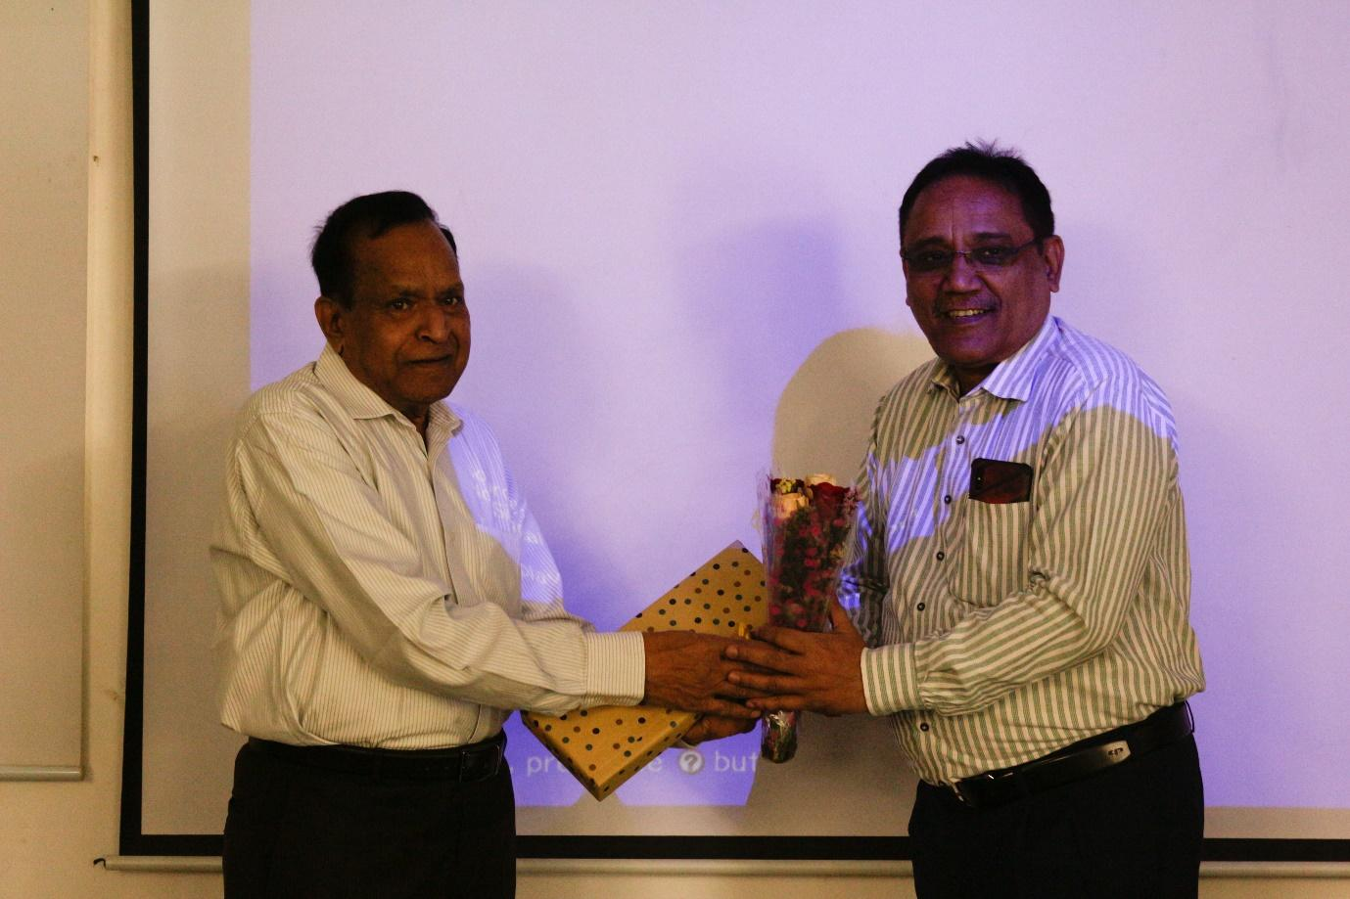

Dr Bimal K Bhattacharya commenced his sessions with a brief introduction of hyperspectral remote sensing, its various applications, and the working principle of imaging spectroscopy. Further, discussing spectral signatures of different kinds of features and technology development by ISRO, contributions by him and his team, different applications of AVIRIS-NG (Airborne Visible InfraRed Imaging Spectrometer - Next Generation) sensors (a jointly developed sensor by NASA, USA and ISRO, India) and ISRO’s contribution to it.

He briefly spoke about Vedas program, which provides the data products for any registered user and discussed about the tool box developed to use AVIRIS-NG data - AVHYAS (Advanced Hyperspectral Data Analysis software toolbox). He discussed several studies carried out, by using this data product, many research papers under his guidance, including creating new indices with existing ones for different applications. He shared some glimpses of upcoming missions under ISRO and collaborative missions.

|  |  |
| --- | --- |
|  |  |

Further, he concluded his session by discussing the integration of new technologies, like AI and ML for specific issues like food monitoring. By automating feature extraction, improving classification accuracy, and enabling efficient data analysis, AI empowers researchers and agricultural professionals to gain deeper insights from hyperspectral data and make informed decisions that enhance food quality and production practices. As an example, this technology was used on a Sahyandri farm, a farmer community in Nashik. It has a big area, and farmers are facing issues in identifying the health of grape plants. They monitored the health of the grape plants using hyperspectral remote sensing.

He closed his session, by talking about the the upcoming and current training programs carried by the SAC and encouraged everyone to participate in it as per their suitability. Around 50 students and professionals participated in the event from Silver Oak University, Gujarat University, IIT Bombay, Bharathidasan University, SpaceX Tech etc. were gathered to attend the session. The students had a great discussion with the guest related to the lecture and about the opportunities in this field.

The event concluded with a vote of thanks given by Shraddha Shende, a group photo and a refreshments.