**IEEE SRI SAI RAM INSTITUTE OF TECHNOLOGY**

**Innovation and Entrepreneurship**

**Outreach Program in Schools**

**NAME OF ORGANISING UNIT:**

IEEE Sri Sai Ram Institute of Technology Student Branch (STB03109)

UBA Sri Sai Ram Institute of Technology

IIC Sri Sai Ram Institute of Technology

**DATE OF THE EVENT:** Thursday, 7th March 2024

**Coordinators:**

Dr. Saritha G, IEEE SB Counselor

Ms. Vanitha N, IIC Coordinator

Mr. Muralidharan D, Ponshanmugakumar A

**MODE OF EVENT**: Offline

**TARGET AUDIENCE:** School students of Government Higher Secondary School

**ATTENDANCE:** 100+ Participants

**TIMINGS:** 10:00 am – 1:00 pm

**VENUE**: Government Higher Secondary School, Pazhanthandalam Village

**EVENT SUMMARY:**

The Innovation and entrepreneurship outreach program commenced with a stirring speech by Mr. Muralidharan D, UBA Coordinator, setting a vibrant atmosphere for the event. Led by IEEE Computer Society volunteers from IEEE Sri Sai Ram Institute of Technology Student Branch, the session primarily targeted class 9 students from government schools. Through detailed campaigns, students gained invaluable insights into the admission processes for engineering and technical schools, with a particular focus on the intricacies of Anna University's counseling procedures. The volunteers elaborated on the 7.5% special reservation quota for government school students, clarifying how fees are waived off under this provision and emphasizing its accessibility even after completing diploma education.

In addition to counseling on admission processes, the event aimed to foster a culture of innovation among the students. Innovative engineering ideas were shared, aimed at introducing sustainable technologies at the school level and inspiring creativity among participants. This segment of the session proved highly impactful, with over 100 students benefiting from the exposure to novel concepts and technologies. The interactive nature of the discussions encouraged students to think critically and engage actively with engineering concepts, providing them with a tangible vision of the possibilities within the field.

Furthermore, the event provided crucial information on competitive exams such as JEE and NEET, offering guidance on preparation strategies and exam patterns. Students were equipped with essential knowledge to navigate these exams effectively, empowering them to pursue higher studies in engineering and related fields with confidence. By igniting their passion for engineering and innovation and providing clarity on academic pathways, the session played a pivotal role in shaping the aspirations and ambitions of the participating students, laying a strong foundation for their future endeavors.

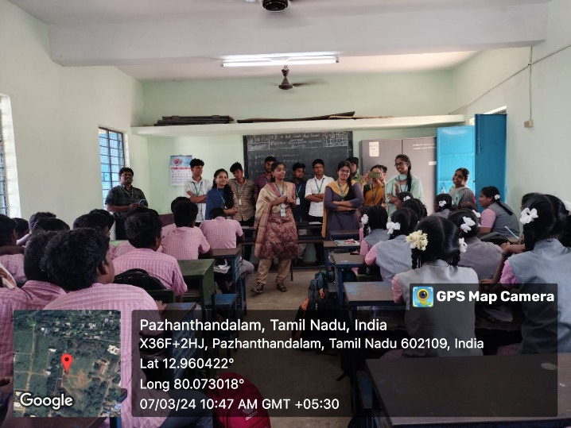 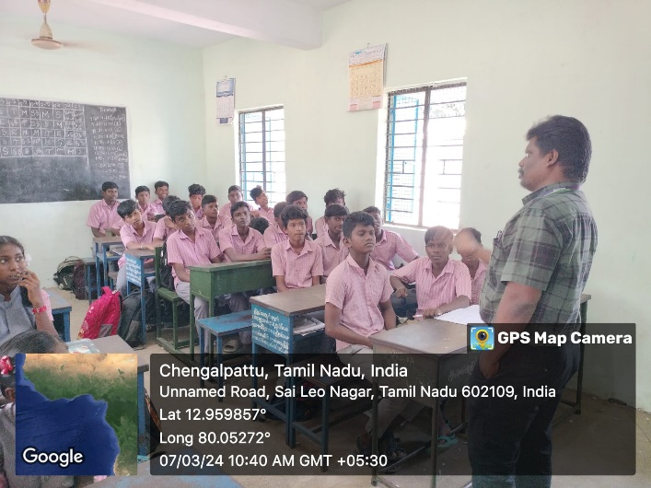

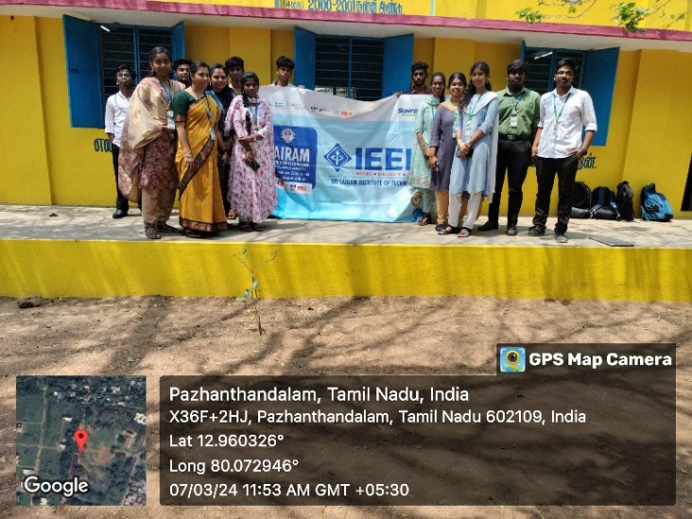

**Reported By:**

Balaji V S, 3rd year- CSE