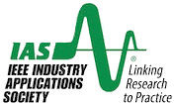

**IEEE PES & IAS BOSTON** PRESENTSA

**TECHNICAL MEETING** ON**:**

***Modern Grid Power Quality Challenges***

**Speaker**: **Dario Rozman  
 Sales Manager, Americas, ABB**

**Date: Tuesday, October 24, 2023**

**Time: Presentation starts at 6:00 pm**

**Location: Online only via MS TEAMS; no in-person gathering**

**(*Rsvp & Join on our website below)***

**Abstract**:

Power quality is a concern that can impact various businesses and locations across the globe. Even developed countries with modern power networks are not immune to power quality issues. Although local utilities strive to supply reliable and high-quality power, power quality issues persist and are inevitable.

This presentation focuses explicitly on power quality in critical continuous industries. Leveraging our expertise, we provide an overview of typical power quality challenges, how they affect various critical industries, and the solutions that can mitigate the challenges caused by poor power quality.

**Biography:**

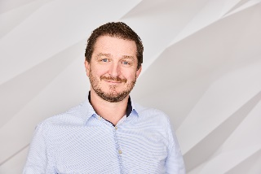Dario is the Regional Sales Manager for the Americas, and his primary role is the growth of the ABB Power Conditioning business in both North and South America. He is located in Calgary, Alberta, Canada, and his expertise comes from 18 years of experience in industrial power protection, electrification, and control applications across the globe. Before taking the Americas role, he managed the Global Product Management team in the Power Conditioning Center of Excellence in Napier, New Zealand. He joined the Napier team in 2013 from ABB Croatia, where he held different product and sales management positions for industrial products and systems.

Dario studied electrical engineering at the Faculty of Electrical Engineering and Computing in Zagreb, Croatia, focusing on automation and process control.

***Free and Open to the Public; RSVP is appreciated***

***Visit the IEEE PES Boston Chapter website for further details -*** [***http://www.ieeepesboston.org/***](http://www.ieeepesboston.org/)

***For any questions regarding this presentation or any IEEE PES Boston Technical Meetings,***

***please contact Risa (781-227-7999, risa.karanxha@nationalgrid.com)***