

IEEE COMPUTER SOCIETY SIT

THE UNVEILED SERIES EPISODE 8– THIRSTY AI

NAME OF THE ORGANIZING UNIT: IEEE COMPUTER SOCIETY SIT
DATE OF EVENT: Friday, 1st March
TOPIC: THE UNVEILED SERIES EPISODE 8 – THIRSTY AI
MODE OF EVENT: Online
TARGET AUDIENCE: Student Members
ATTENDANCE: 60
EVENT SUMMARY:
It is an online event which covered the information about the environmental impact of AI development and environmental challenges by AI development and actionable steps to be taken for implementing sustainable practices in AI-development. The analogy of sipping a 500ml water bottle and the researchers approach to water-supply officials were also discussed briefly.
TIMINGS: 7:00 pm – 8:30 pm
In the this online session , The development of AI exemplified by ChatGPT's energy consumption, underscores environmental challenges was elaborated . Insights were given about Researchers actively collaborating with water-supply officials to address sustainability concerns. Implementing actionable steps is imperative to mitigate AI's ecological footprint which includes optimizing energy consumption, engaging stakeholders and fostering a culture of environmental consciousness within the AI development community. Such efforts are essential for ensuring that technological advancement aligns with broader environmental goals and promotes sustainable innovation. Overall, the session successfully intertwined theoretical knowledge with practical applications, empowering participants with valuable insights about Thirsty AI.

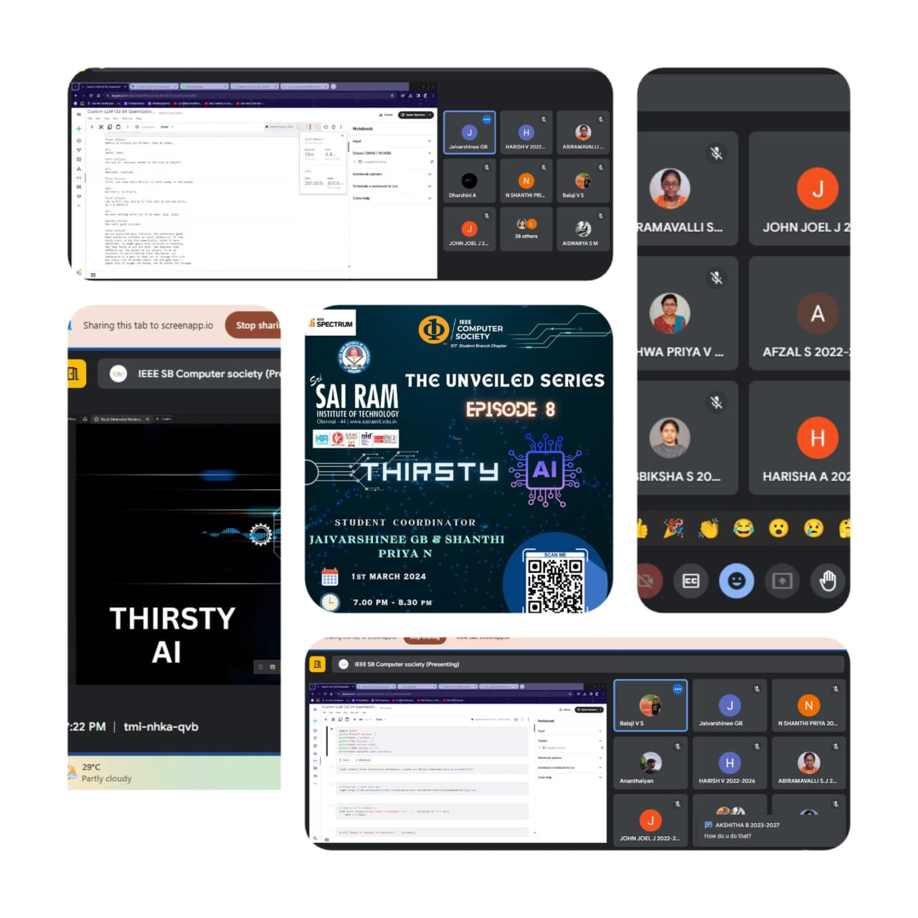
REPORTED BY:
KIRTHANA MOHAN R - – IEEE CS SECRETARY

