

IEEE COMPUTER SOCIETY SIT
THE UNVEILED SERIES EPISODE 9– AUTO ML

NAME OF THE ORGANIZING UNIT: IEEE COMPUTER SOCIETY SIT
DATE OF EVENT: 14th March , Thursday
TOPIC: THE UNVEILED SERIES EPSIDOE 9– AUTO ML
MODE OF EVENT: Online
TARGET AUDIENCE: Student Members
ATTENDANCE: 60
EVENT SUMMARY:
The online event covered about the data science and essentials of machine learning and then dived into the topic of Auto-ML . The roadmap for the domain data science and machine learning was covered in the session . Hands on session related to Auto-ML was also done at the end of the session.
TIMINGS: 7:00 pm – 8:30 pm
In this online session , initially The roadmap for Data Science and essentials of Machine Learning was covered before diving into the topic of Auto-ML. Auto-ML is the process of automating the end-to end process by applying Machine Learning to real world problems. It aims to make Machine learning accessible to individuals and organizations without expertise knowledge in data science and machine learning. An hands on session was also covered at the end of the session for an imperative understanding for the participants.
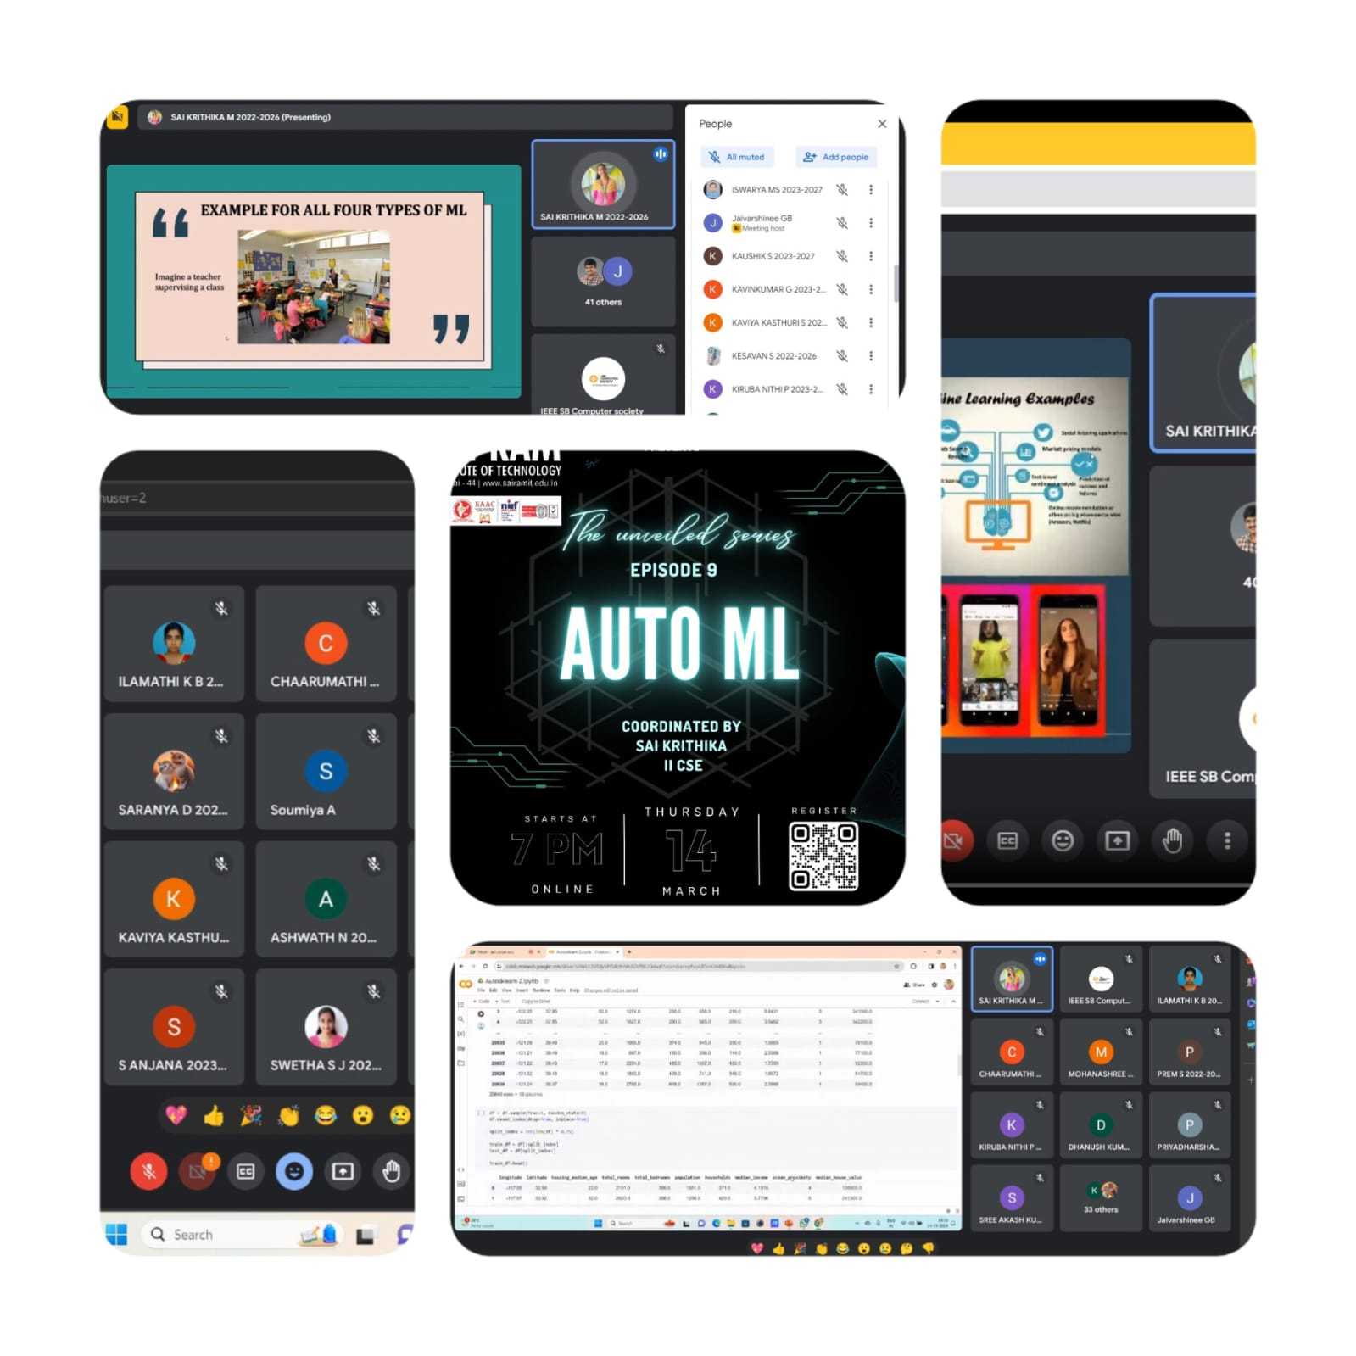
REPORTED BY:
KIRTHANA MOHAN R - – IEEE CS SECRETARY

